Buyer side: contact seller form “send” button is not working

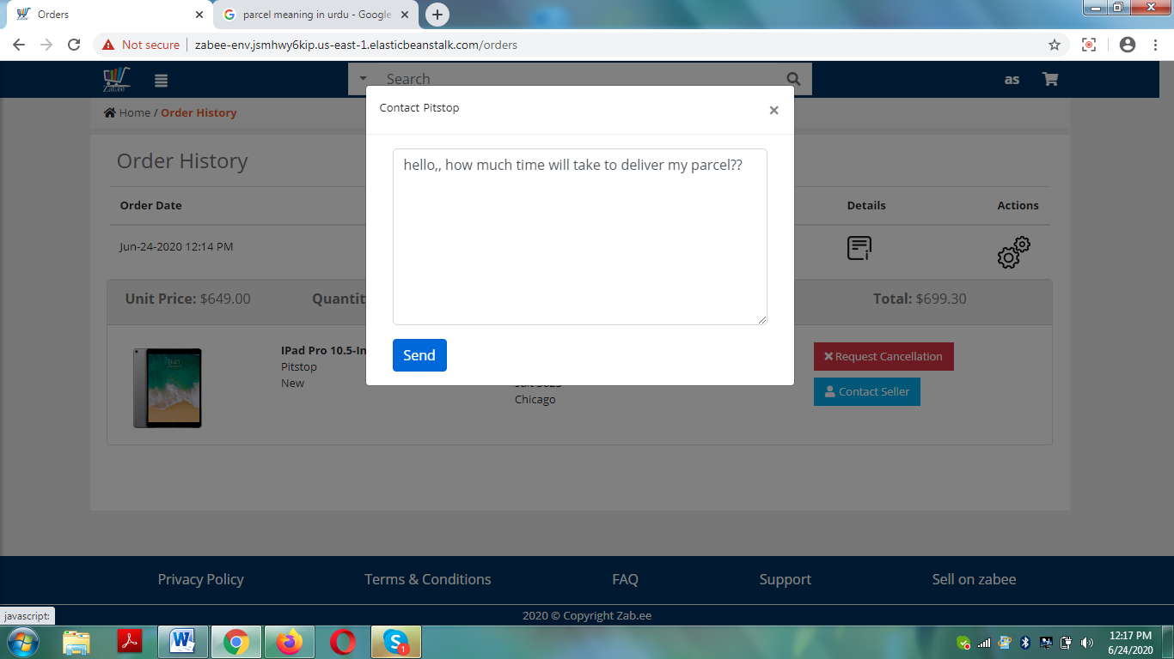

Invoice page-> wrong time is showing on invoice pages (buyer & seller)

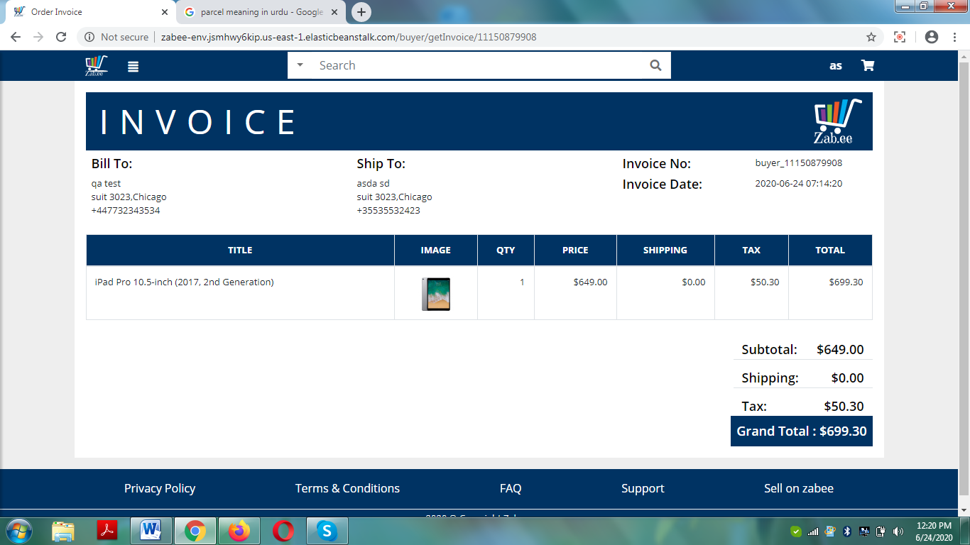

When user hit cancellation request text is appearing like a fog means totally invisible

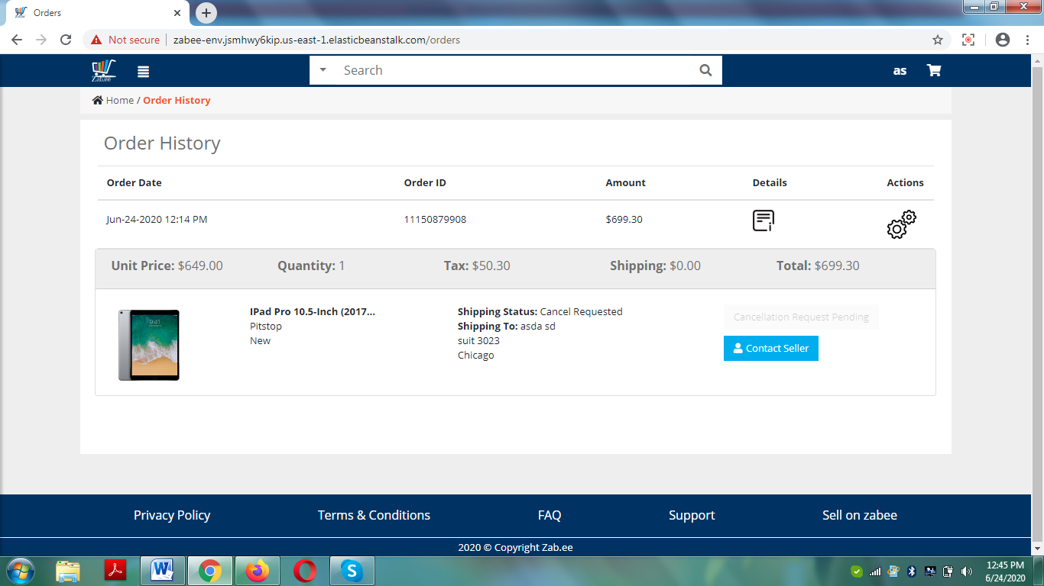

And its only sowing when hover over it

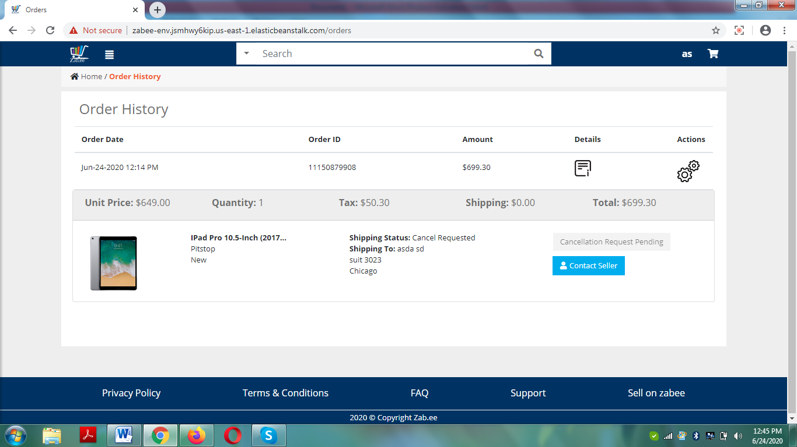

Seller side: contact Buyer form “send” button is not working.

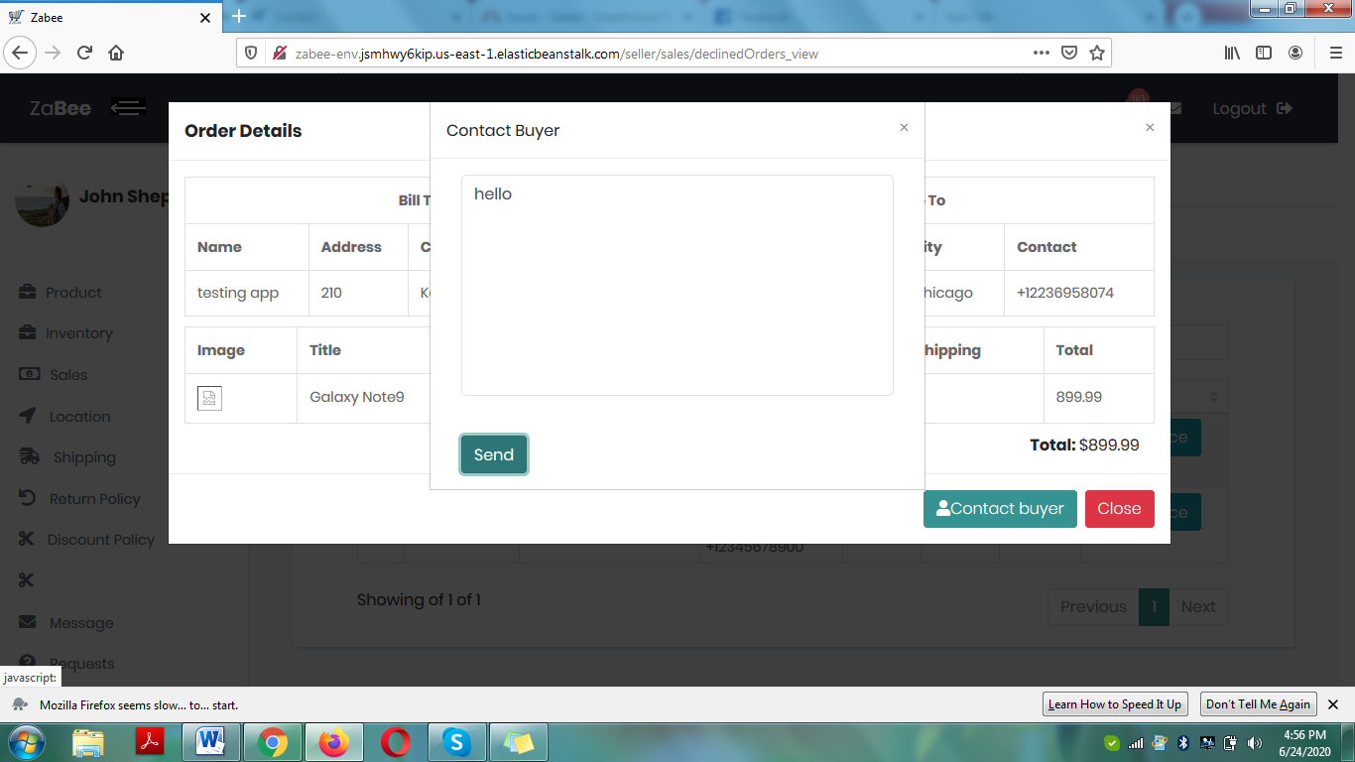

**Test case: add product to cart then login with an account which have saved shipping address only; should directly open the payment card form for checkout.**

**Login with on caps lock/ upper letter is not performing**

**“Message” is neither working on buyer side nor on seller side**

Pagination on categories is not working and search bar is also not searching

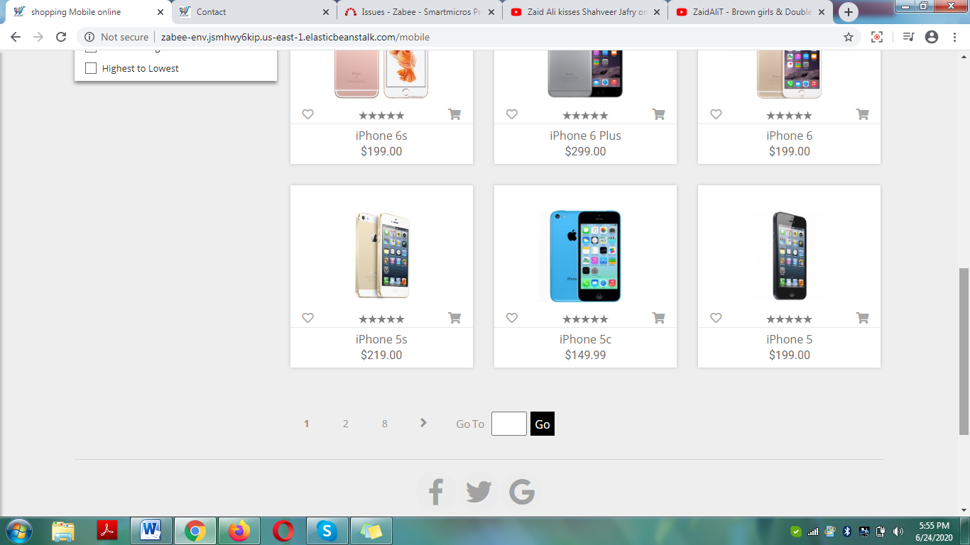

Seller side: wrong time is showing on cancel order page

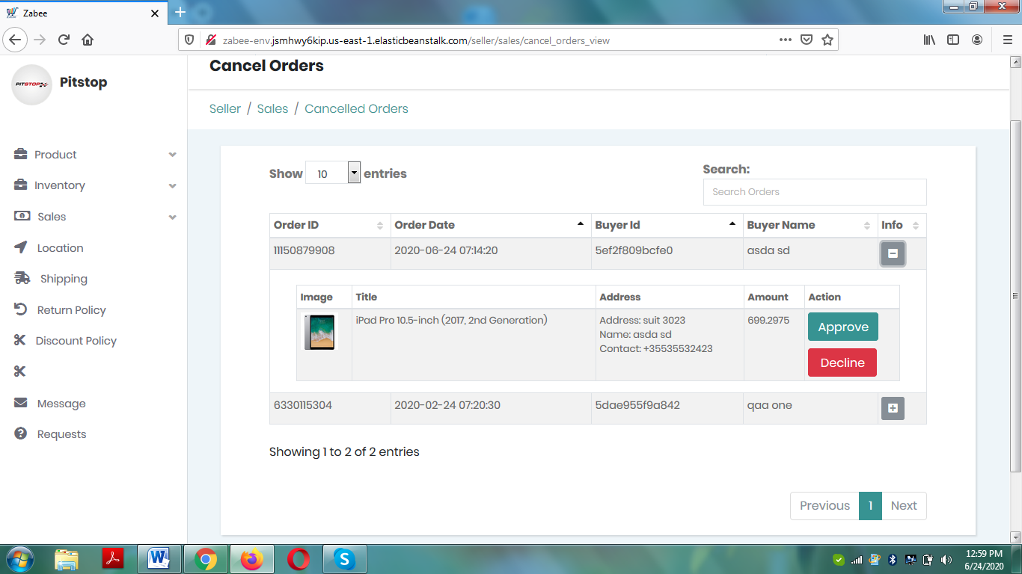

Seller side: Pending order page on approval form “yes” button is not working

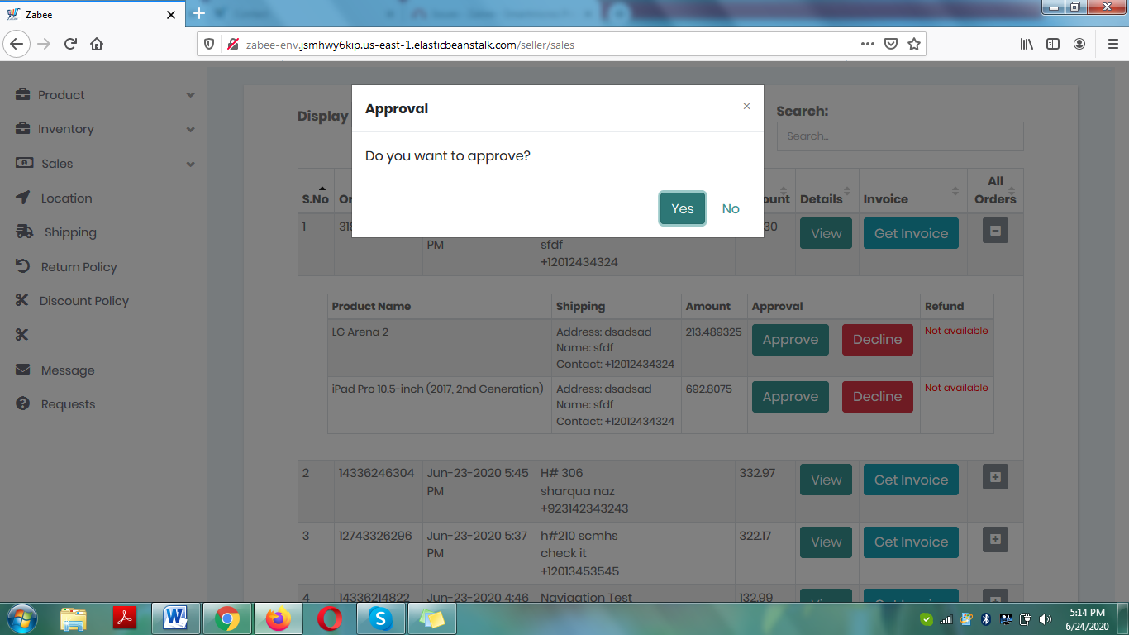

Decline product from pending order page seller side; hit the Cancel request from buyer side. Wrong status and wrong text is appearing. Because first order is declined by seller.

