On product detail page shipping values is not showing.

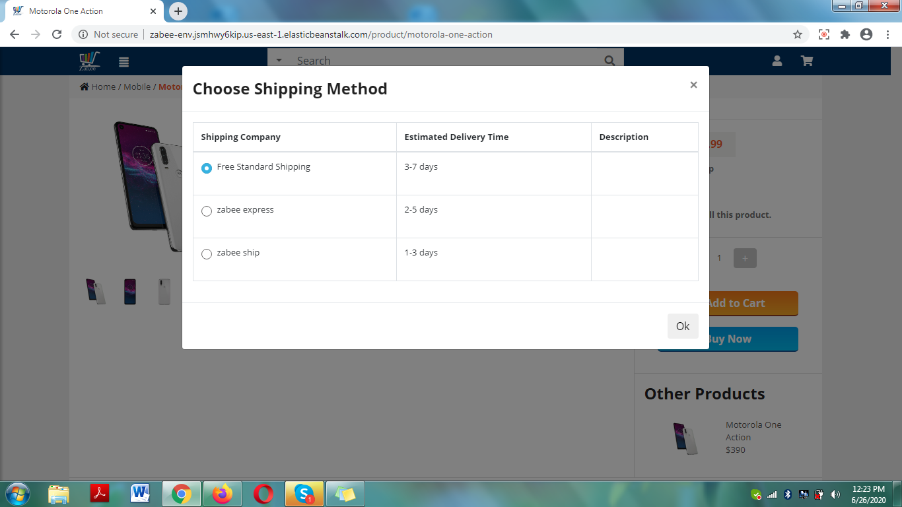

Shipping values not getting free after crossing the max shipping price value check the reference images 1 & 2

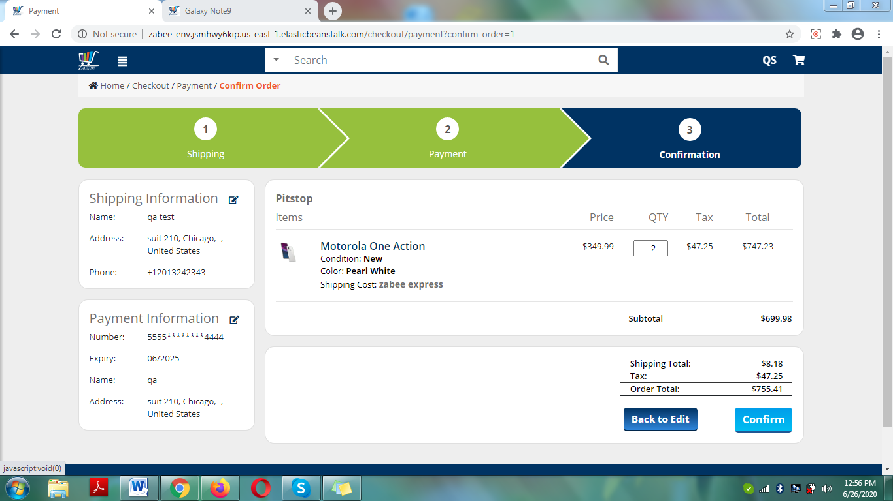

2.

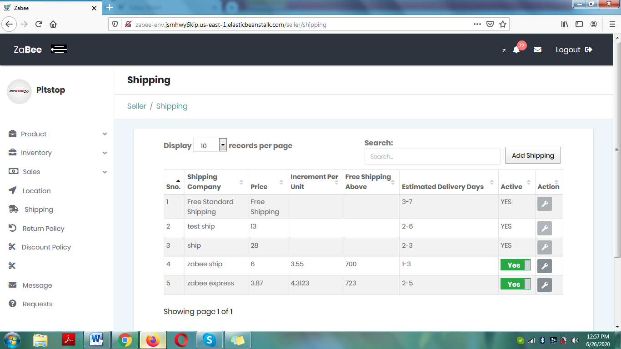

On view cart page: “shipping company” text color is blur.

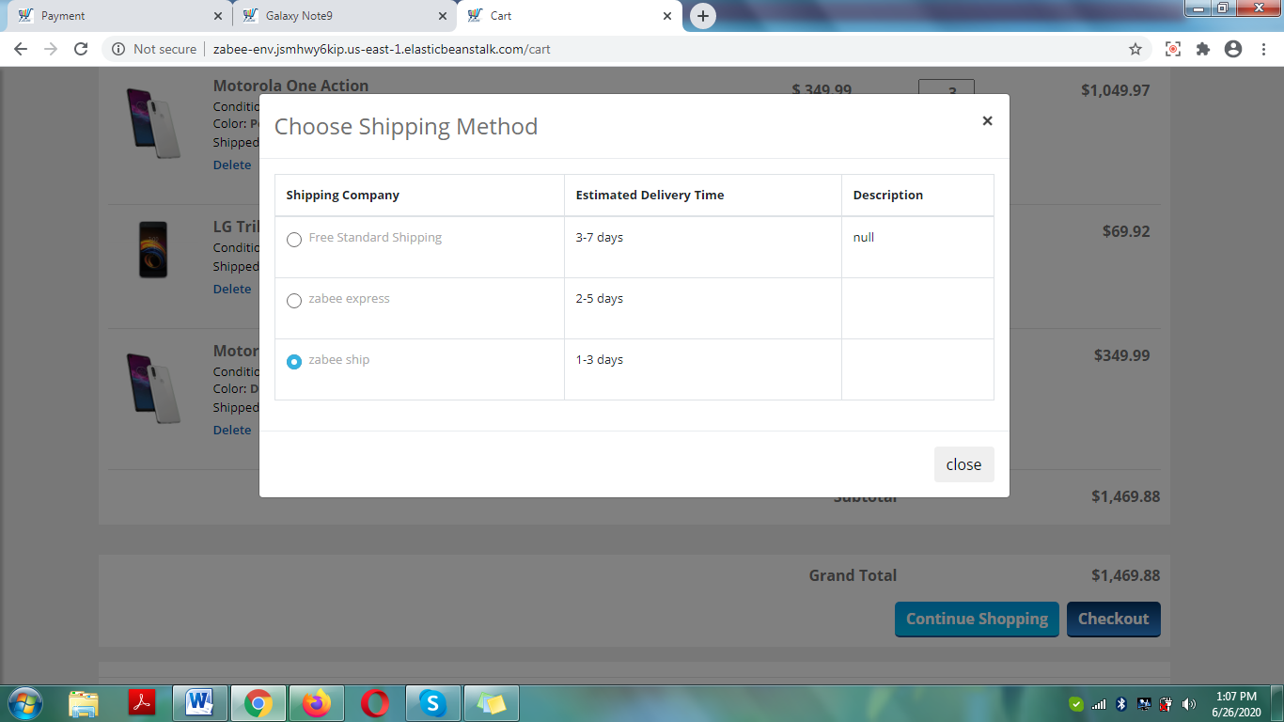

View cart page: as can see on first product quantity is 1 and shipping is “zabee express” and on the next highlighted product as quantity increases “shipped by” values changes to the “free shipping” and this is reflecting after refreshing the page

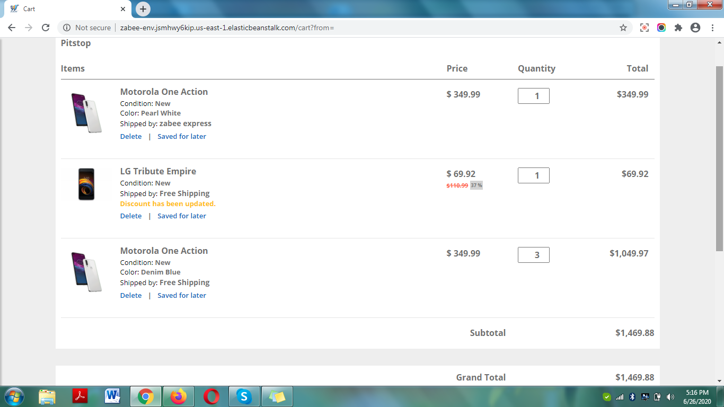

Checkout page:

* 1Change “shipping cost” label to “shipping method”
* If these shipping method are not changeable on checkout page so shouldn’t need to show the hover over it
* Price values are not updating on run time

