On “My order” page from front side at “Get invoice” section same address is showing on both address boxes. Here on **sub-total** its takes last order **price** as showing on picture after loop of 3.

<https://dev.zab.ee/buyer/getInvoice/1576838449>

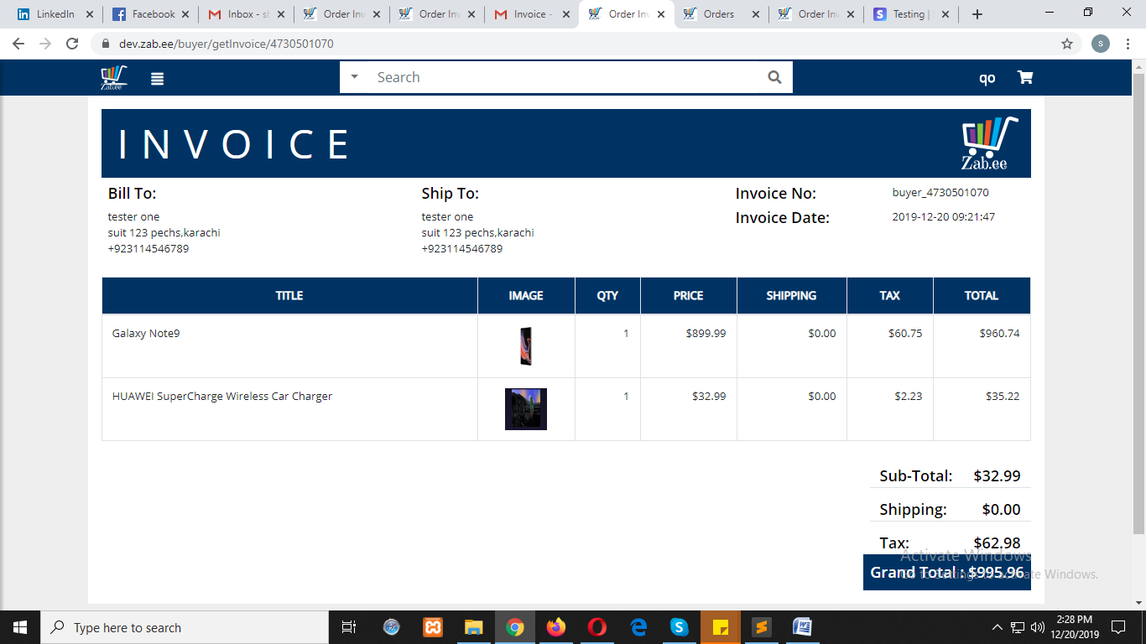

This is for the evidence of separate addresses on both info.

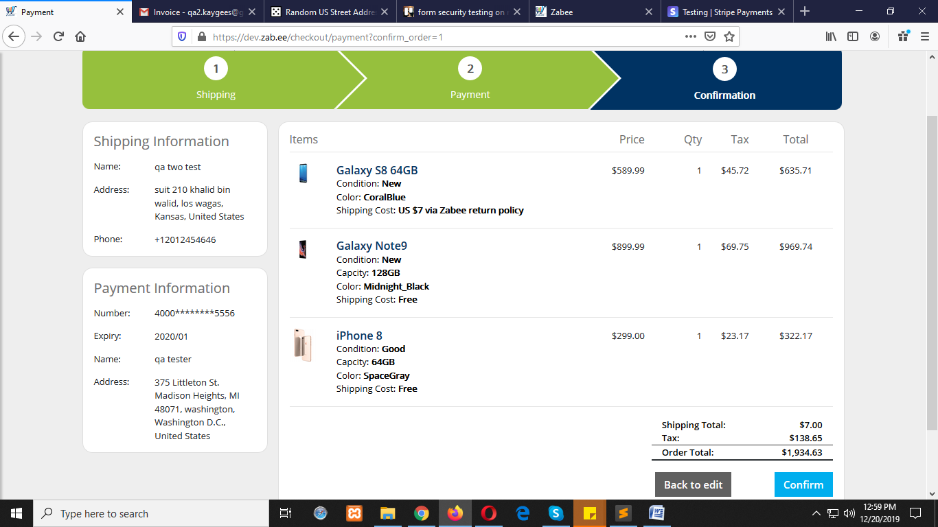

On email wrong tempalte is displaying.this acount is qa2.

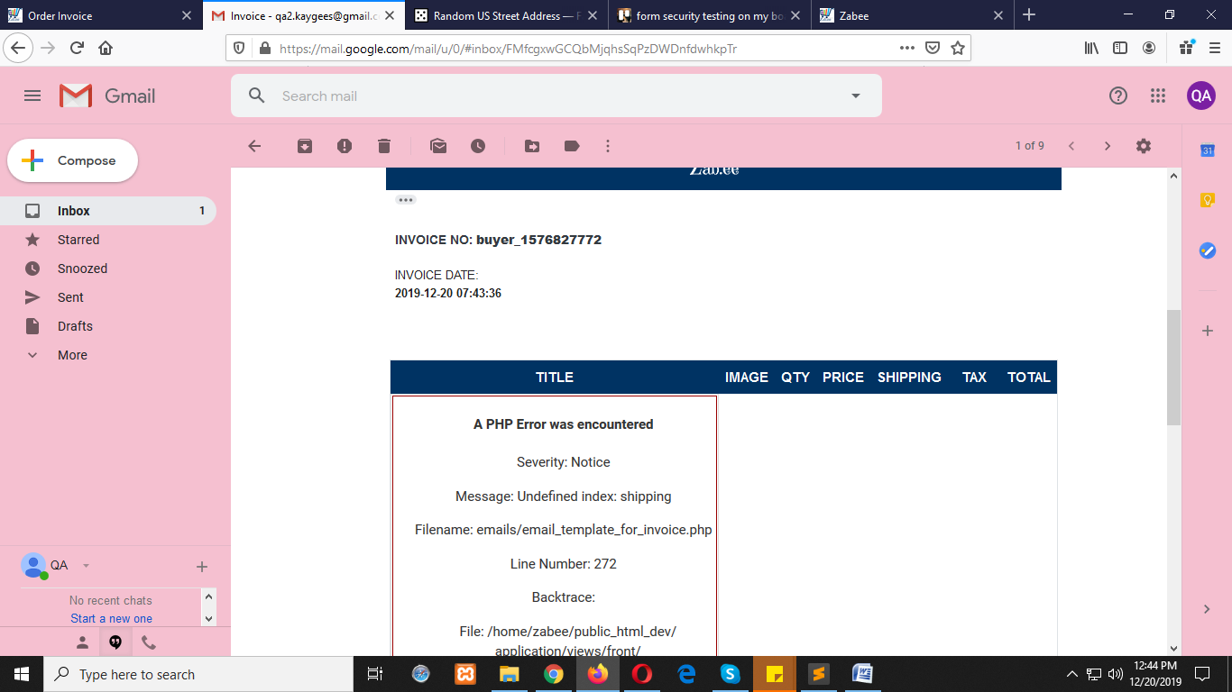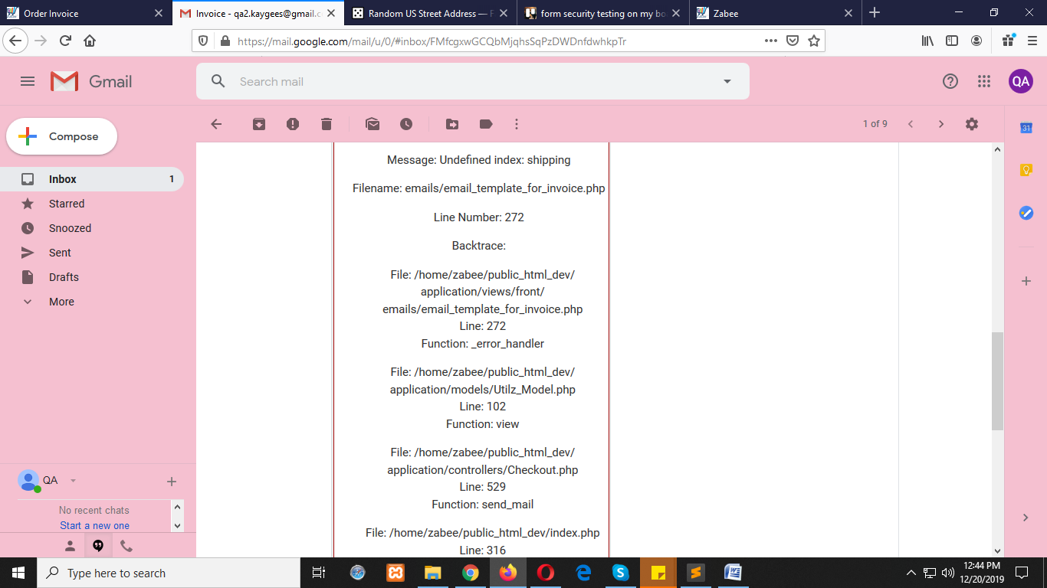

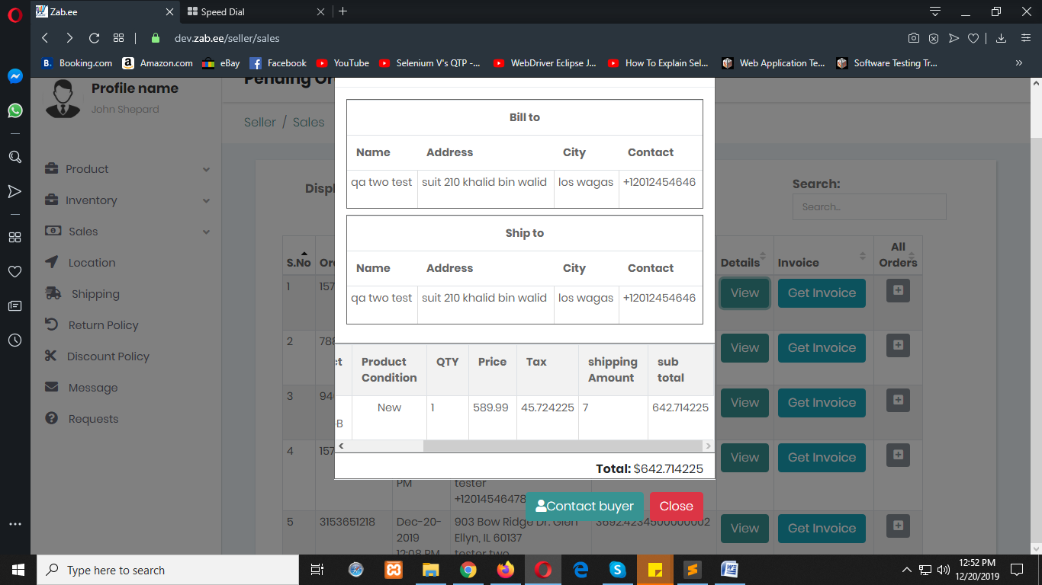

When add new address; should add a message to when nothing is selected like here.

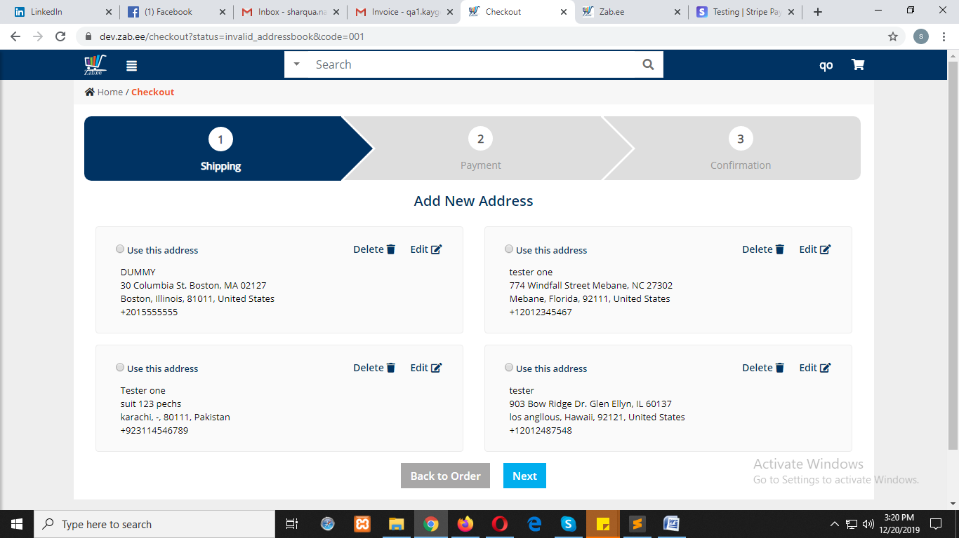

On deleting an address added message is showing.

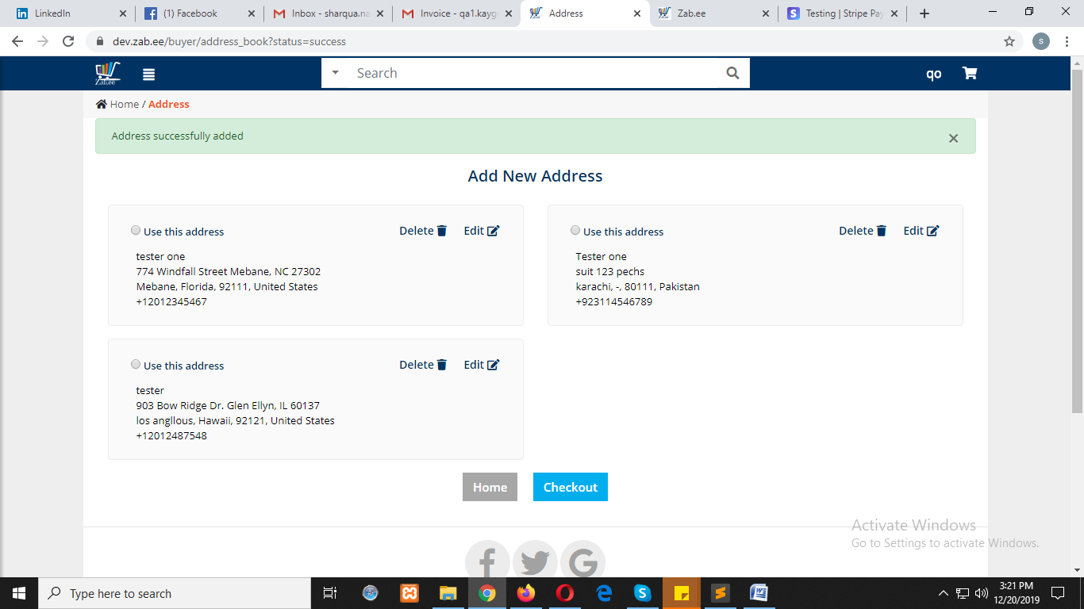

When getting back on payment from confirmation page.

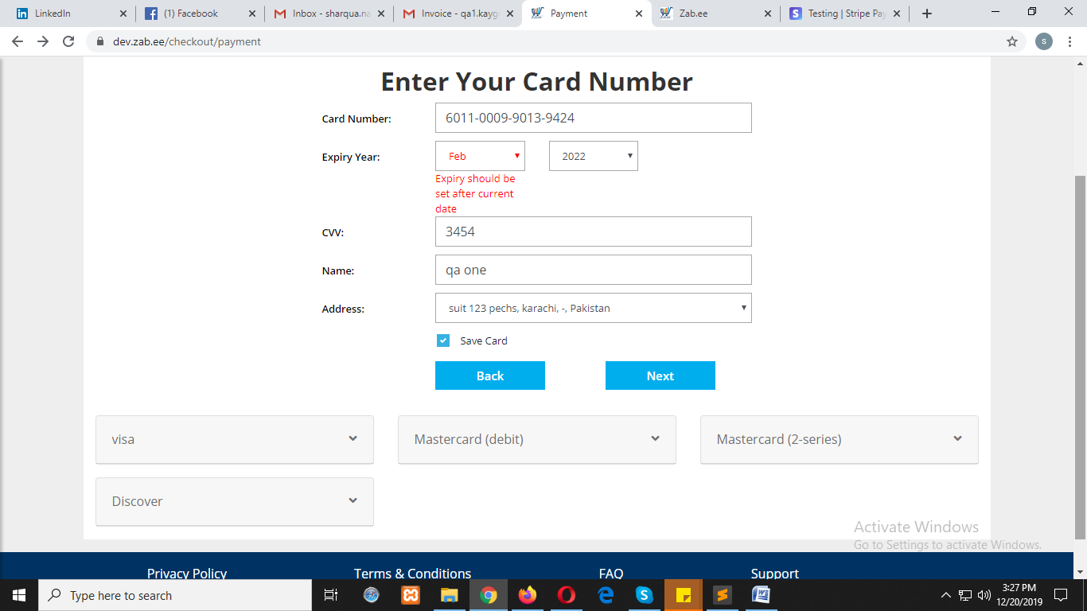

When add to cart a product then login with an account its redirects on home page instead to proceed.

<https://dev.zab.ee/checkout/signin>

Proceeds a checkout as a guest

<https://dev.zab.ee/Home/guest_registration>

