Although image is selected but message is pop up that “no file is selected”

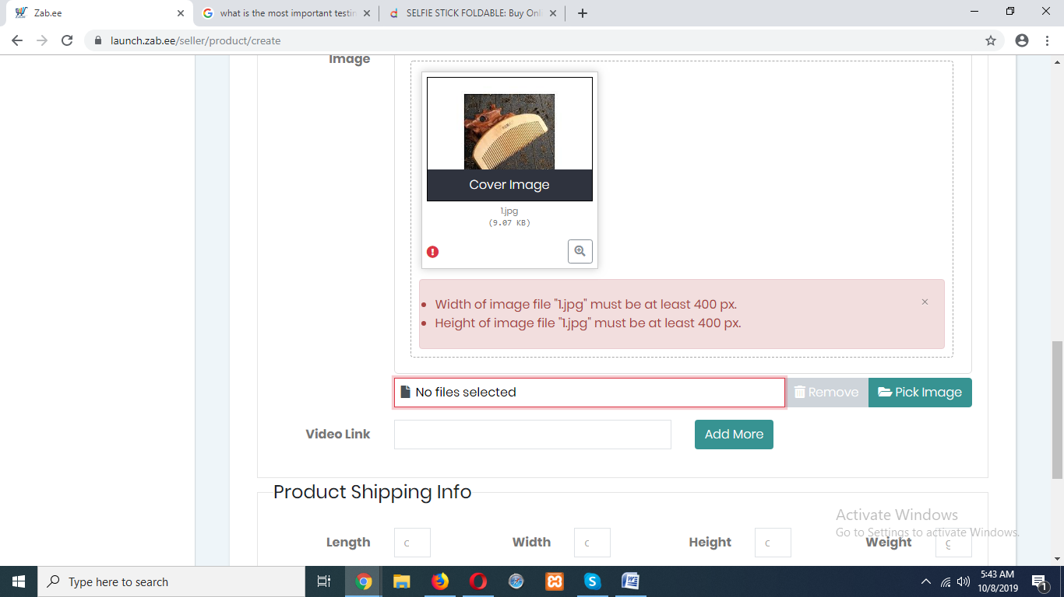

On inventory creation at **QUANTITY** point, unlimited numbers are acceptable and on **PRICE** field there is a validation of 19 digits which is a very big number

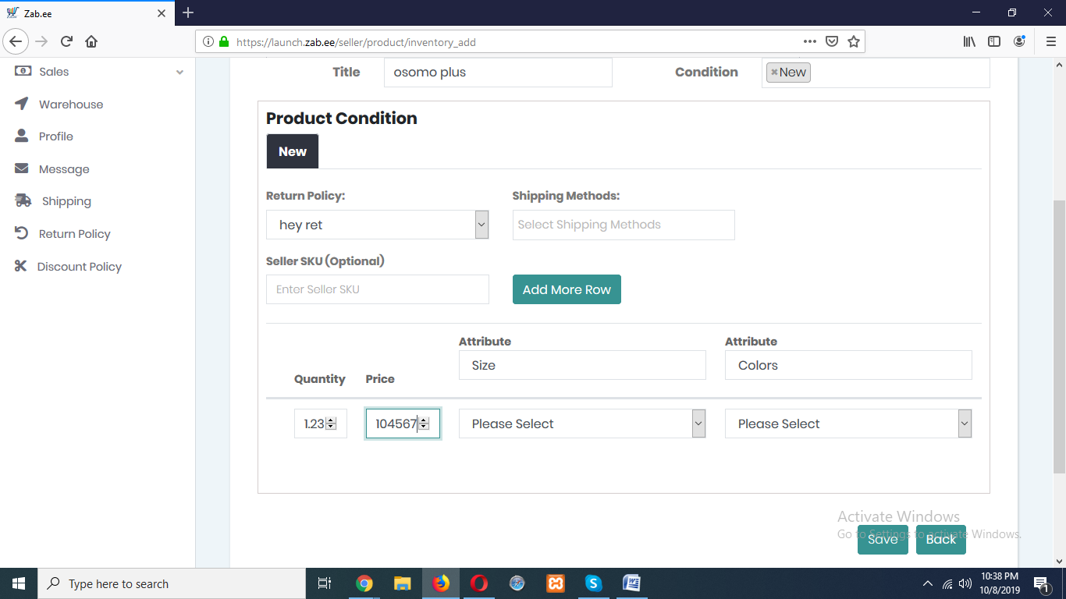

On shipping info dimension boxes are shrinking. **UNLIMITED NUMBERS** are accepted in these dimensions also **POINT** is not acceptable here.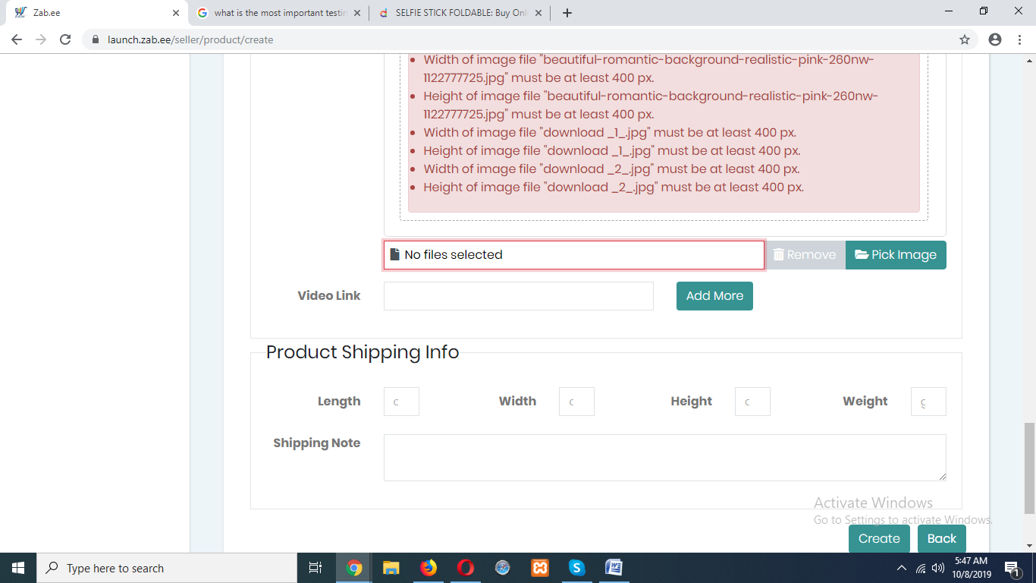

**TAX** is neither added nor updated on seller store page.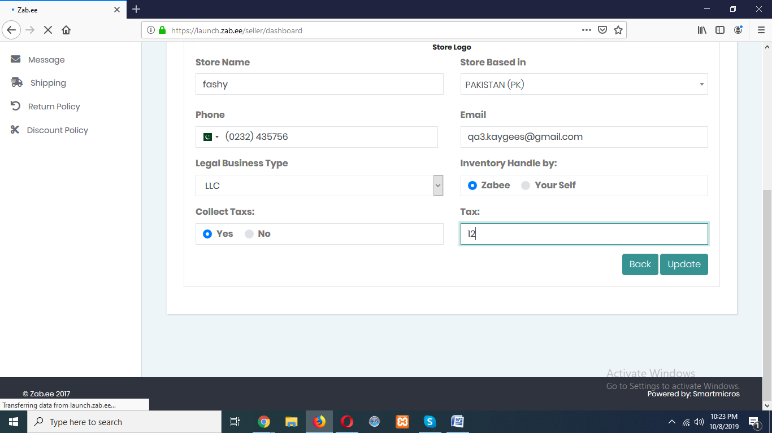  
Product with double quote” as title is not edited/updated by admin.

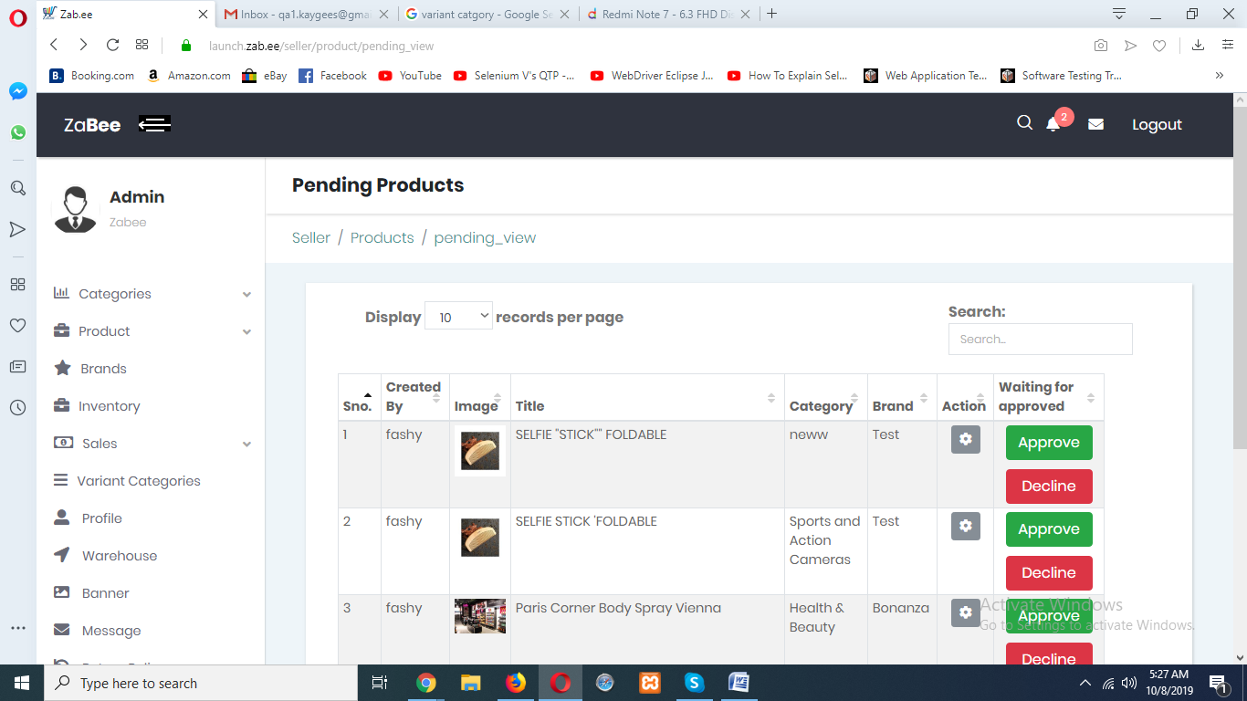

**There should be a tab for accepting product when product is approved by admin. so that it is easy for seller in making inventory of that product.**

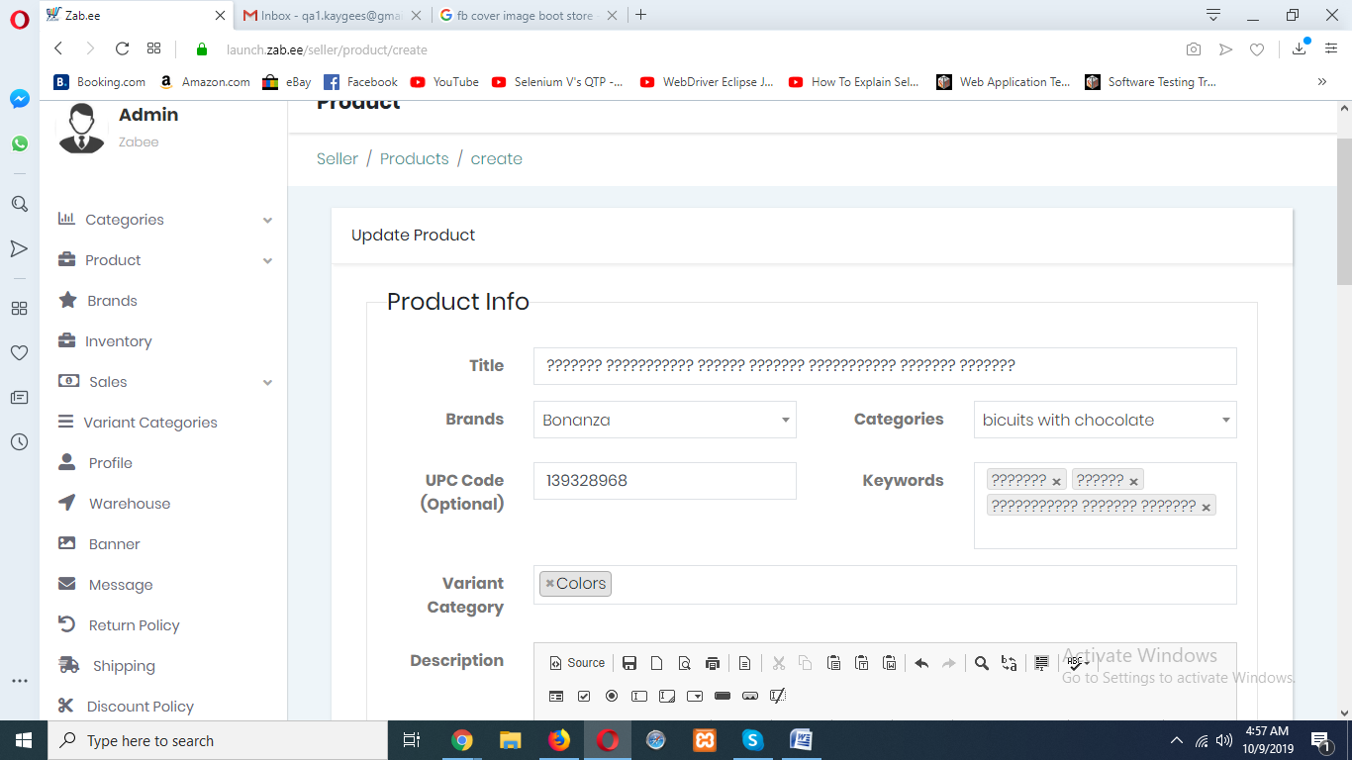

No limitations of characters on any field, no validation on title.

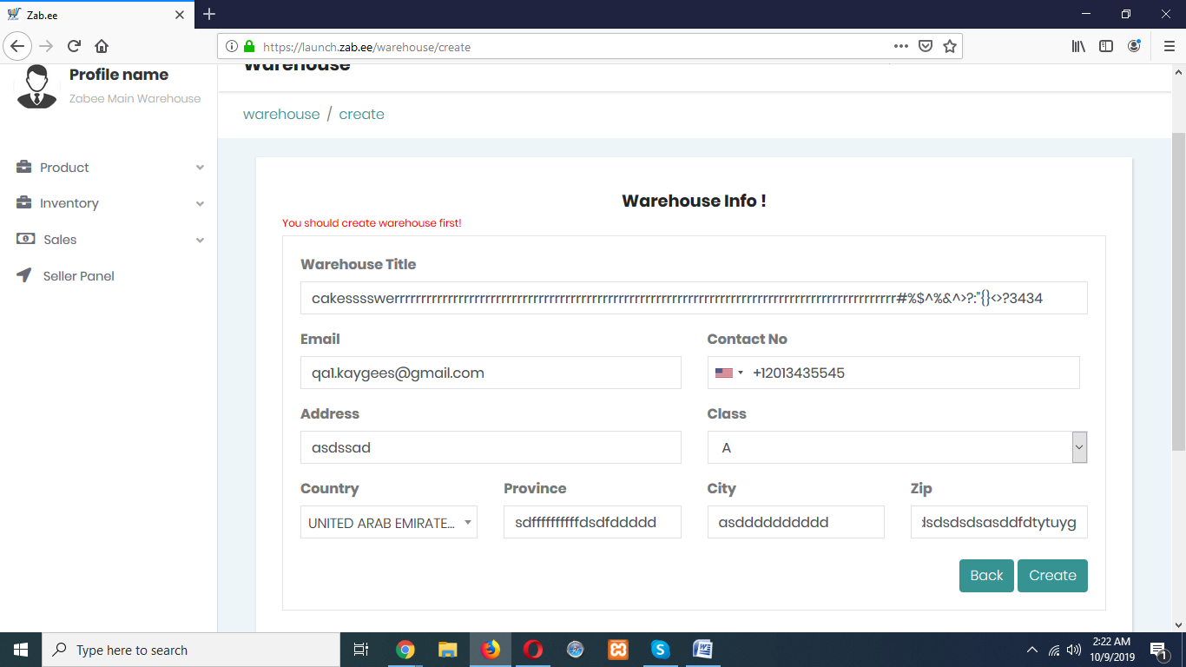

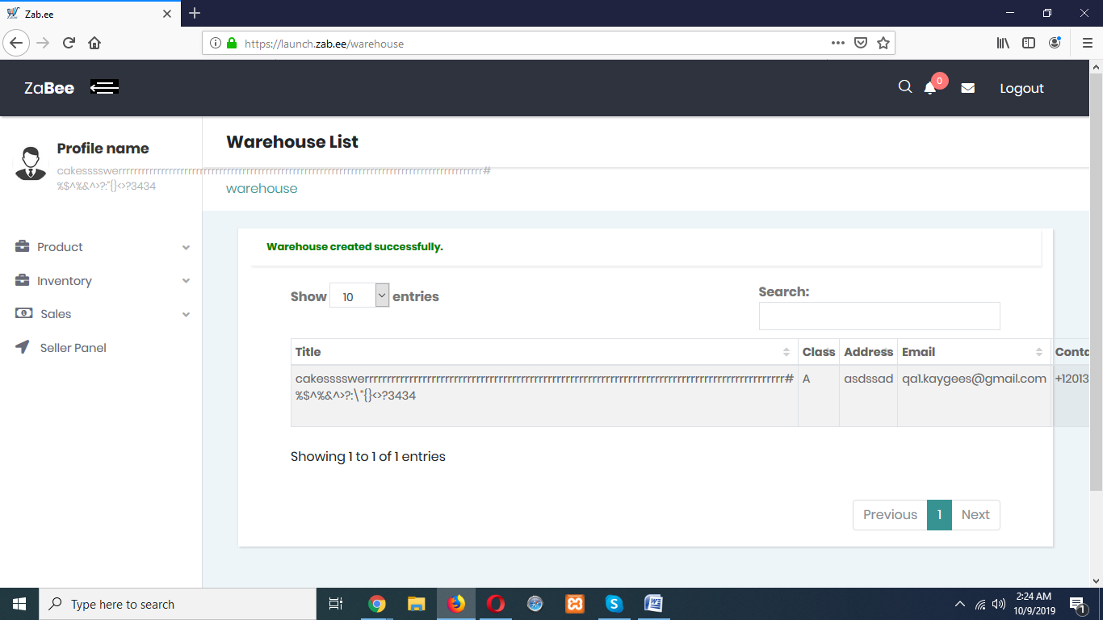

Some time it is happen that values for the attribute is not displaying.

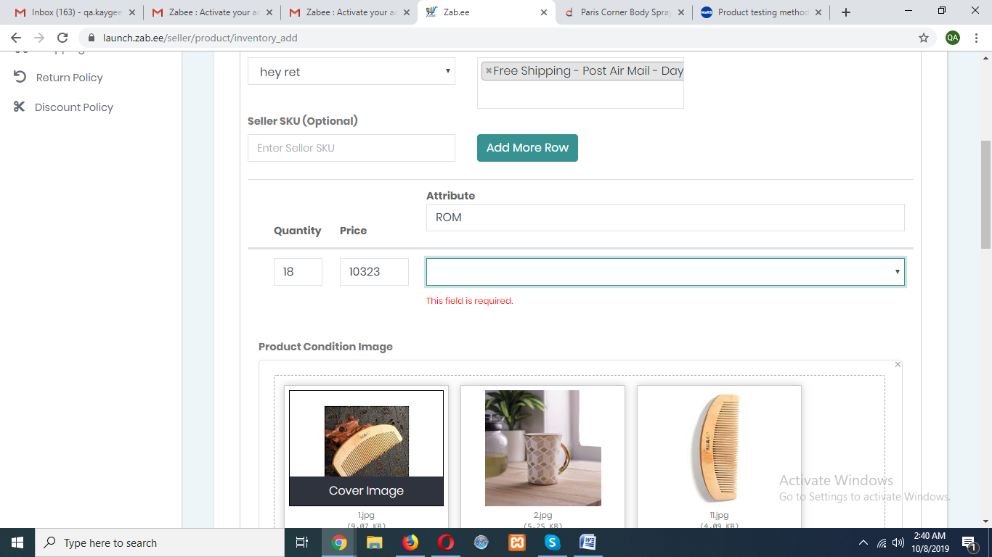

I add shipping note here but it shows 0, also this note is not updated from admin panel.