Zabee:

No validation on address field it accepts any character.

Shows **STATE** option only for **UNITED STATE** and for all others shows **PROVINCE.**

No limit of On zip taking letters or numbers

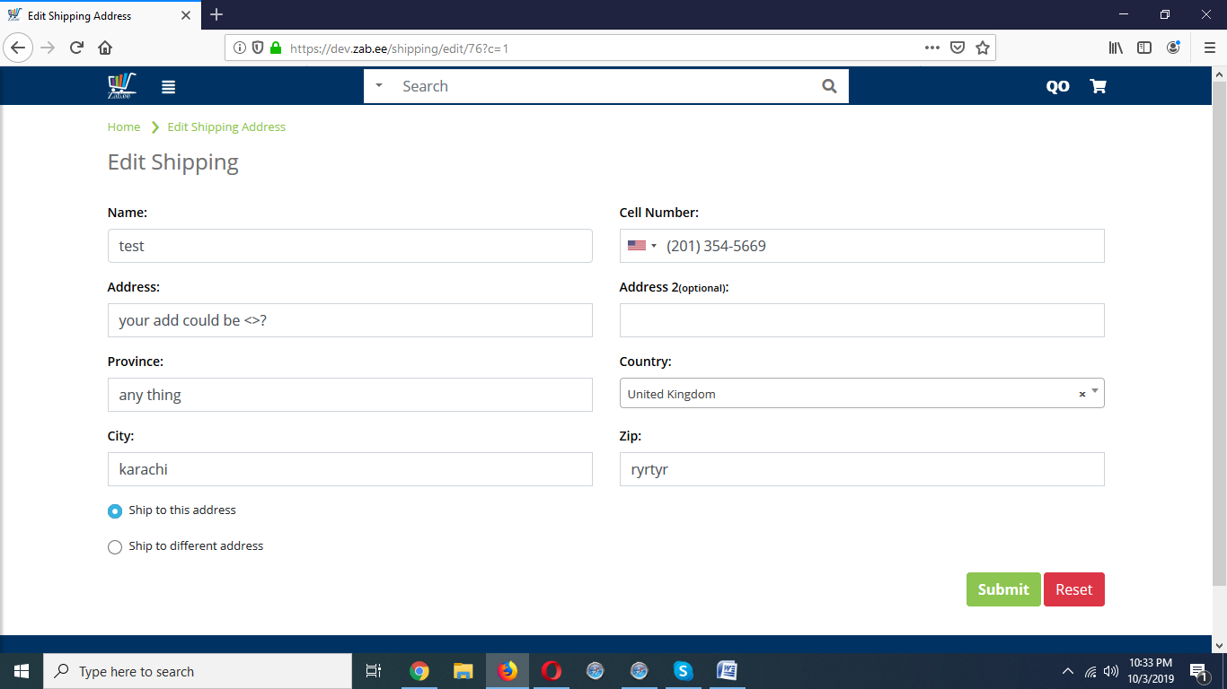

Ware house

