UI of page is disturbed also contact button is not working.

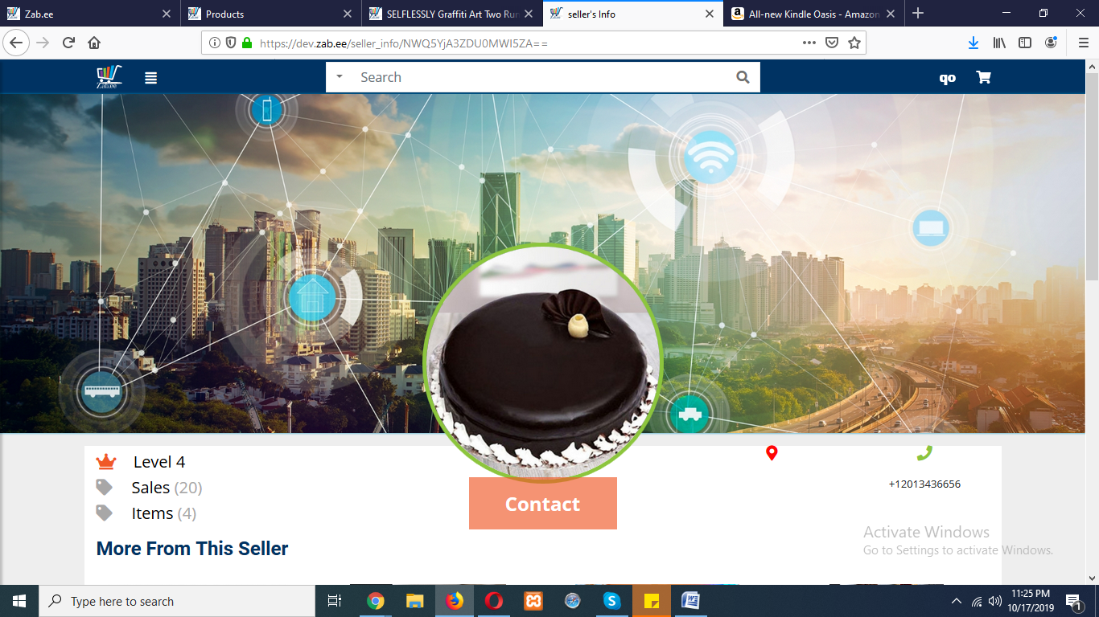

Drag n drop picture on creating a product gives message thatbis not allolowed

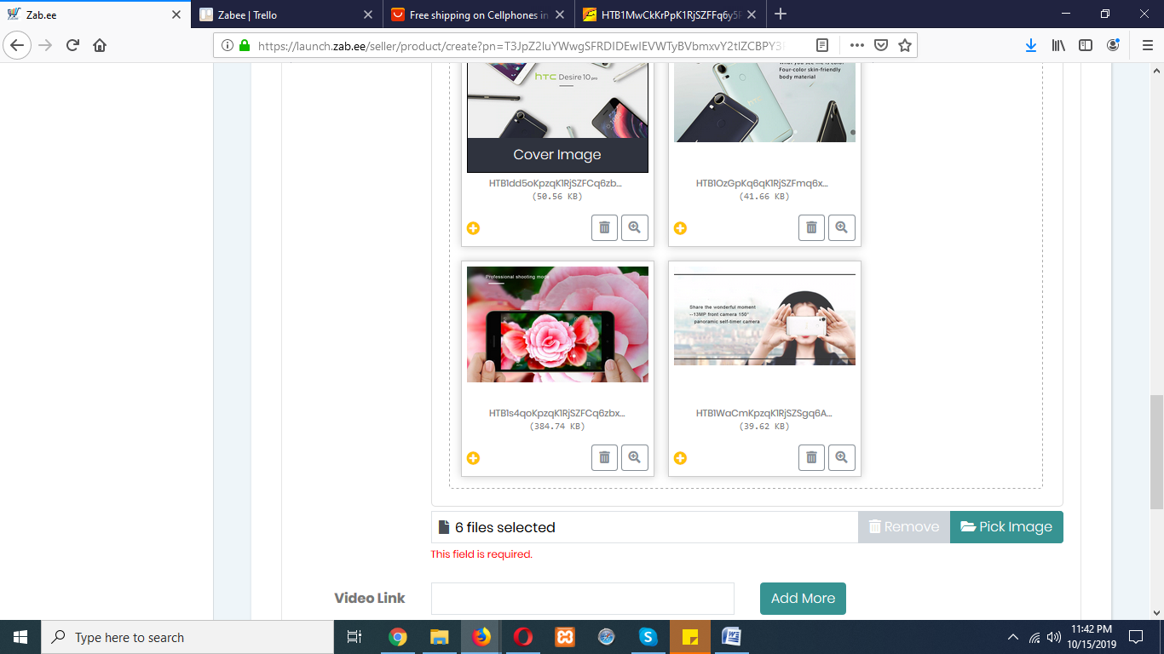

Editing a product title from any side either from admin or seller.

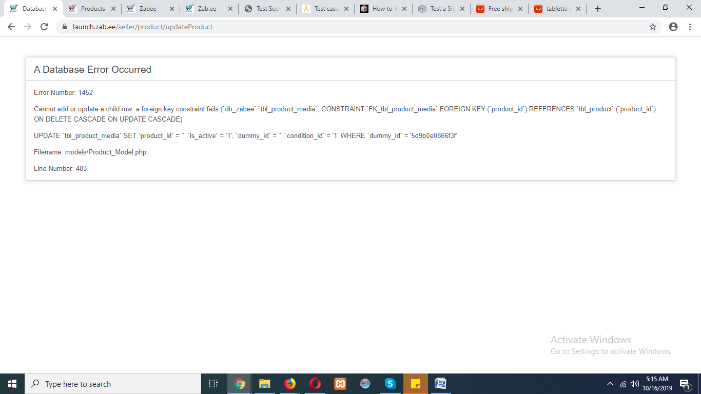

Variant category:

