When edit a pending product**: images got hide** and by adding image multiple product is created same goes for the title ; if edit **a title** new product is created and shows on pending product list.

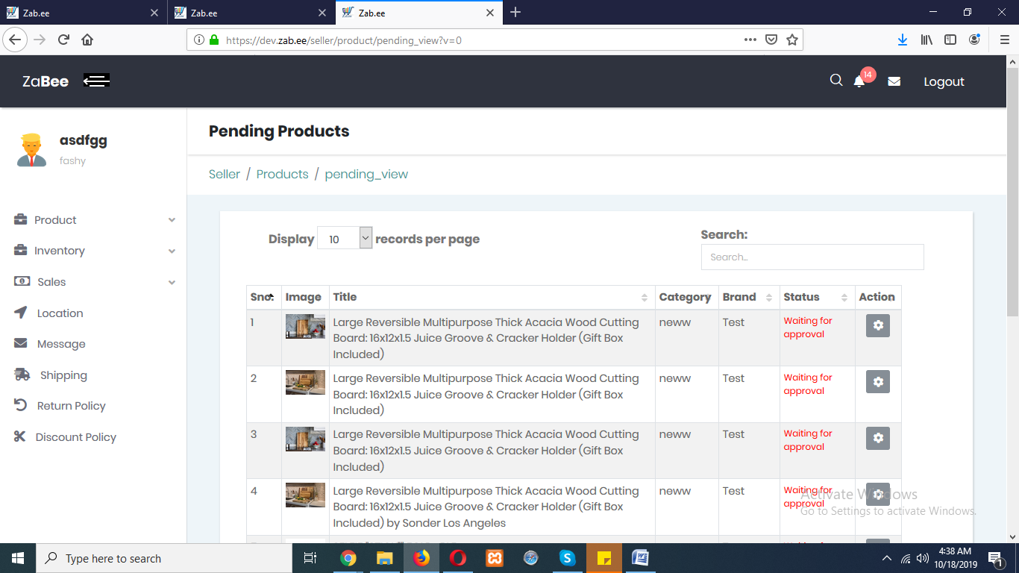

Rejected product: when edit a rejected product , edited product goes to the peding product list but the real product remains on rejected product list.

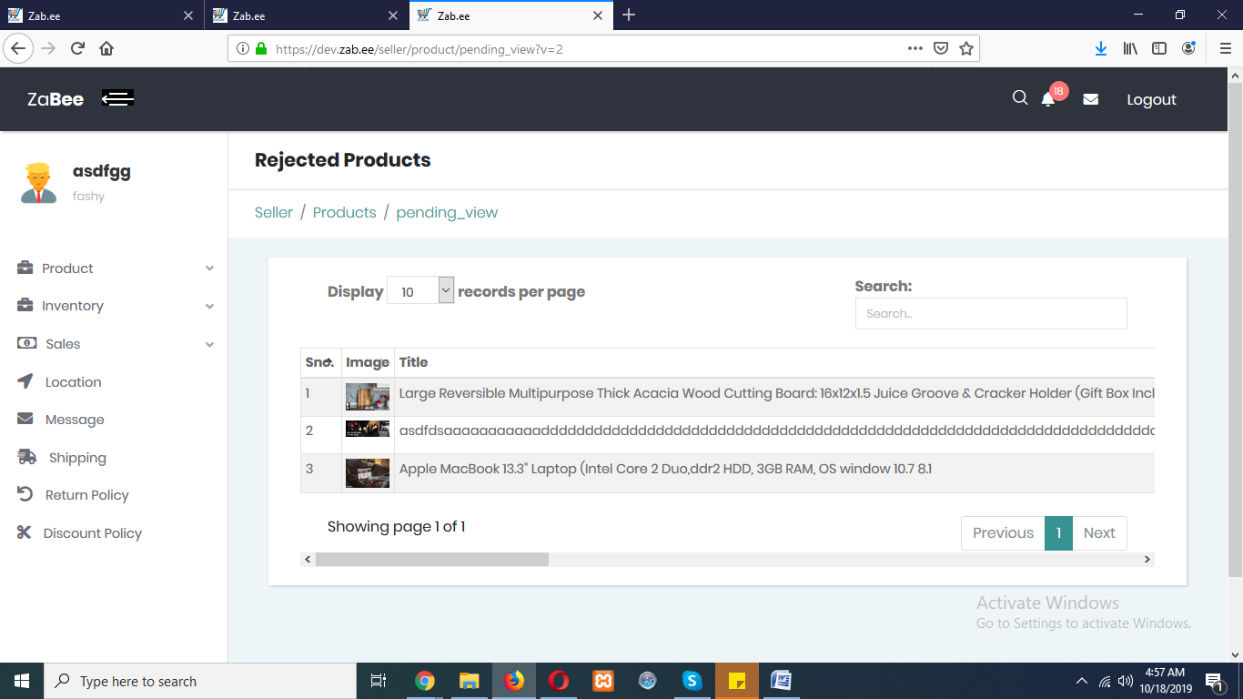

I edit this marked product. It remains same and at here.

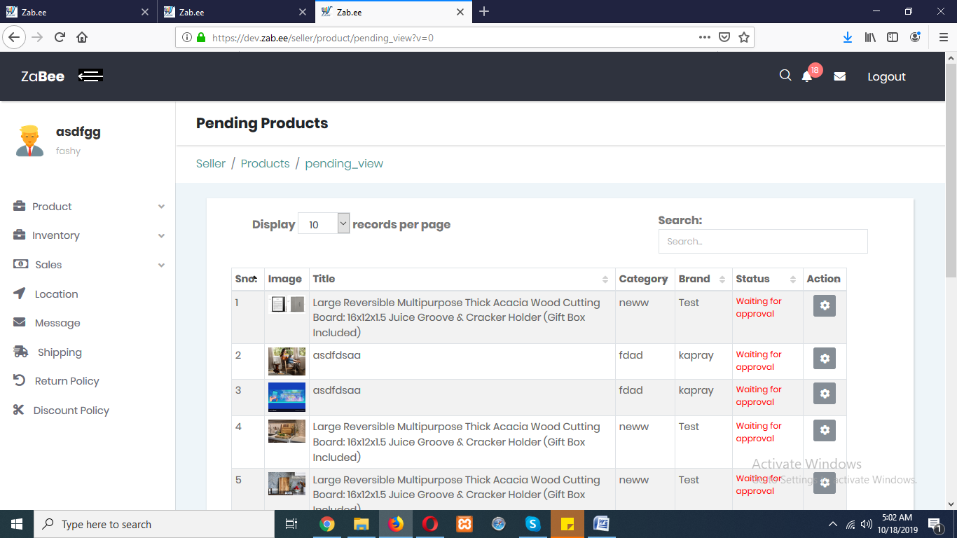

The edited comes on pending list.

Product image is not displayed. Price box screen has shrinked.

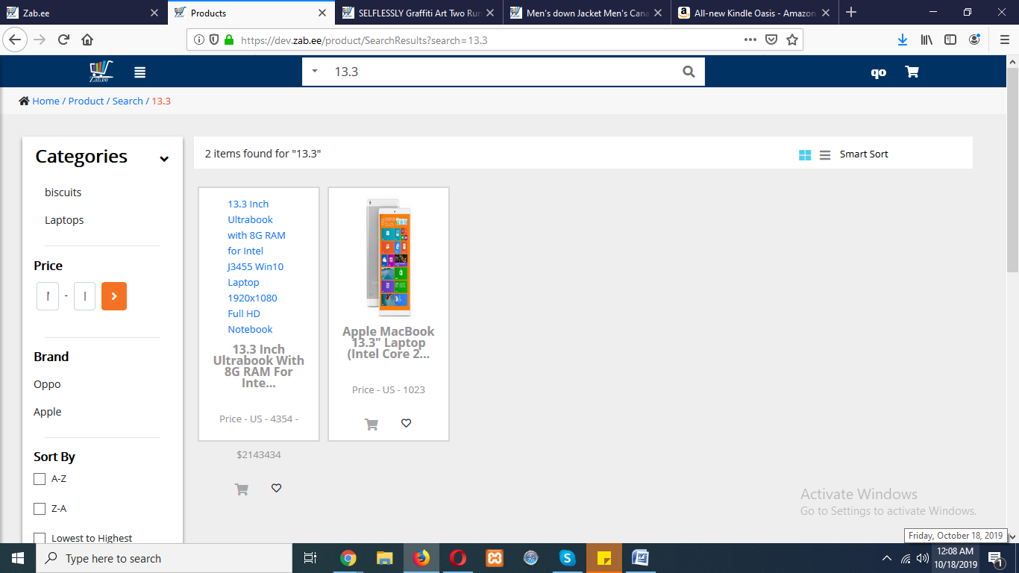

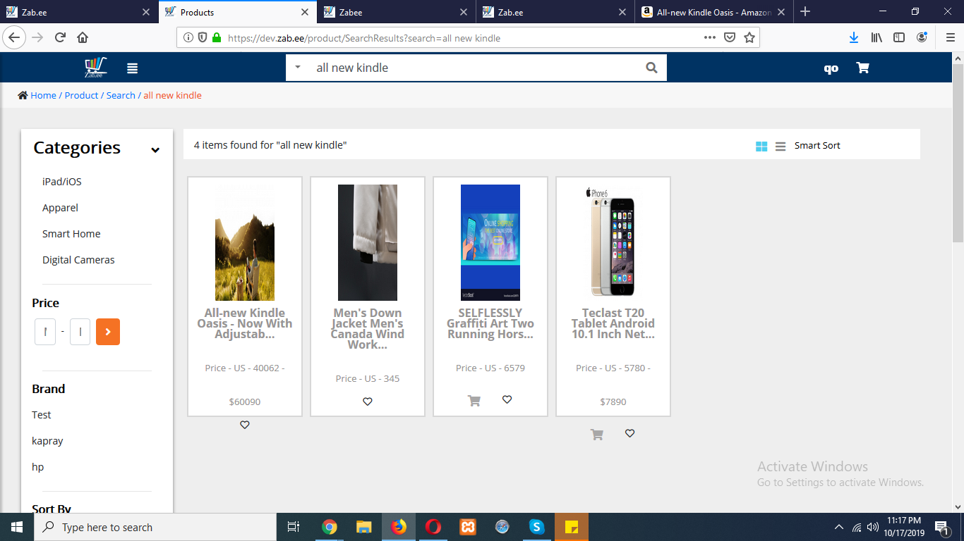

**UI** of page is disturbed. **Contact button** is not working.

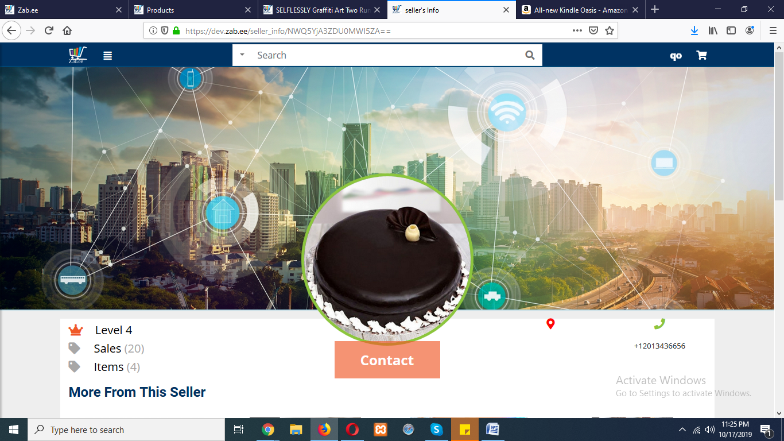

Got this when click on variant like color here. Also quantity button is not working.

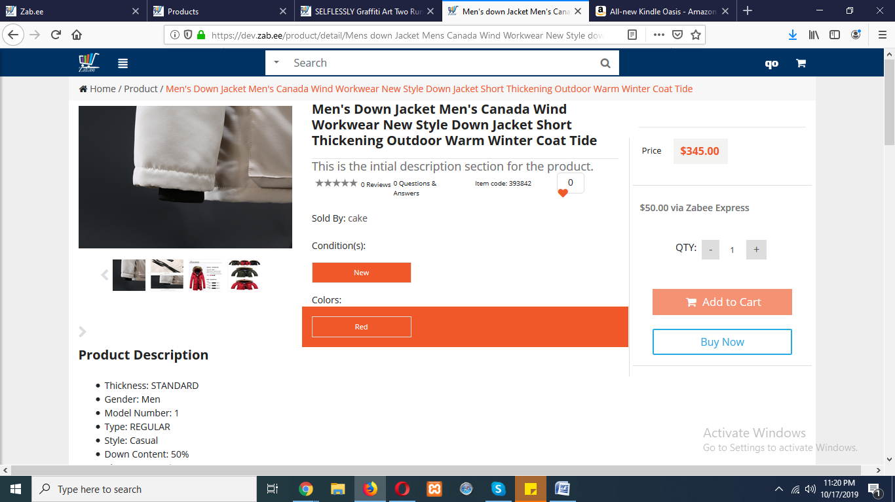

Have this message box when click on variants.

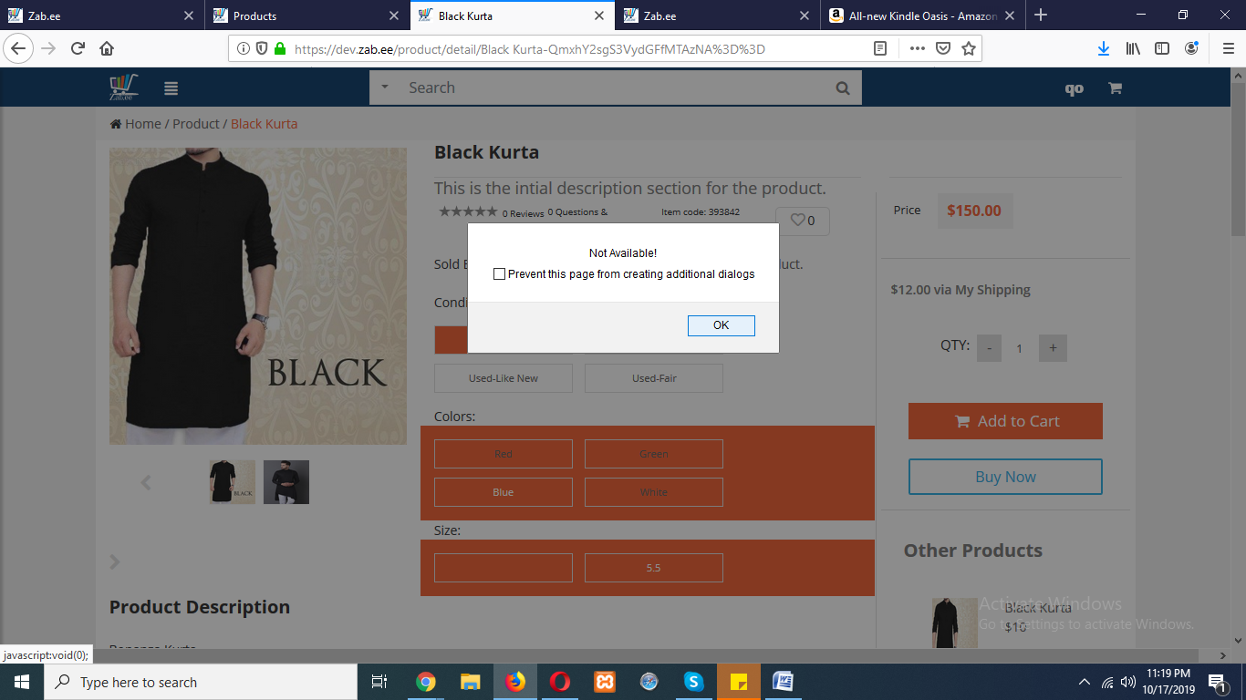

When creating acessories of these highlighted products got stuck mean its not created.

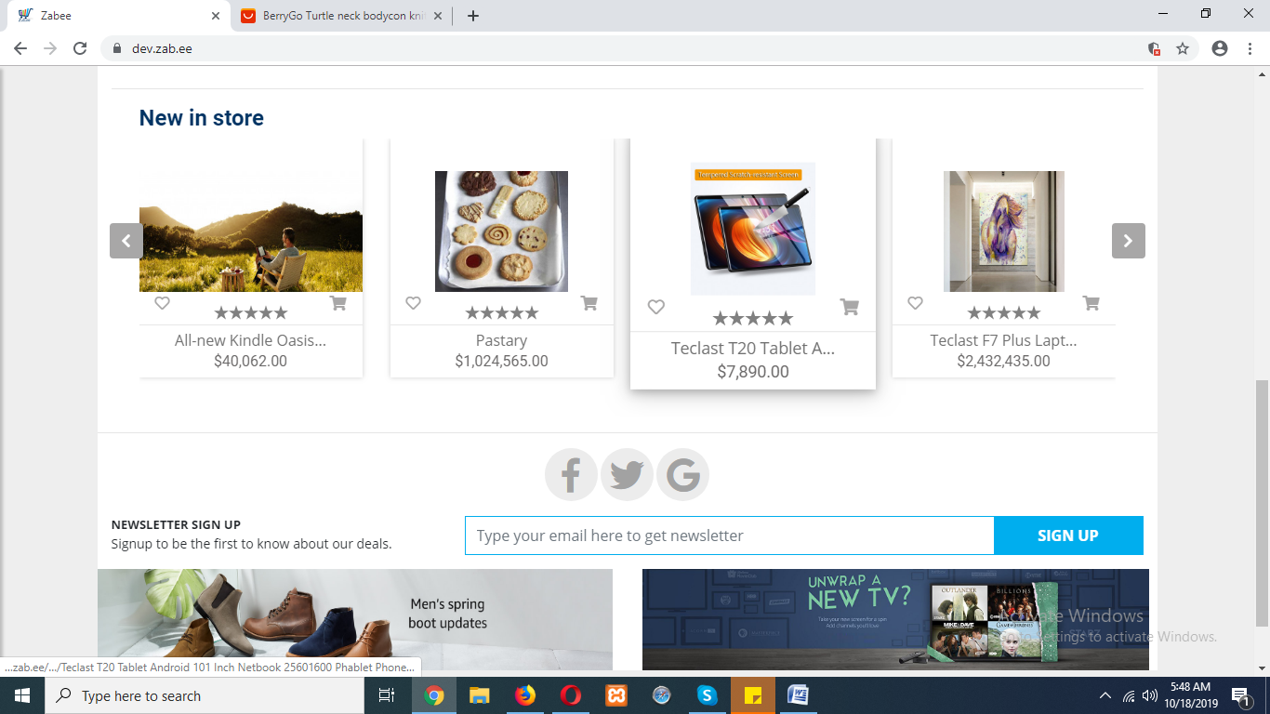

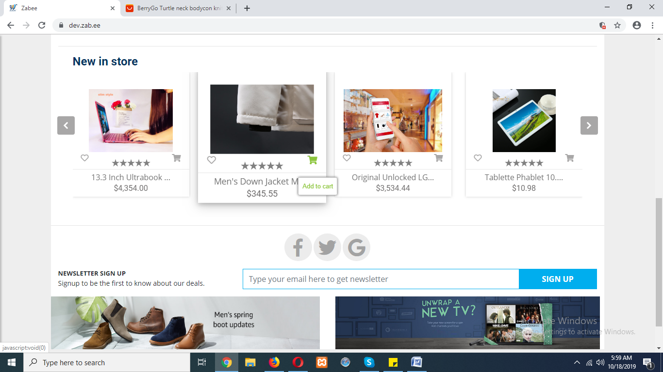

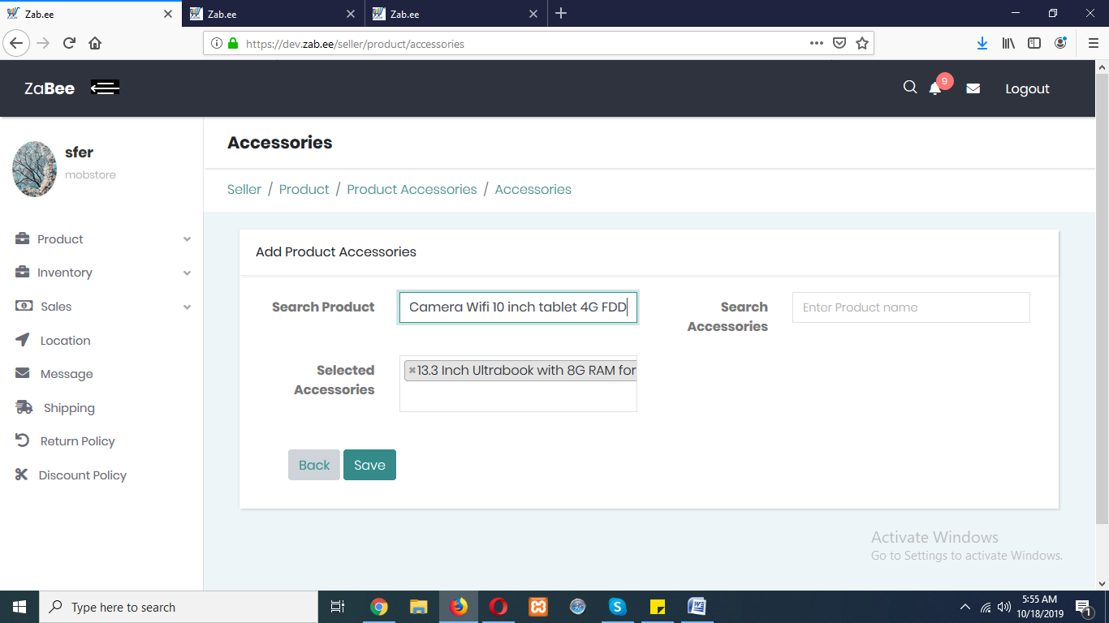

Here it is seen that on clicking save button searched product is highlighted.

Back button on **store page** is not working.

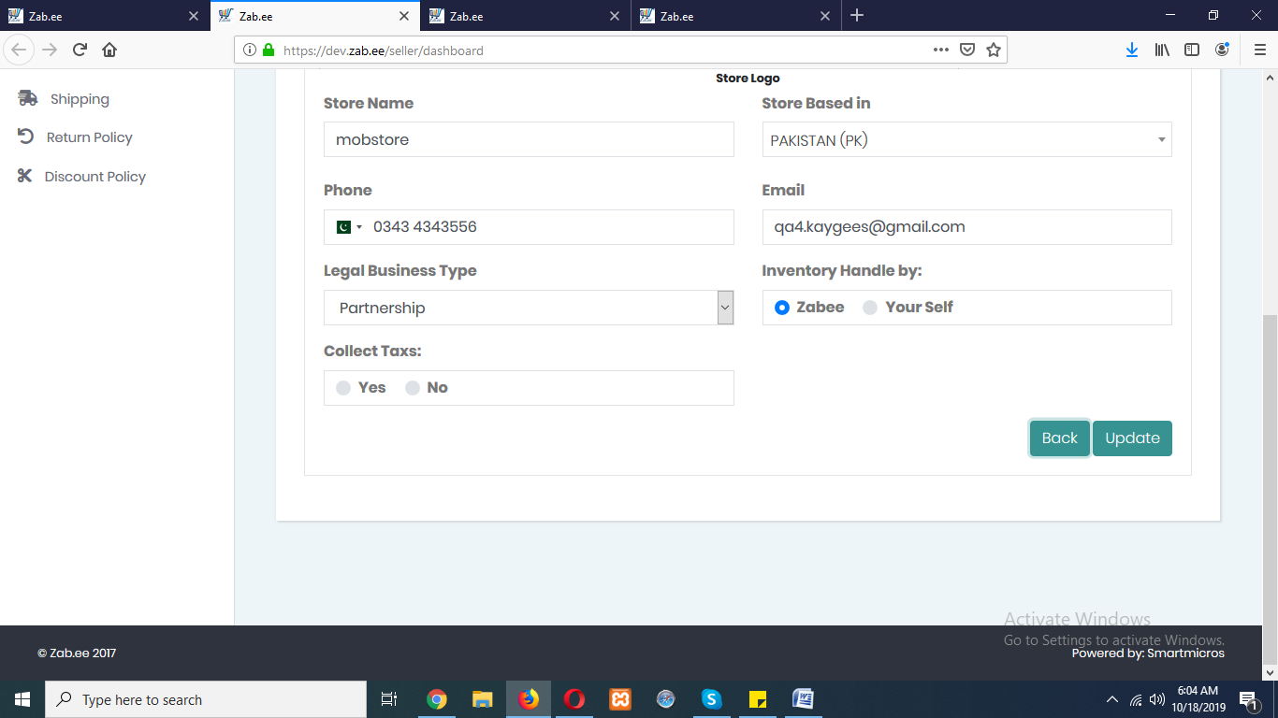

**On product report searching a product opens a blank page.**

**When inventory is edited by seller like title and other fields this changes is shown on seller side on inventory page as well as on admin side inventory page but not on product list page of both the side. Also on buyer/user side no changes on title are shown but other fields changes is appeared.**

**I updated the title and other field of this product but title is not changed here.**

