Order placing flow: Galaxy note 10 order is placed

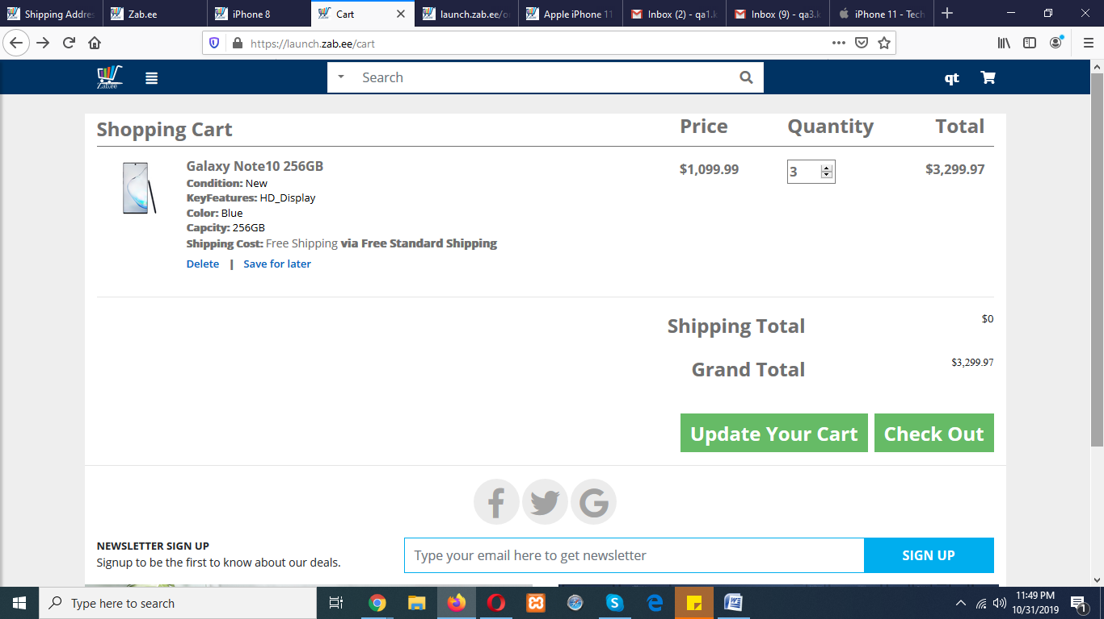

An error window is display

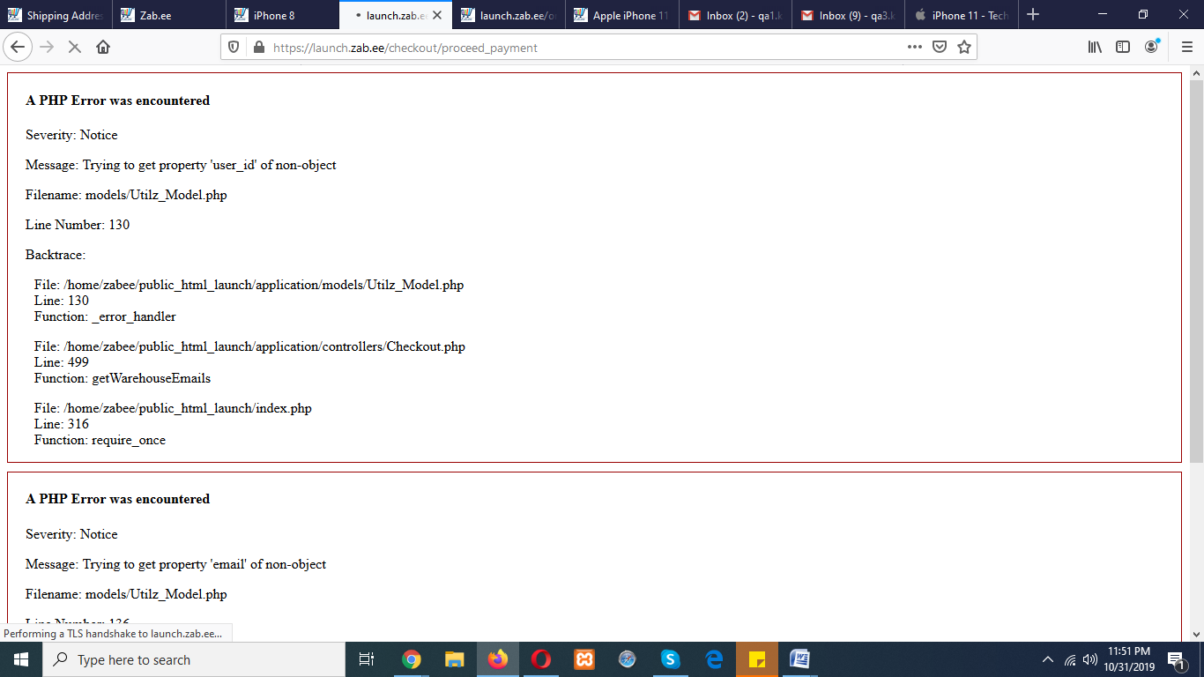

After that completion page is shown

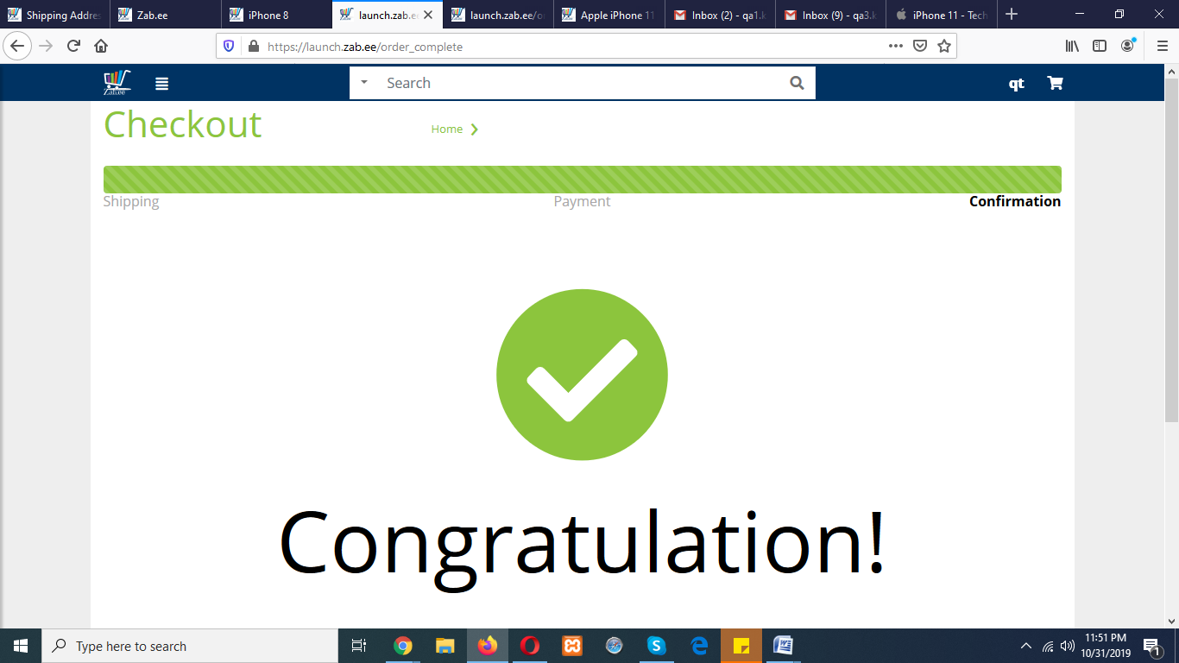

No billing is email received.

Note: any product could be chosen same error is occurring. For the reference images are below

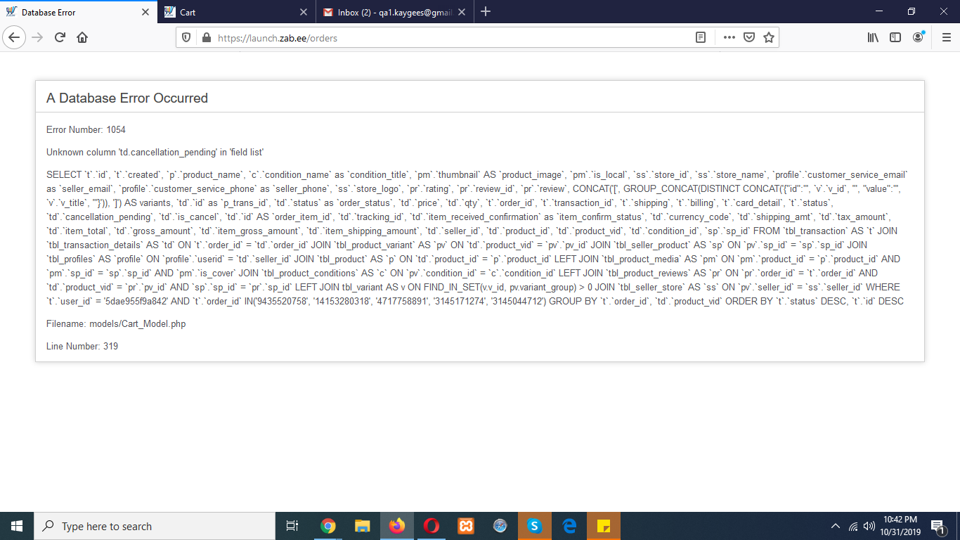

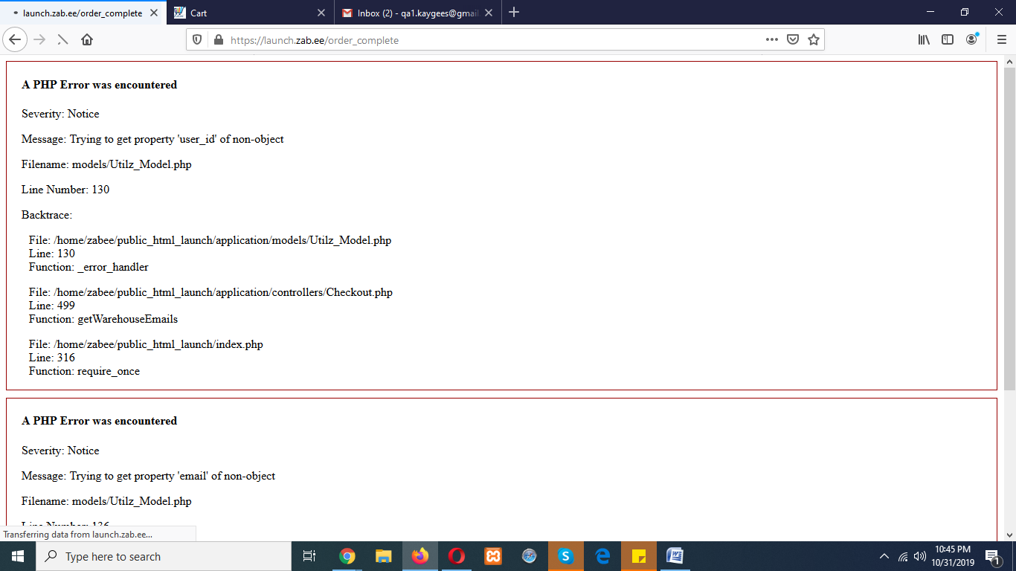

Usability: When new user makes a shipping address for order placement, finds no way to move further. 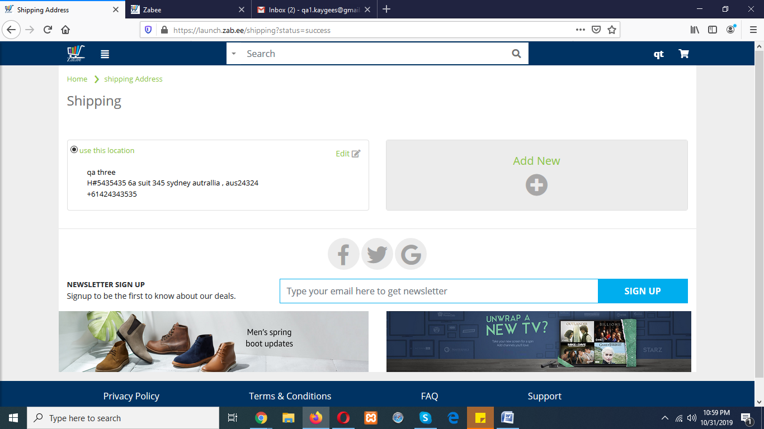

New inventory are not adding. From **qa3 account,** new inventory is added but not shown on front.

Also inventory is saved.

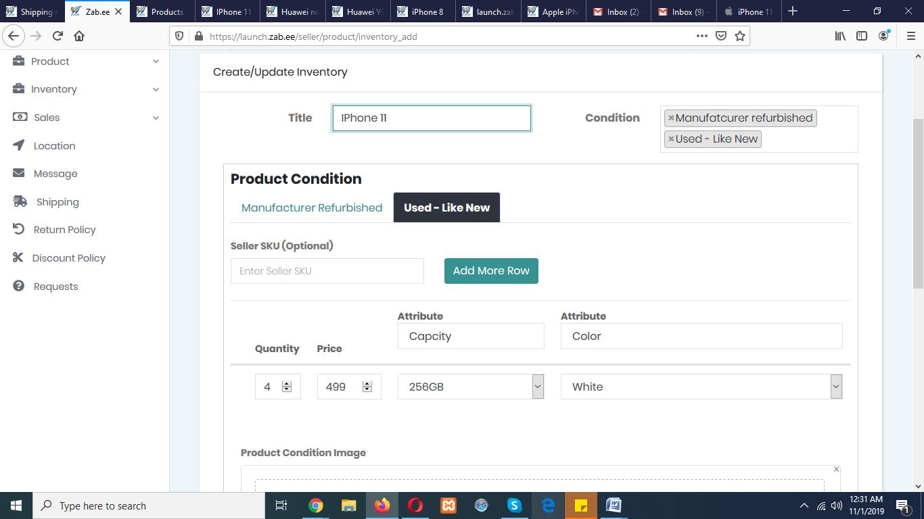

Present on inventory list.

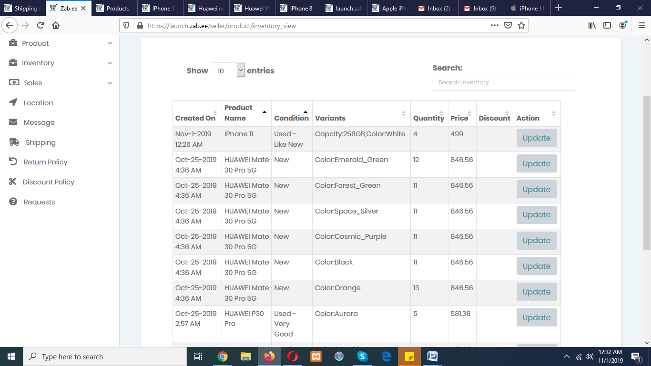

But not display here.

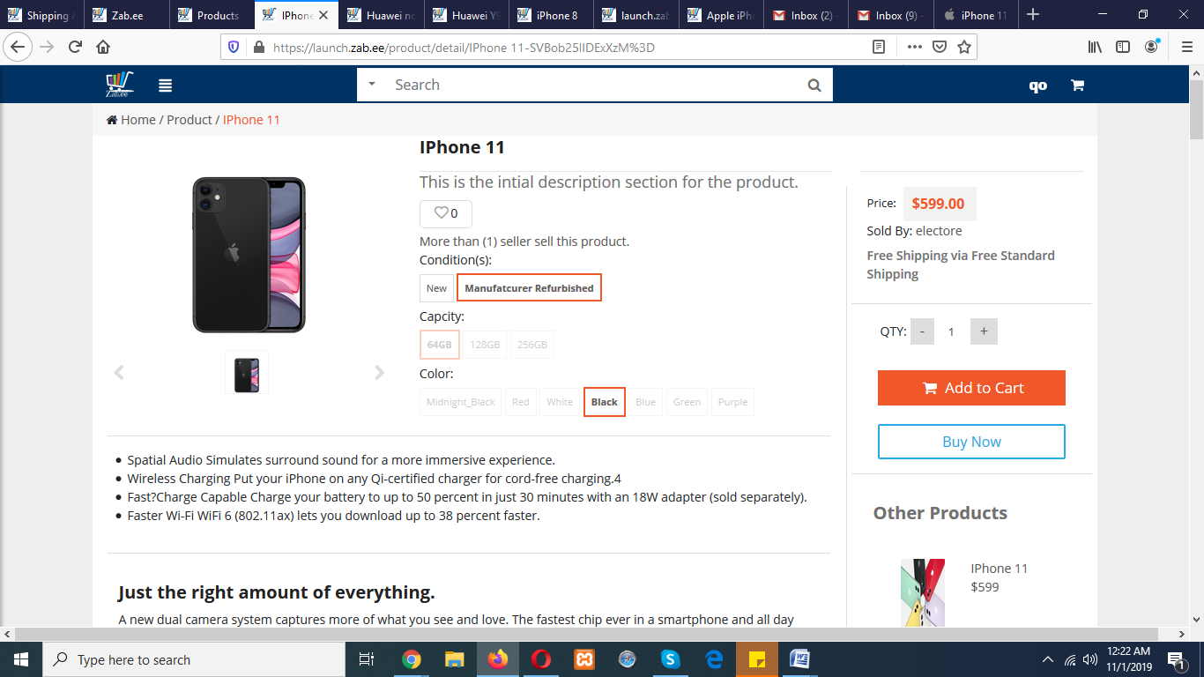

new

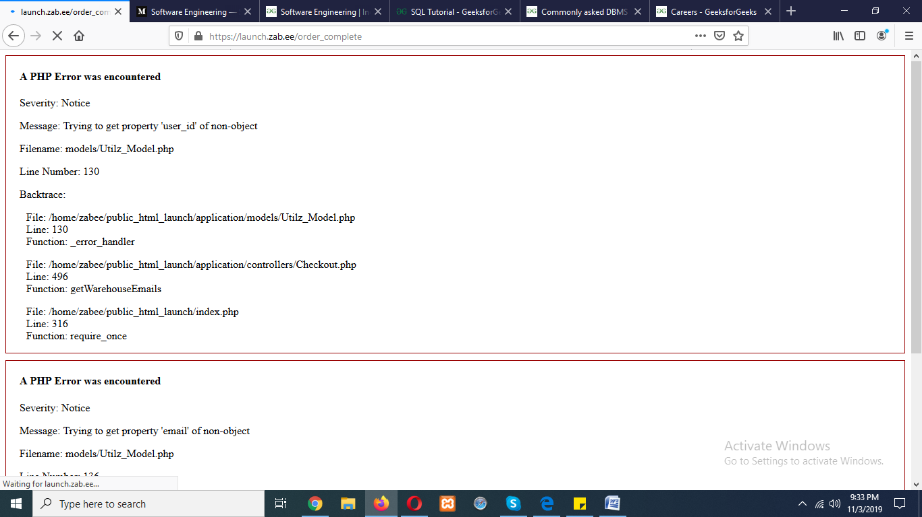

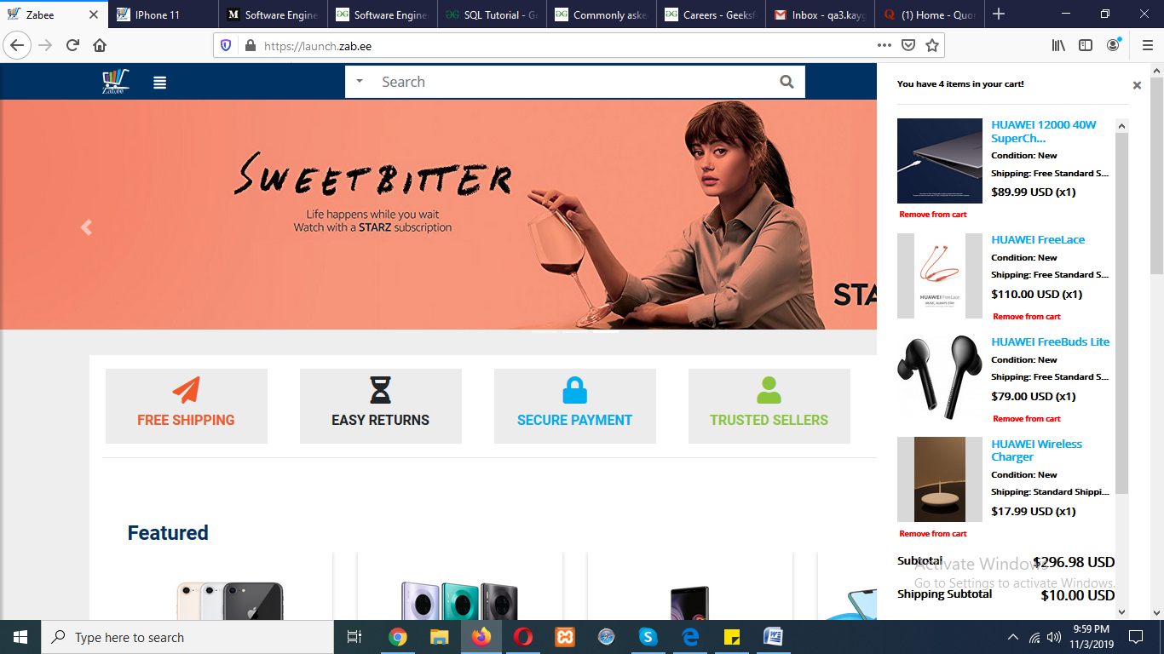Ui : on click update cart button isn’t alerting its working fine but not highlight.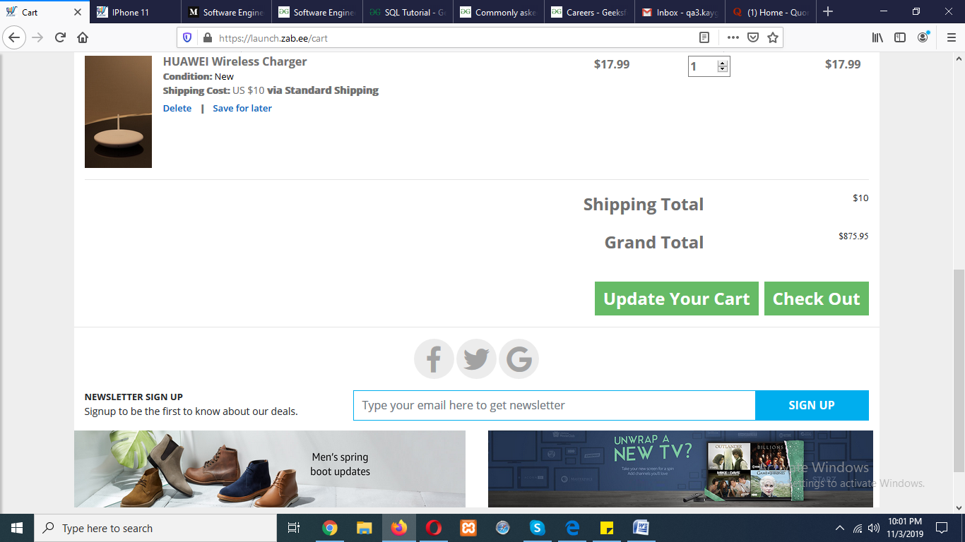

Buy now button is unclick able

Ui of save for later is disturbed

