***11 July 2016***

* After Allowing Multiple Services in Company Settings and setting the Service Priorities of one of the services to
  1. Alone Service
  2. Cannot be followed after any service
  3. Cannot be the first service

And rest of the services’ priorities to None, Scheduling appointments through widget creates them successfully but doesn’t show correctly the appointments and their details in the Calendar. The screenshots are given below

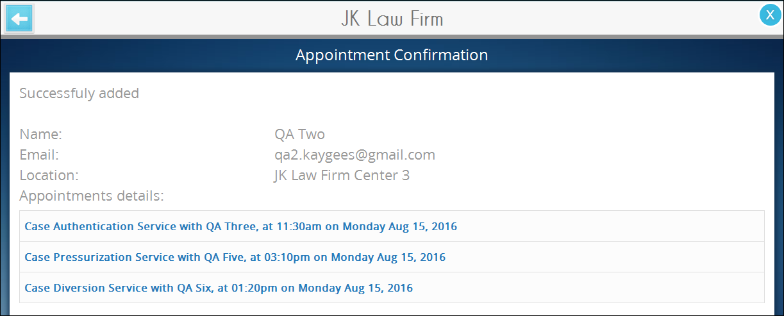

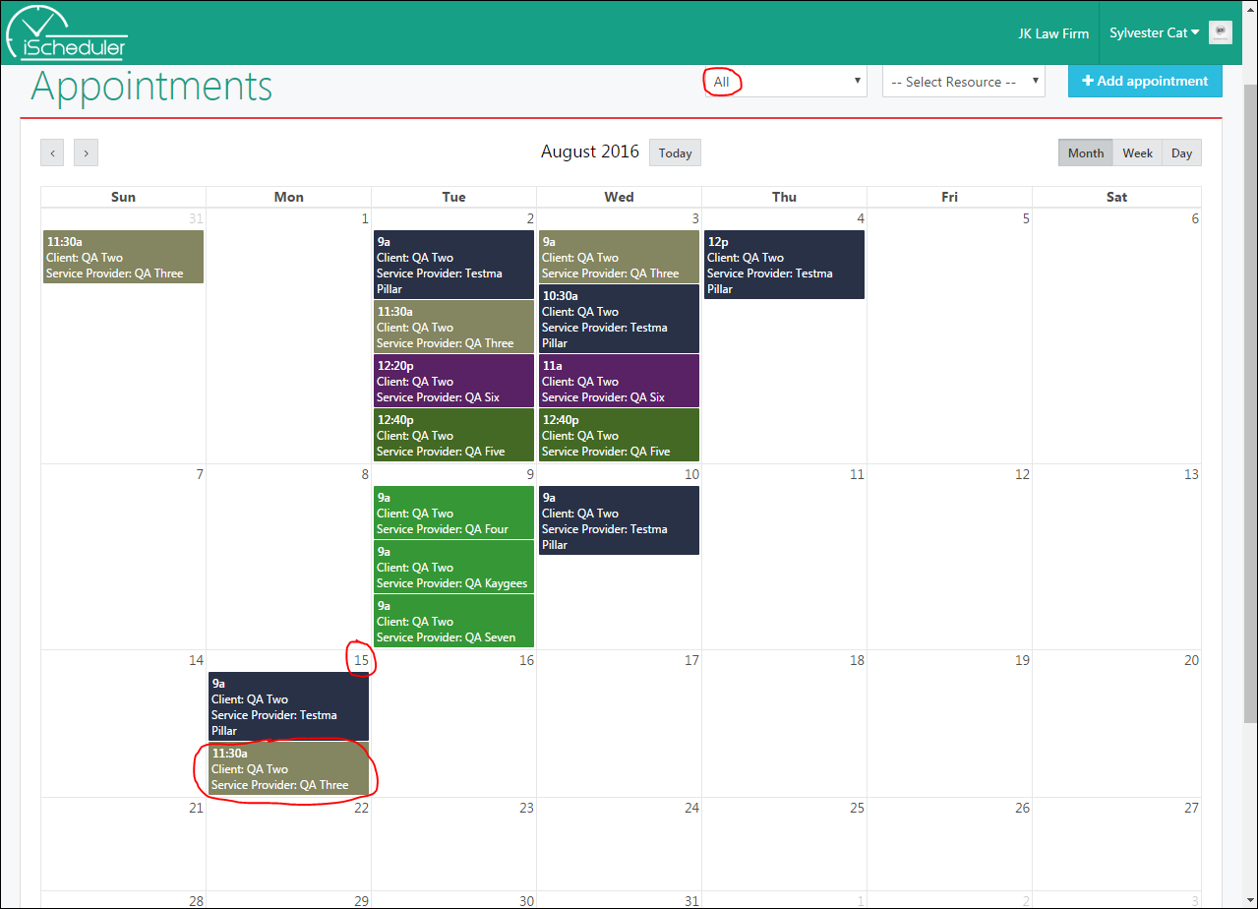

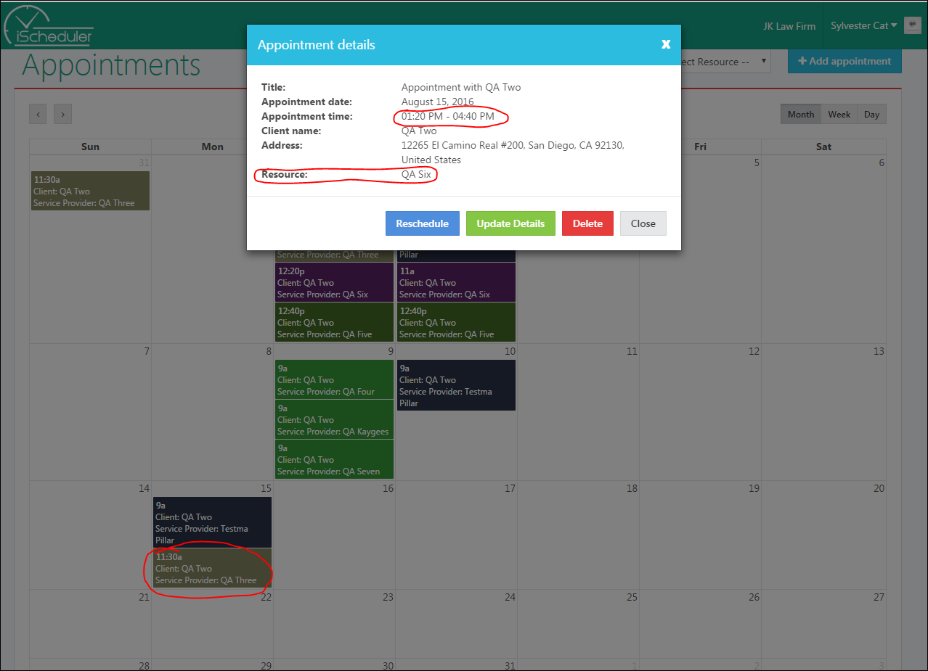

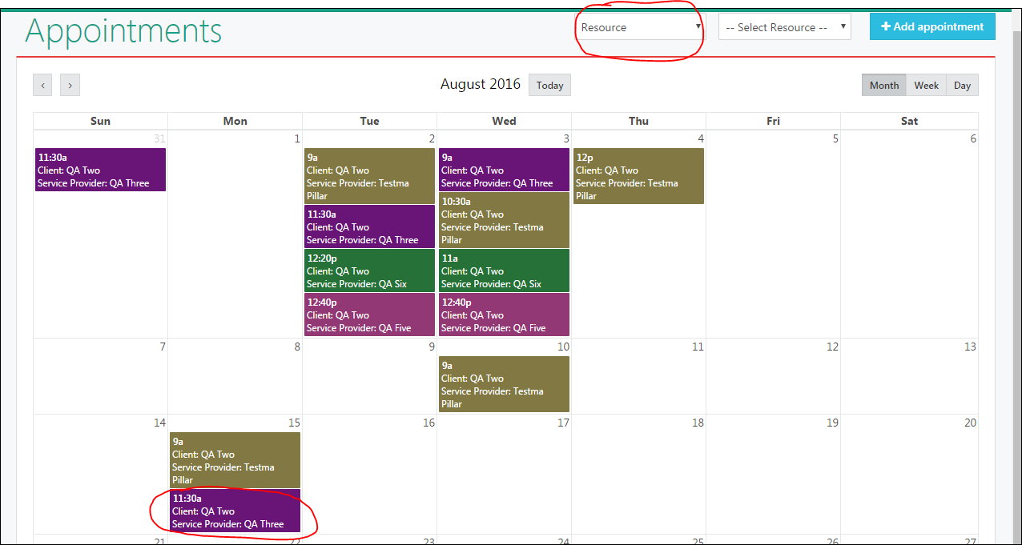

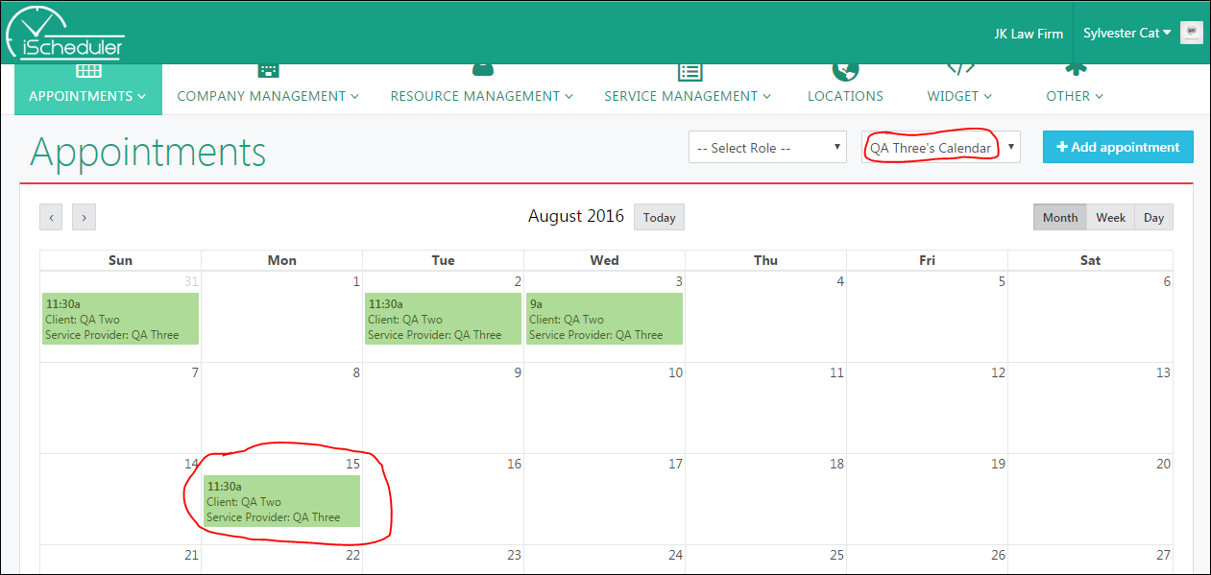

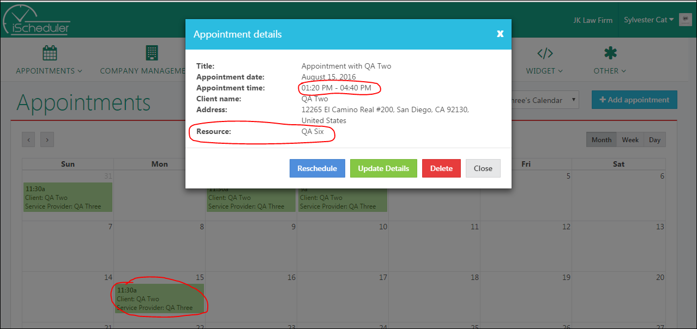

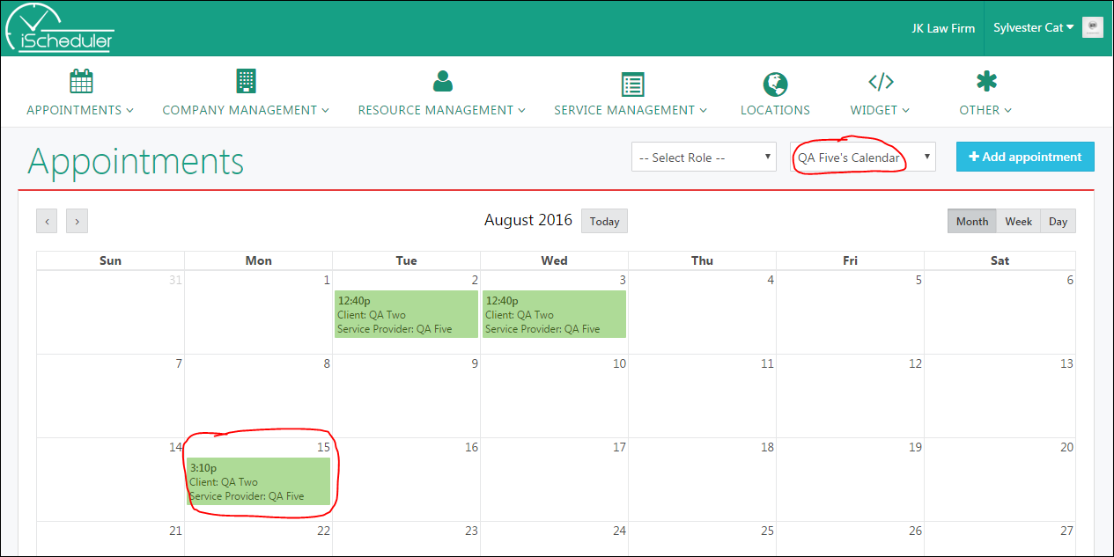

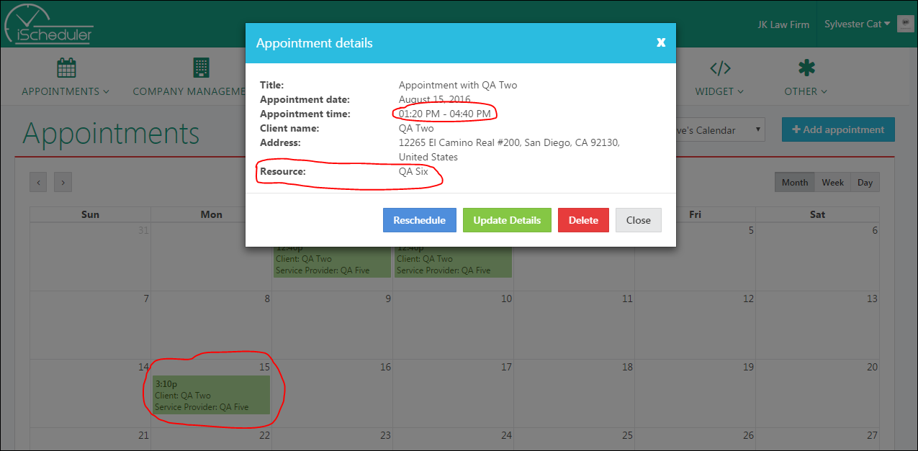

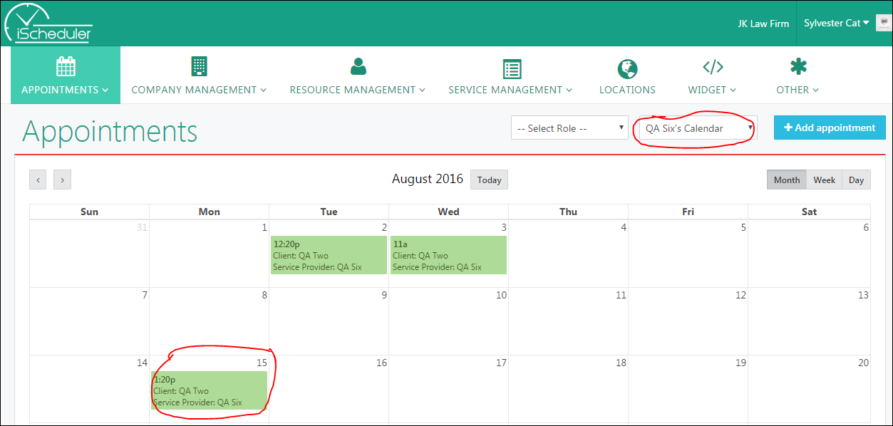

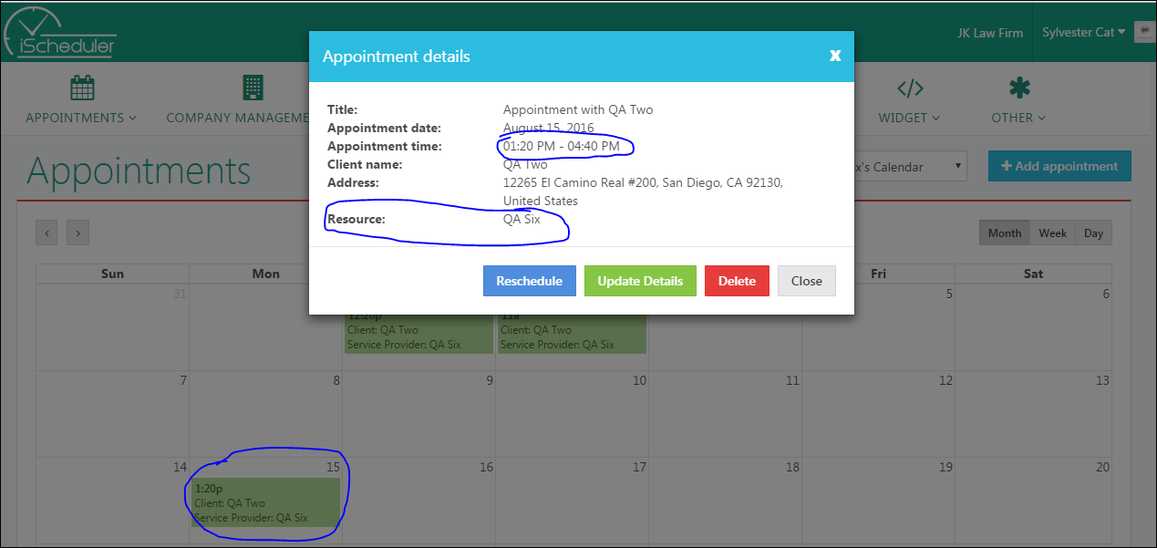

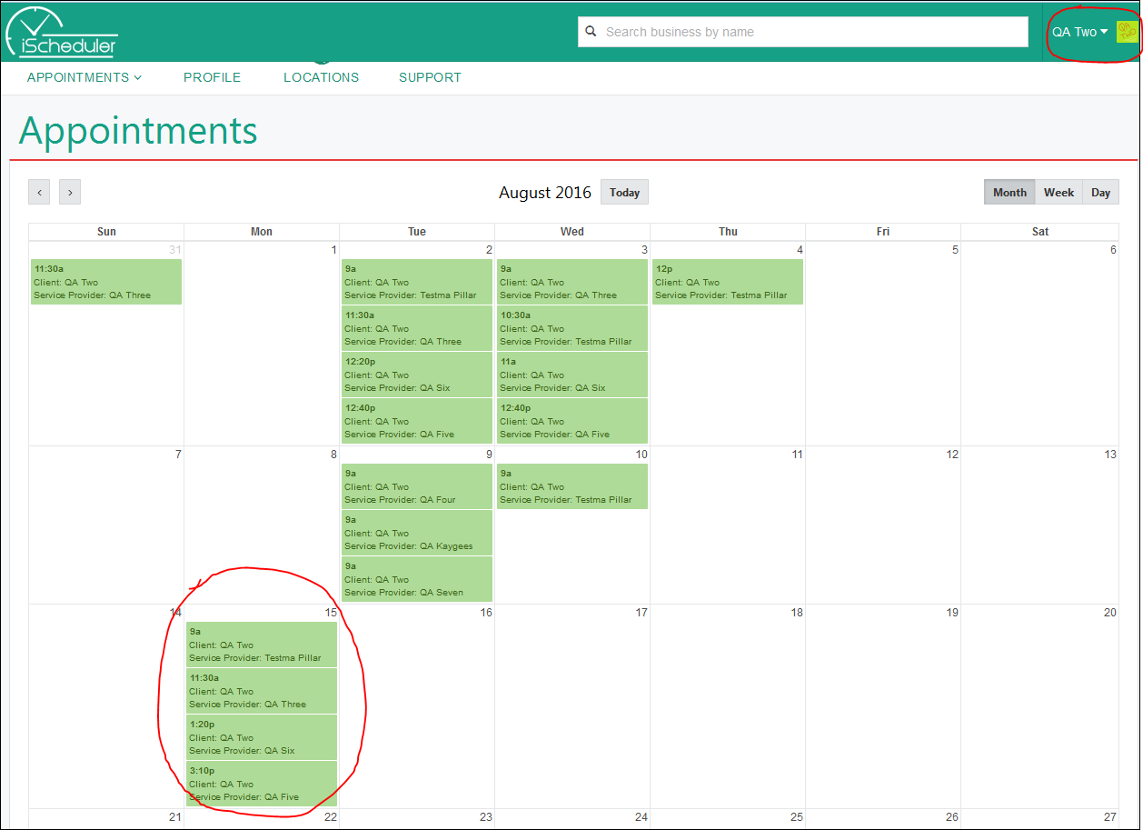

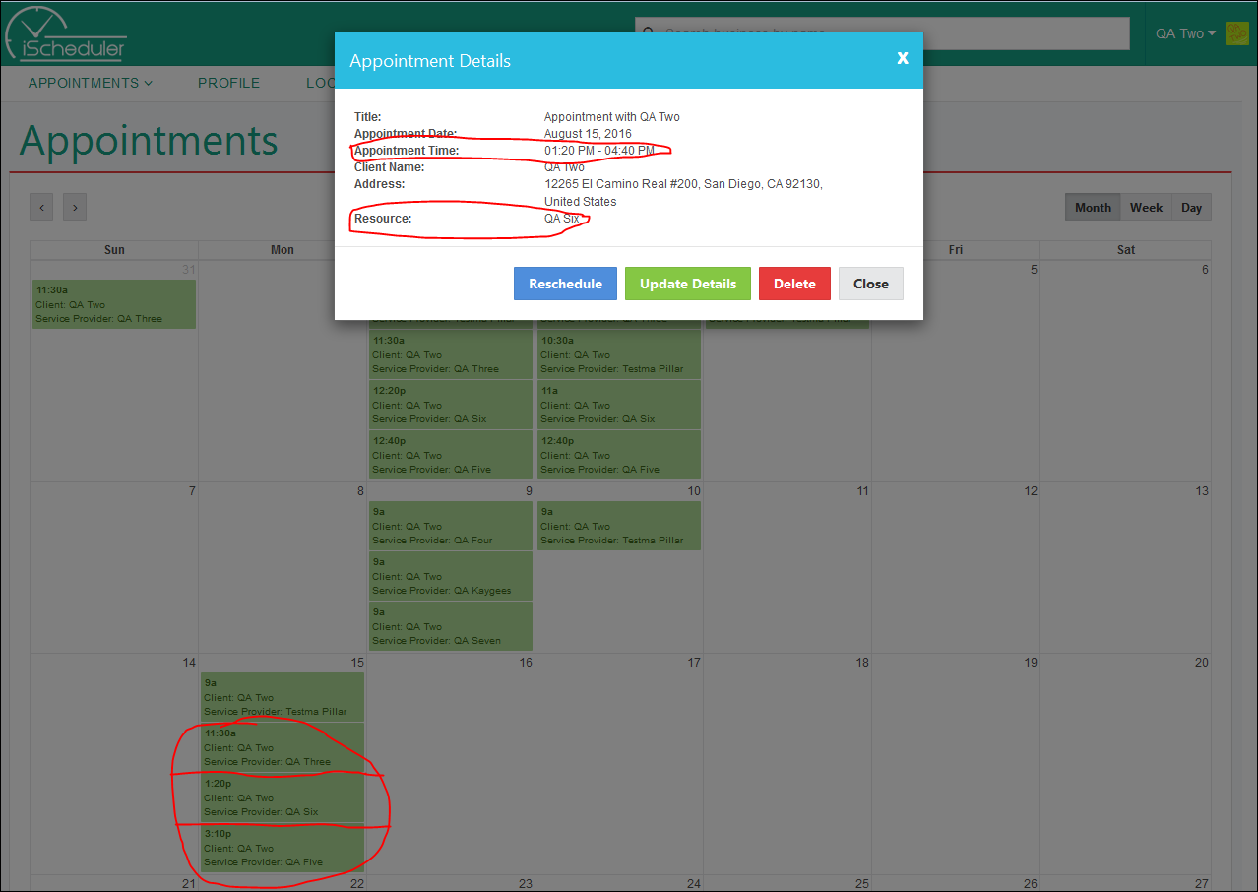

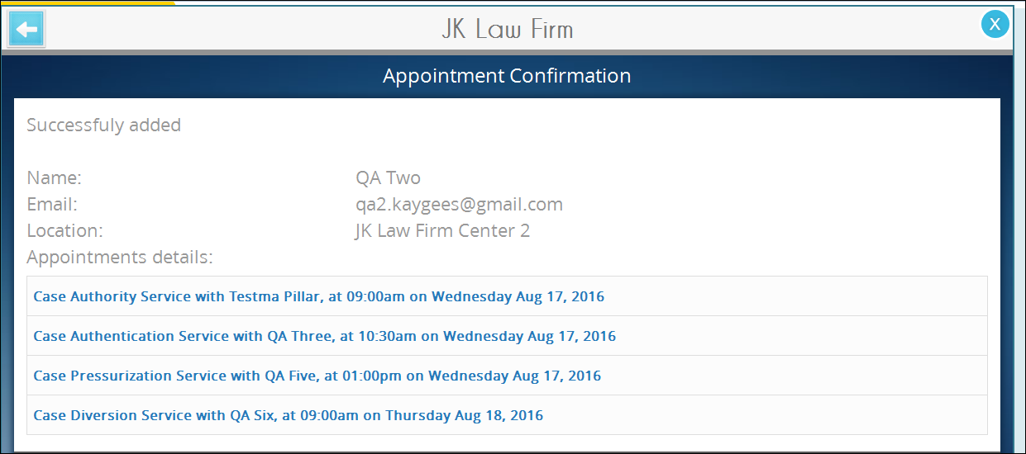

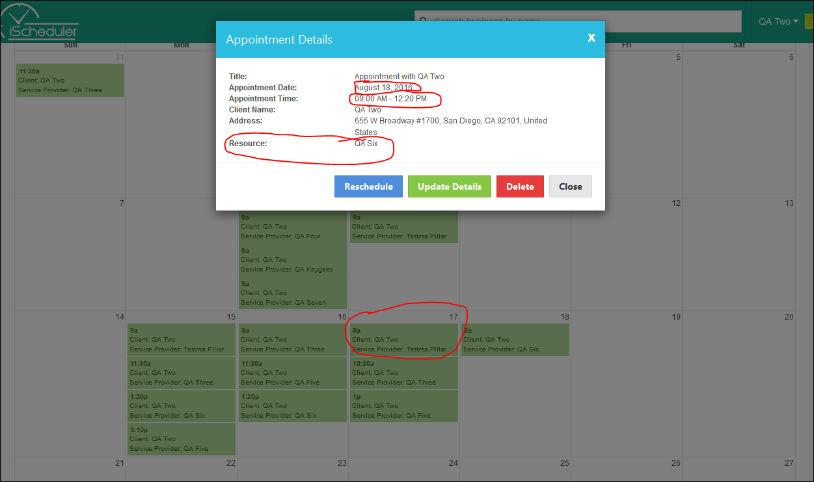

* After Allowing Multiple Services in Company Settings and setting the Service Priorities of one of the services to cannot be the first Service [In our case we have selected Case Authority Service], Scheduling appointment through widget is not working properly on Other Category Service Selection after Case Authority Service. [Fixed on 11 July 2016]  
  