Admin Panel

1. Appointments
   1. Calendar View 
   2. List View 
2. Company Management
   1. Company Information 
   2. Company Settings 
   3. Company Business Hours 
   4. Customize Email Template 
   5. Company Holidays 
3. Resource Management
   1. Service Provider 
   2. Equipment 
   3. Room/Space 
   4. Resource Types 
   5. Groups 
4. Service Management
   1. Service 
   2. Service Categories 
5. Locations 
6. Widget
   1. Add to Website (widget) 
   2. Add to Email (widget) 
   3. Add to Facebook Page 
7. Other
   1. Attach Google Calendar [Fixed on 2 July 2016] 
   2. Customer Data  [Fixed on 4 July 2016] 
   3. Support 

**Explanation of the above mentioned points with a cross**  **:-**

* In 1.1 and 1.2, Calendar View and List View respectively the buttons of Reschedule /, Update Details / and Delete / are not working correctly.
* In 2.2 Company Settings the Confirmation Text Field is not working. The text which is being typed inside the box is not displayed at the end of the appointment scheduling. 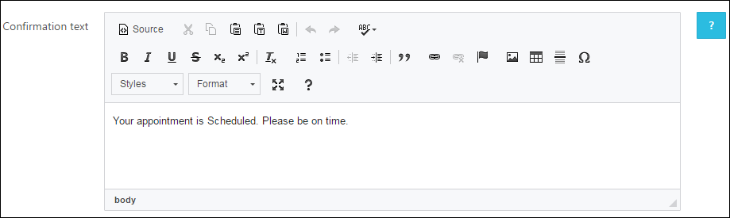
* In 5 Locations not all the special characters are working except for these ! @ & _ - ' . > <
* In 7.1 Attach Google Calendar there is an error of 400 by Google [Fixed on 2 July 2016]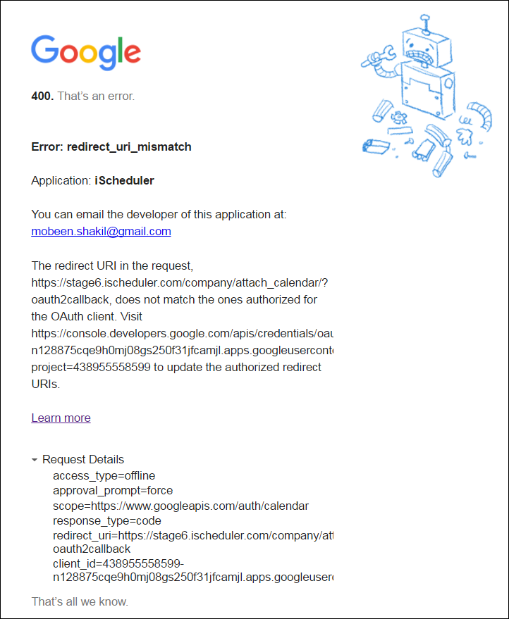
* In 7.2 Customer Data the report being generated is not coming correctly [Fixed on 4 July 2016] 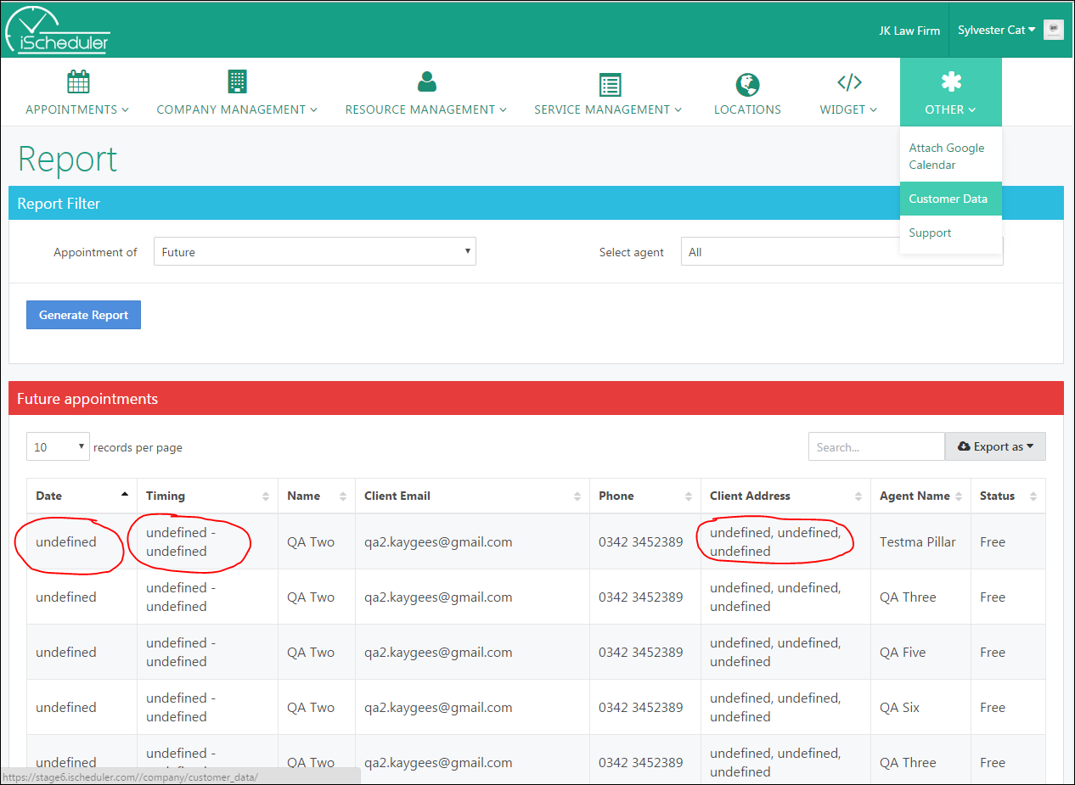
* In 7.3 Support the page is blank 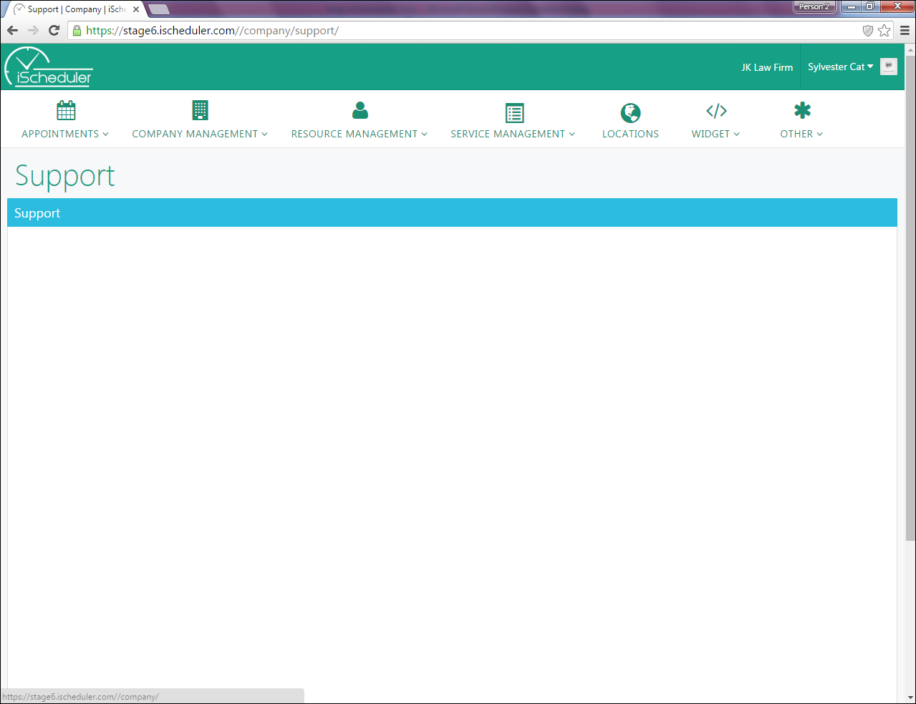

Client Panel

1. Appointments
   1. Calendar View 
   2. List View 
   3. Upcoming Appointments 
   4. Past Appointments 
2. Profile 
3. Locations 
4. Support 

**Explanation of the above mentioned points with a cross**  **:-**

* In 1.1, 1.2, 1.3 and 1.4, Calendar View, List View, Upcoming Appointments and Past Appointments respectively the buttons of Reschedule /, Update Details / and Delete / are not working correctly.
* In 3 Locations not all the special characters are working except for these ! @ & _ - ' . > <
* In 4 Support the page is blank 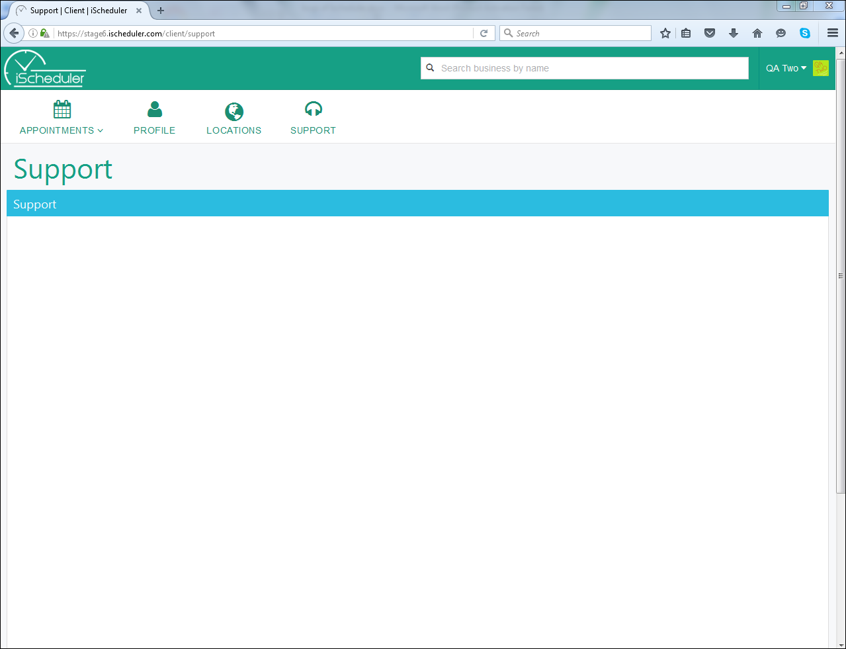

Resource Panel

1. Appointments
   1. Calendar View 
   2. List View 
2. Resource Management [Fixed on 4 July 2016] 
3. Attach Google Calendar [Fixed on 2 July 2016] 
4. Support 

**Explanation of the above mentioned points with a cross**  **:-**

* In 1.1 and 1.2, Calendar View and List View respectively the buttons of Reschedule /, Update Details / and Delete / are not working correctly.
* In 2 Resource Management it is not allowing to Edit/Update the details of that respective resource through which id we are logged in.
* In 3 Attach Google Calendar there is an error of 400 by Google [Fixed on 2 July 2016]
* In 4 Support the page is blank 