***30 June 2016***

Dashboard of iScheduler Version 6

**Incomplete Modules:-**

Here is a list of incomplete modules in iScheduler version 6

* Dashboard Options Module 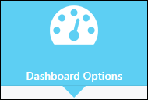
* Help Option Module 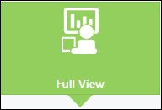
* Full View Module 
* Book Appointment as client Module 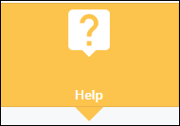
* Next Available appointment by Service Provider option 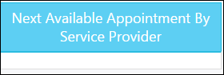
* Wizard Tab is giving a 404 error 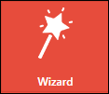  
  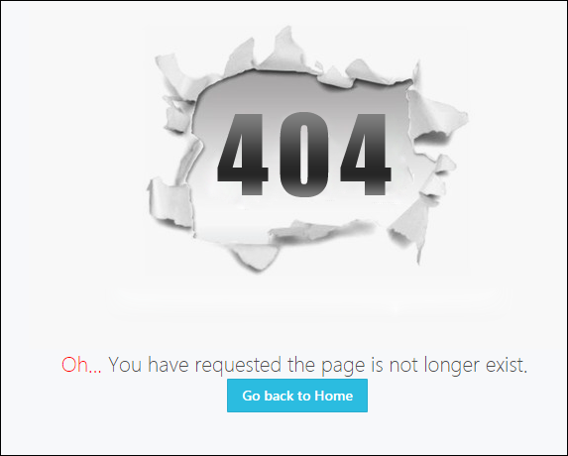
* Editing in To Do List is not working correctly, it vanishes the To Do List items upon editing.
* Next Available Appointment by Service is only showing 4 appointments in its list not all the appointments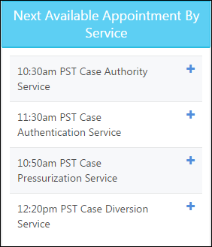.
* The Today’s Appointment and Tomorrow’s Appointment Tabs are not showing any appointments when a date is being selected in the calendar 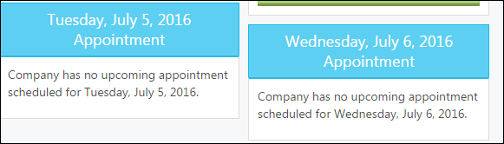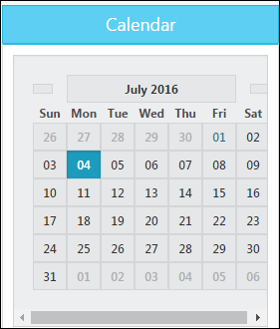
* Manage Calendar Tab is not working 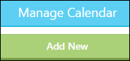
* Manage Clients Tab is not working 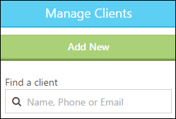
* Manage Calendars is not showing all the calendars of the resources this company has 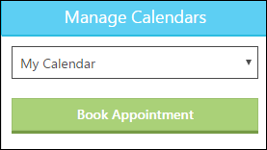
* New Service Provider is not adding through Dashboard.

**Redirection back to Dashboard page:-**

* Client Check-in Tab 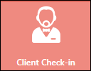
* Add Walk-in appointment Tab 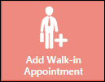
* At 1st attempt when searching for any service provider it redirects back to Dashboard Page 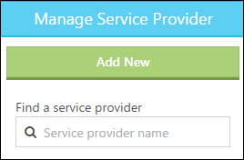

**Redirection to Company Settings page:-**

* Update Appointment Confirmation Message Tab 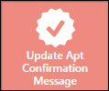
* Settings Tab 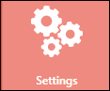
* Manage Company Tab 

**Redirection to Company Information page:-**

* Update Tab 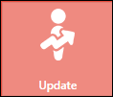
* Upload Tab 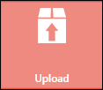
* Upload to Webpage Tab 
* Upload photos to Webpage Gallery Tab 

**Spell Check:-**

* Appointment spelling in Next available appointment by service. [Fixed]
* Client spelling in confirmation text help in company settings.[Fixed]
* First Spelling in User Information Page.
* The spelling of appointment is wrong in Next Available Appointment by Service Tab. In addition to it the button of Make Appointment is not working and instead of correct day, date and time it is showing the symbol of @.