Breaze Archive Bugs 07 March, 2016

* **Include Retracted Bug: -** When we are logged in from a user who is an admin of a team and checking the Exclude Retracted messages it gives the right entries and right entries for when we check the Only Retracted Messages, but when we check the Include Retracted messages instead of summing up the results of (Exclude Retracted messages and Only Retracted Messages) it showed only the entries of Exclude Retracted messages. The screen shots are listed below.  
    
  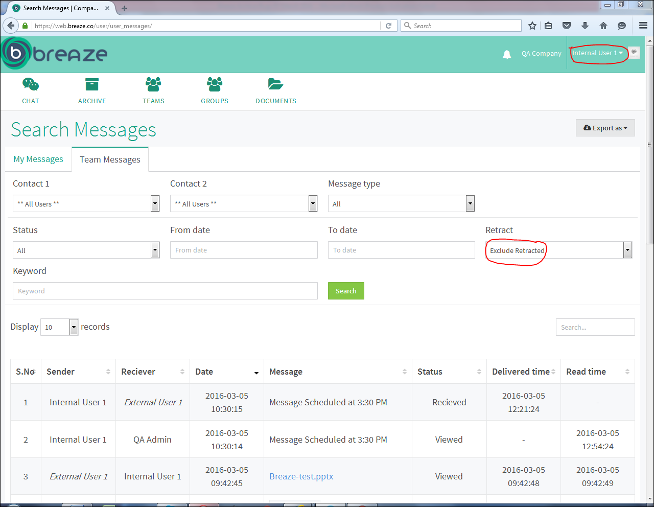  
    
  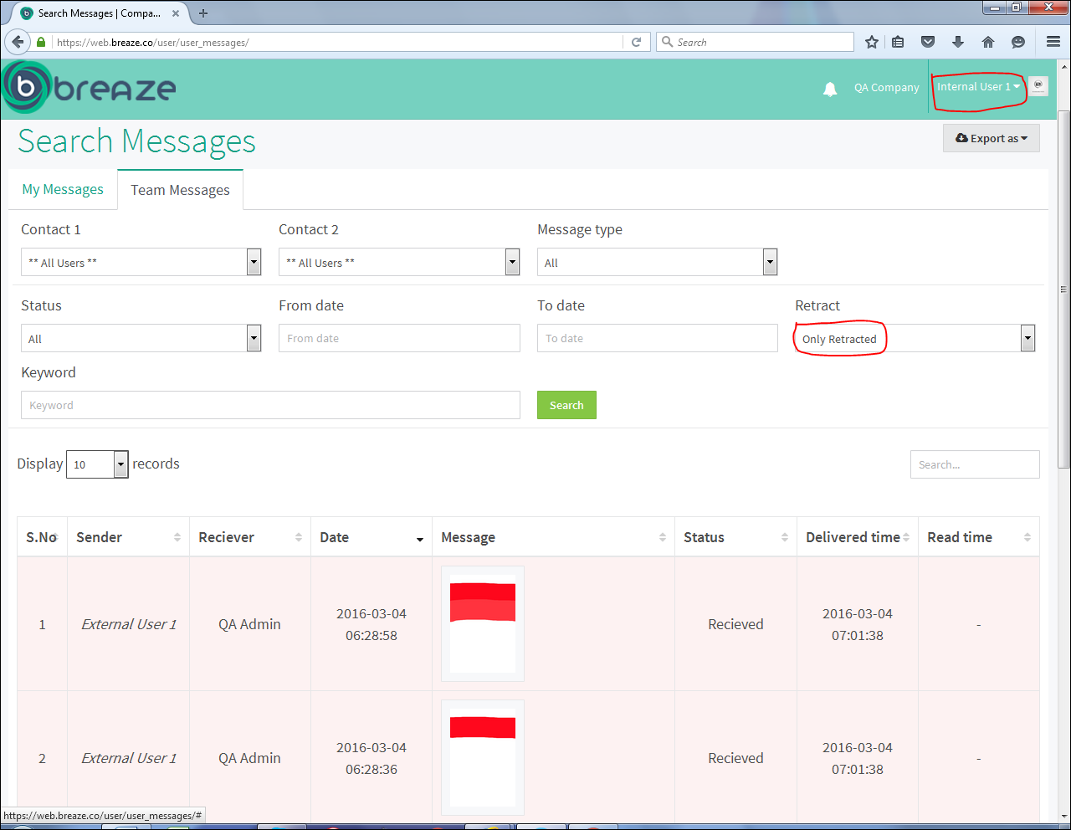  
    
  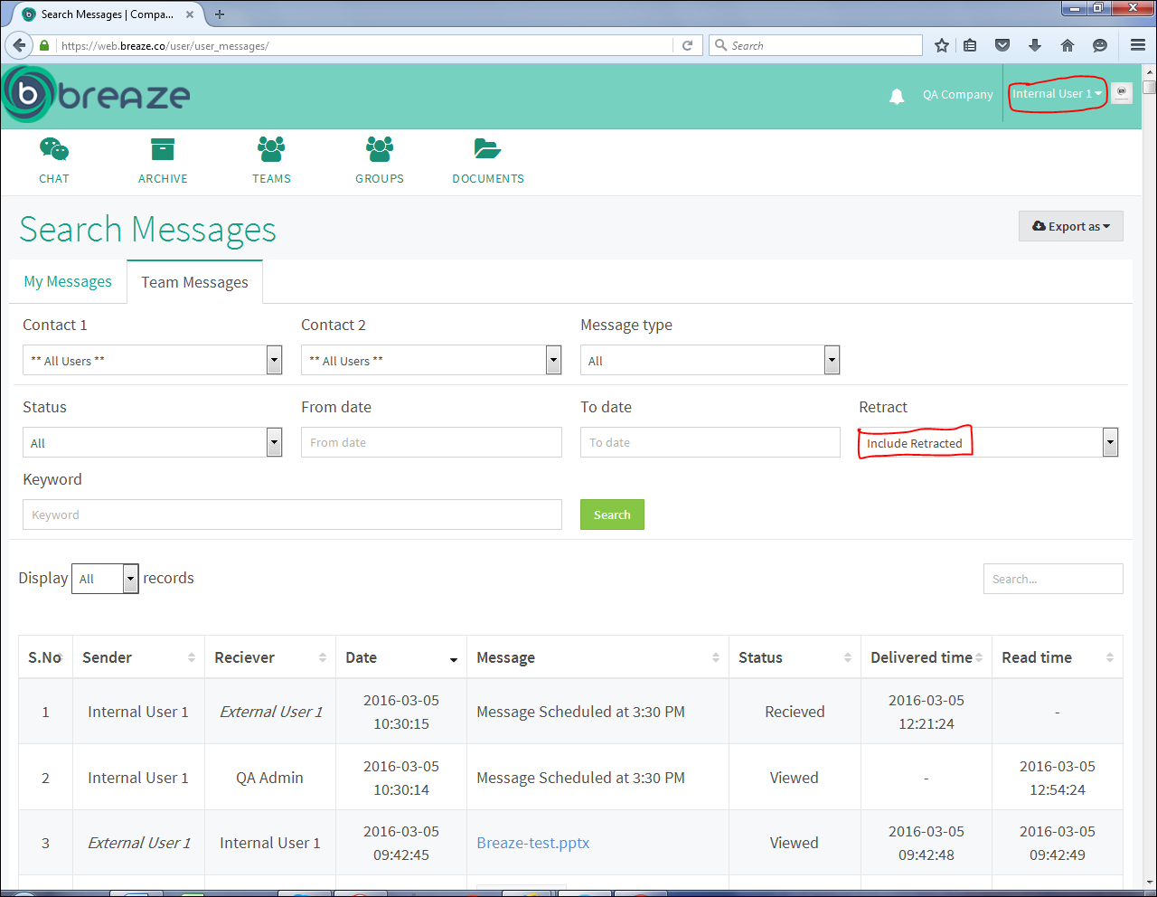  
  It is only showing in user’s id who is a Team Admin not in the id of a QA Admin who is also a Team Admin.
* **Conversation Type Bug: -** The Conversation Type has 3 options   
  i. Both  
  ii. Outgoing  
  iii. Incoming  
  The logic says that no matter what the conversation Type is, it will show no messages at all on all the types if Contact 1 and Contact 2 are same.  
  But here it is showing messages on Outgoing and Incoming Conversation Types if Contact 1 and Contact 2 are same which is not right whereas Both Conversation Type is working fine. It is showing on both the users (QA Admin and Internal User 1). The screen shots are given below.  
    
  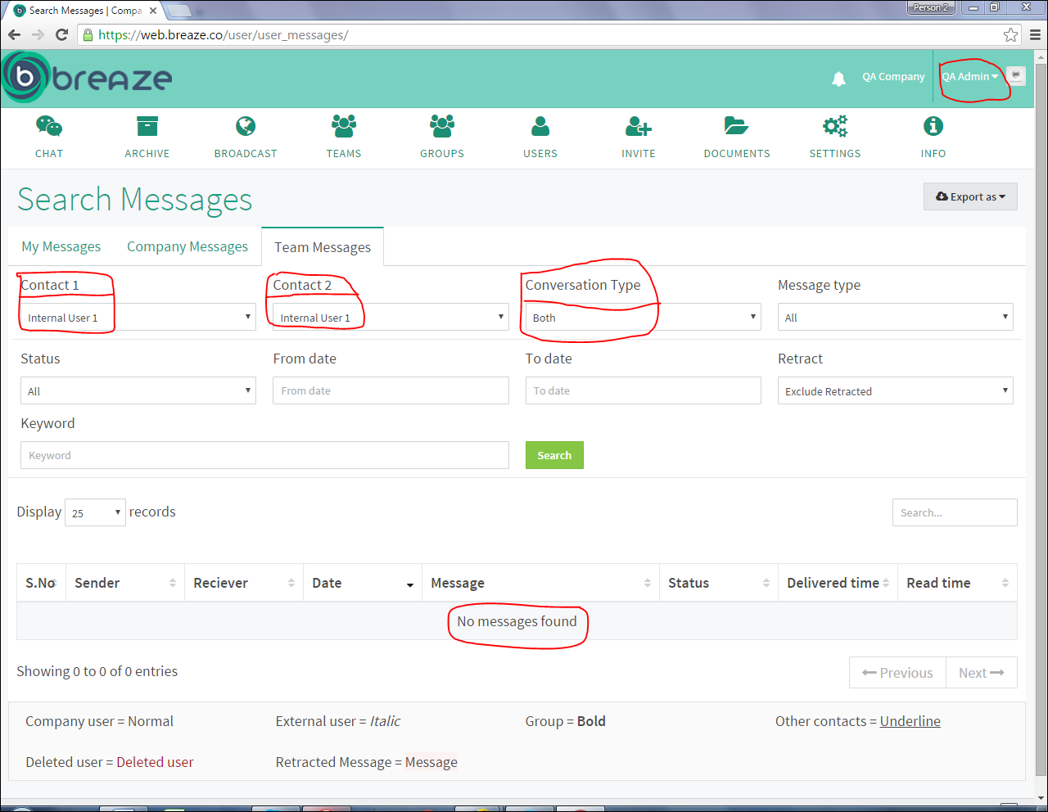  
    
  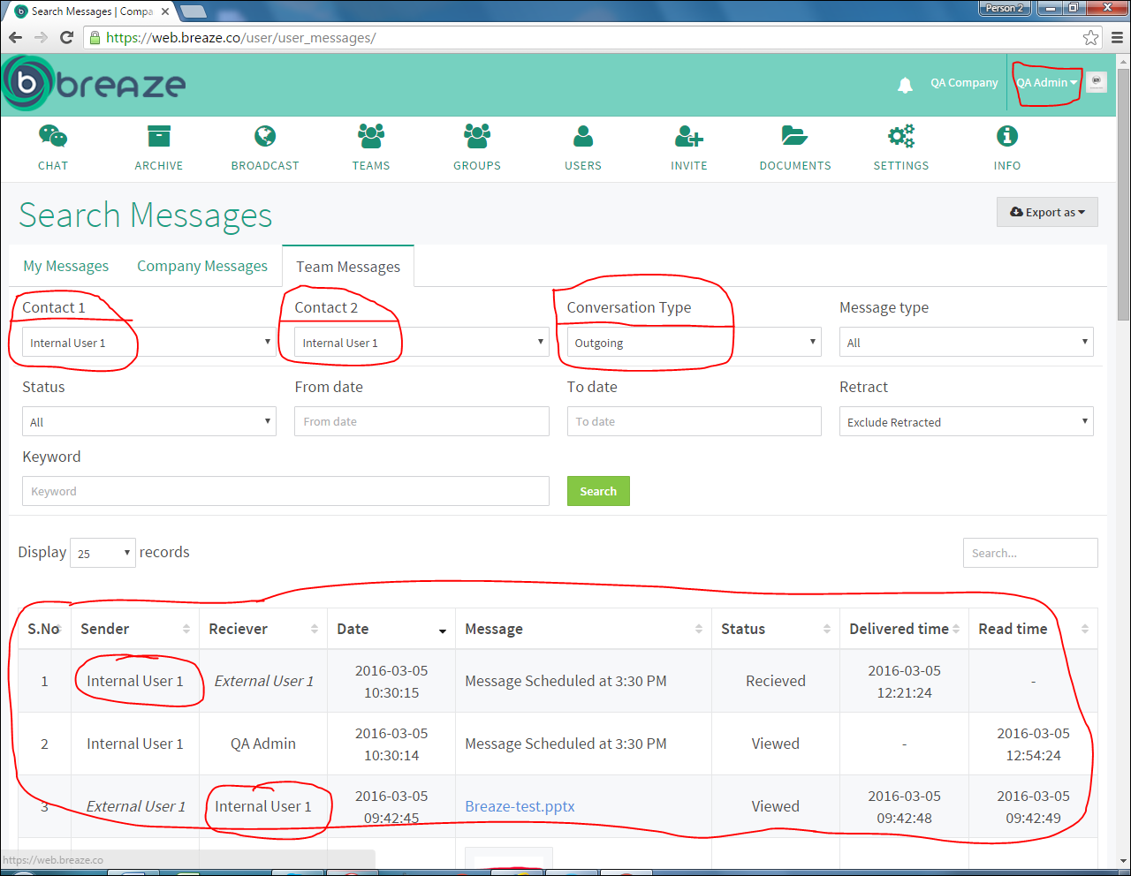  
    
  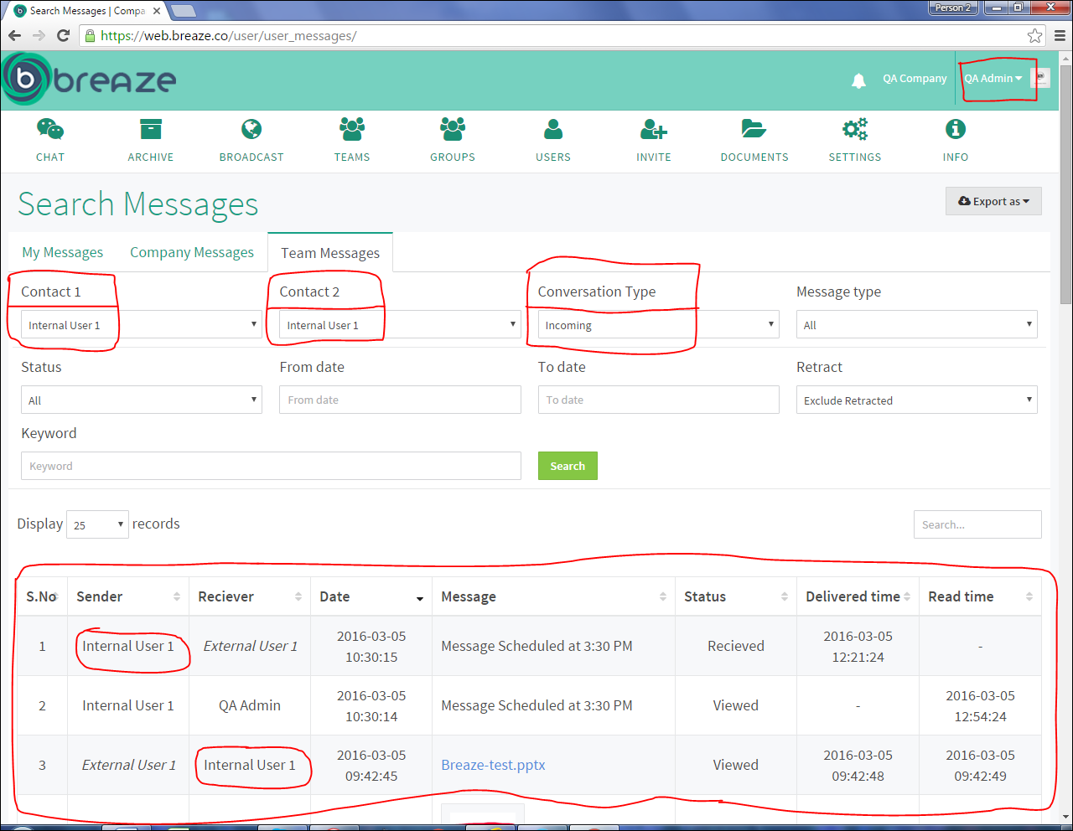  
    
  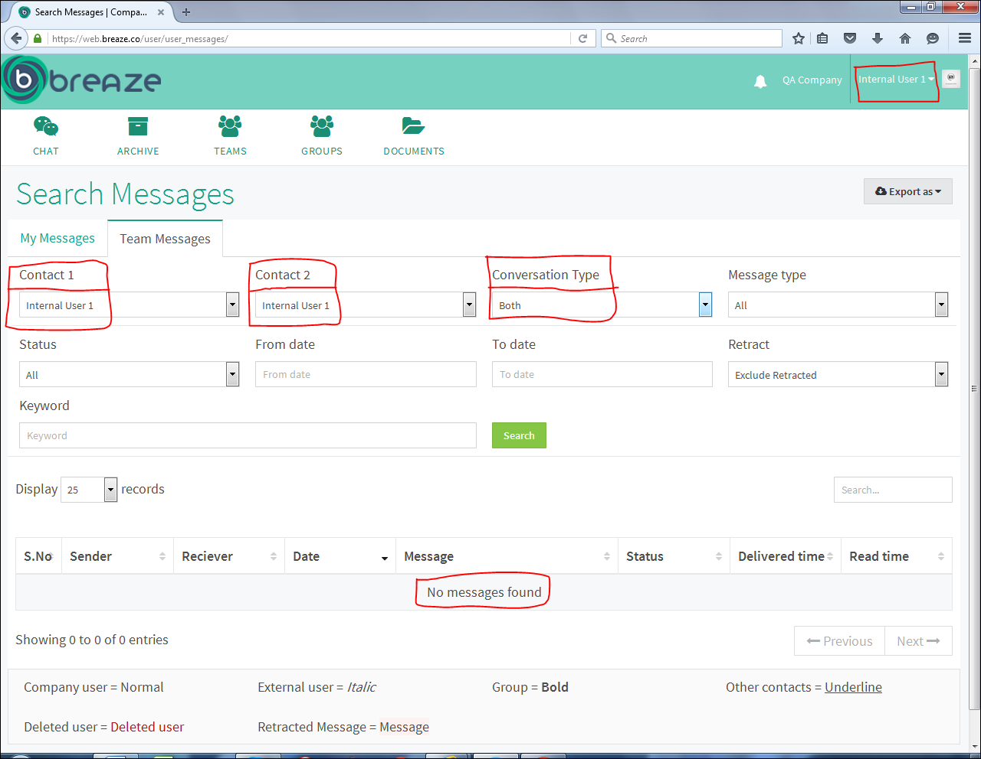  
  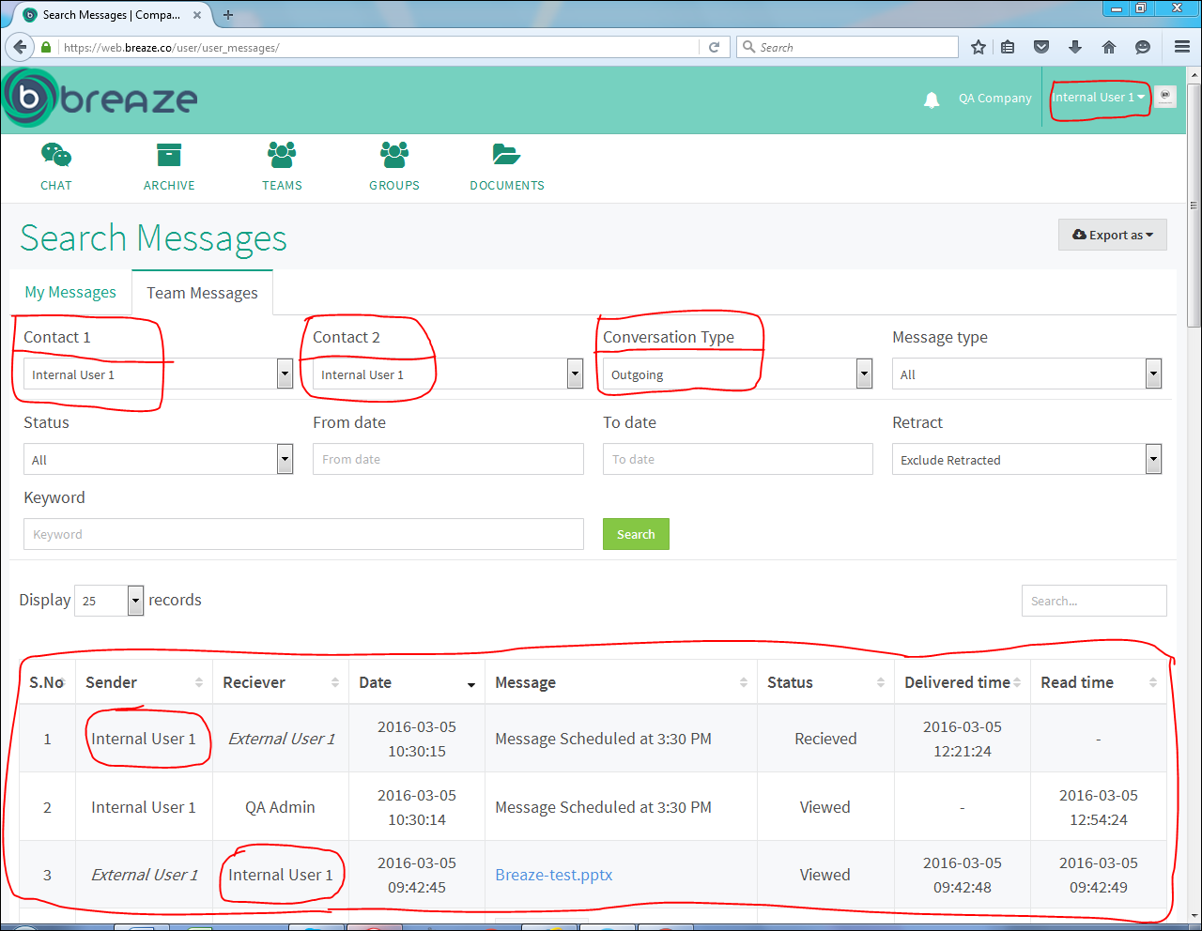  
  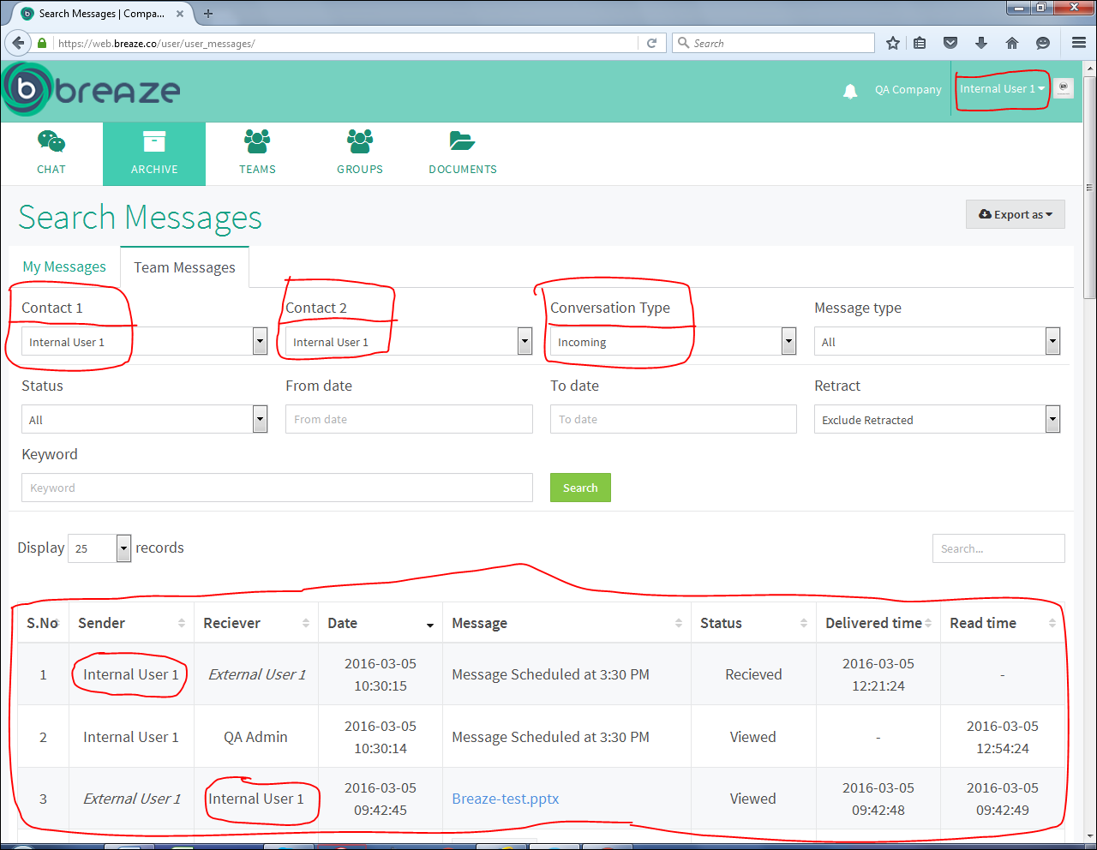
* While Searching this screen appears for a half second.  
  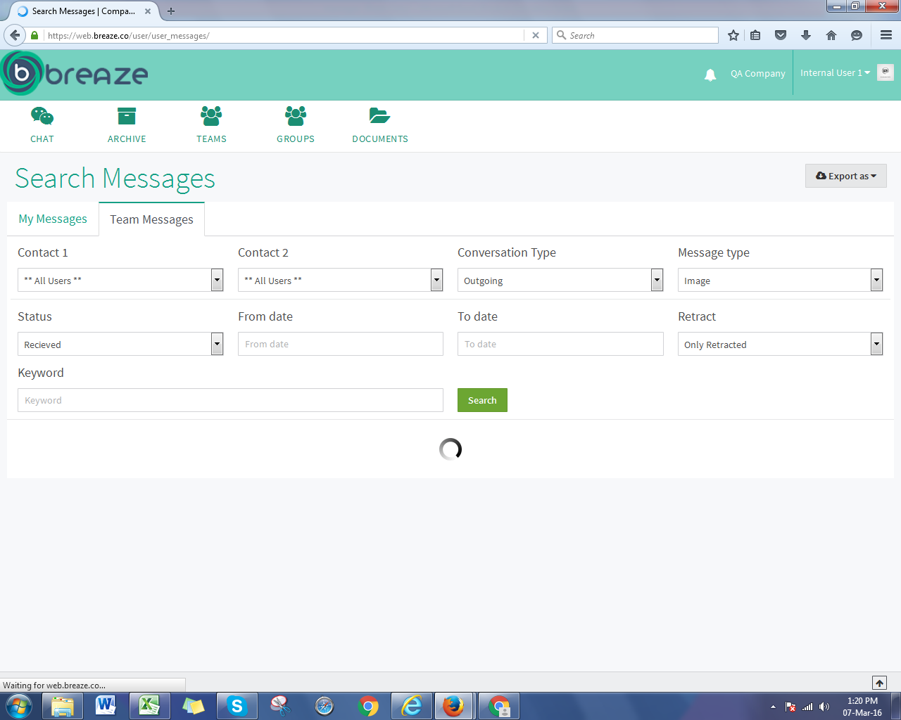  
  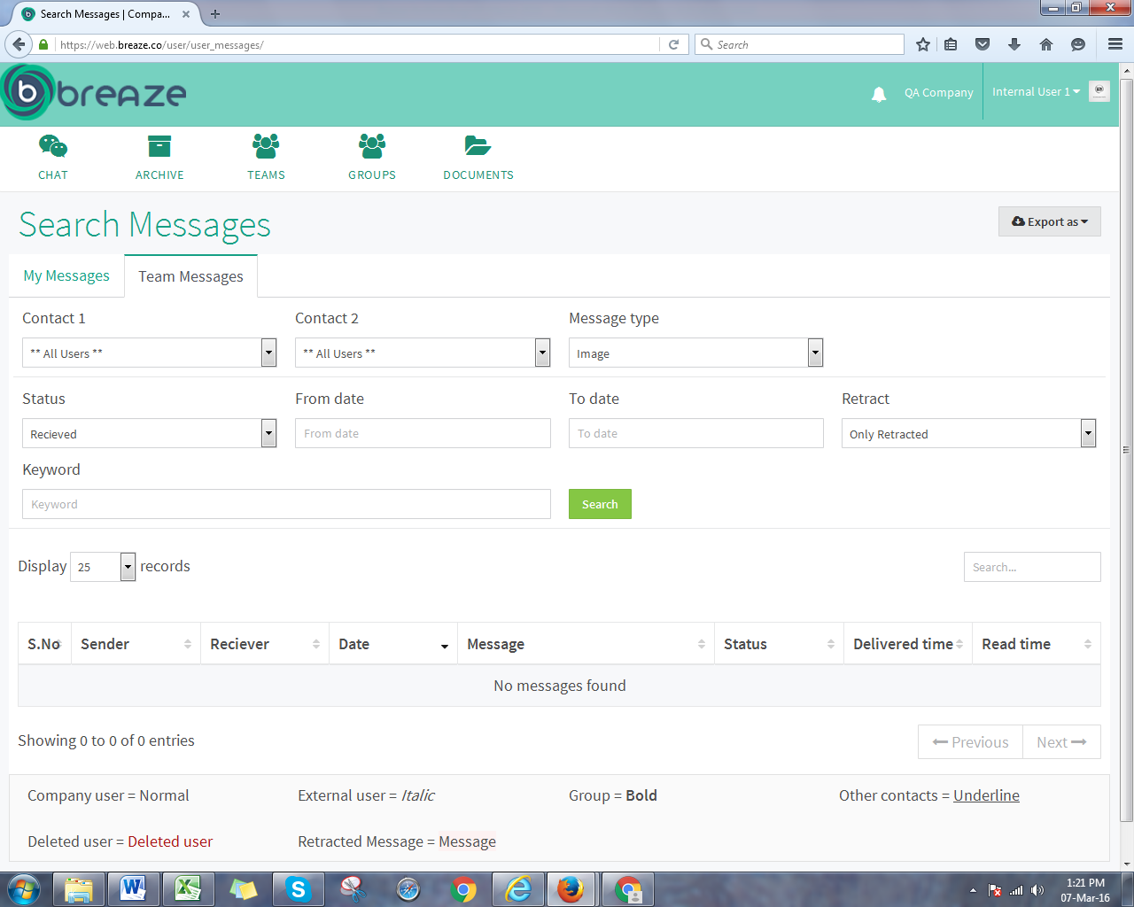
* The Time in the archive is not coming correct.
* While exporting Archive messages into excel sheet these things are not appearing in the sheet as they should be. The list is given below  
    
    
    
    
    
    
    
    
    
    
    
  i. Images  
    
  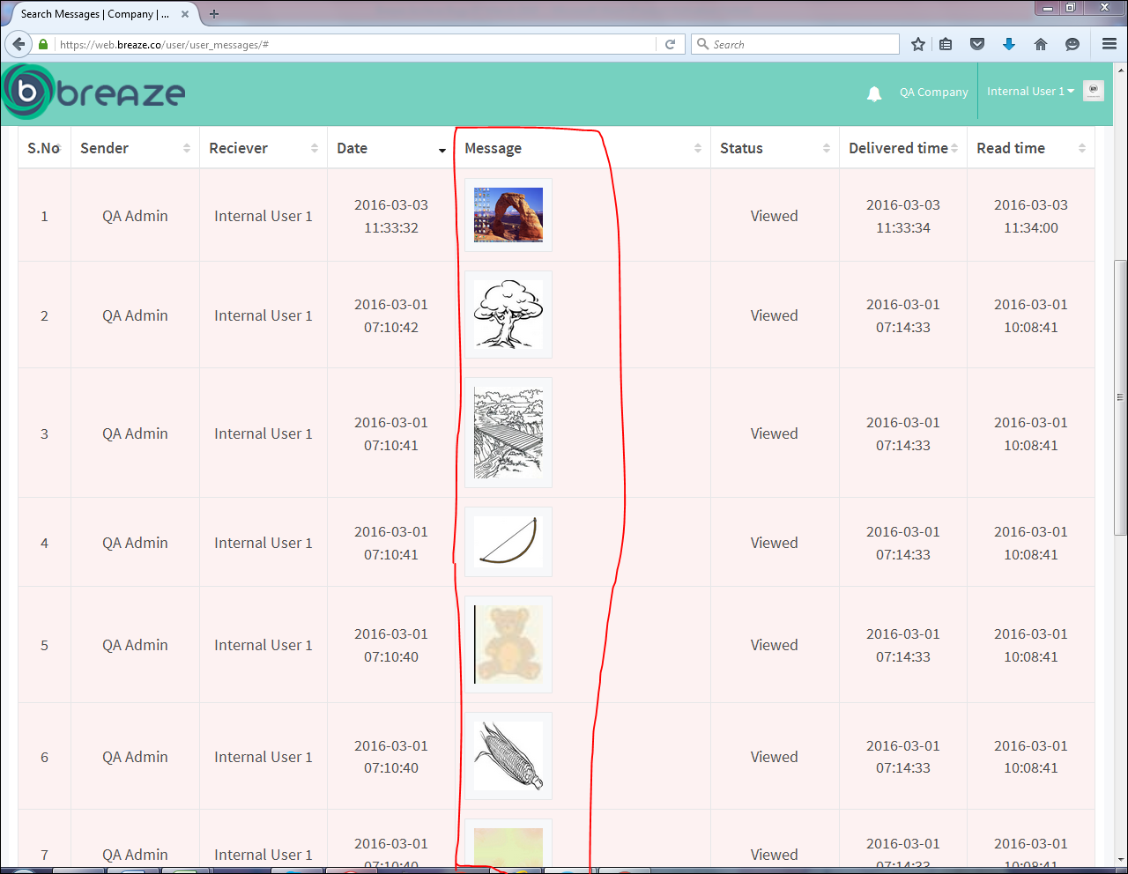  
  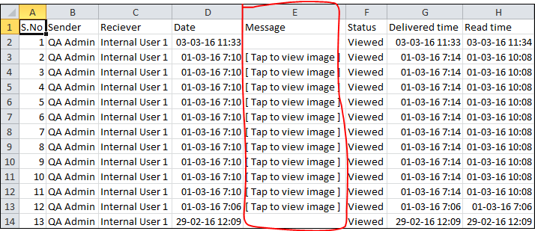  
    
  ii. Audios  
    
  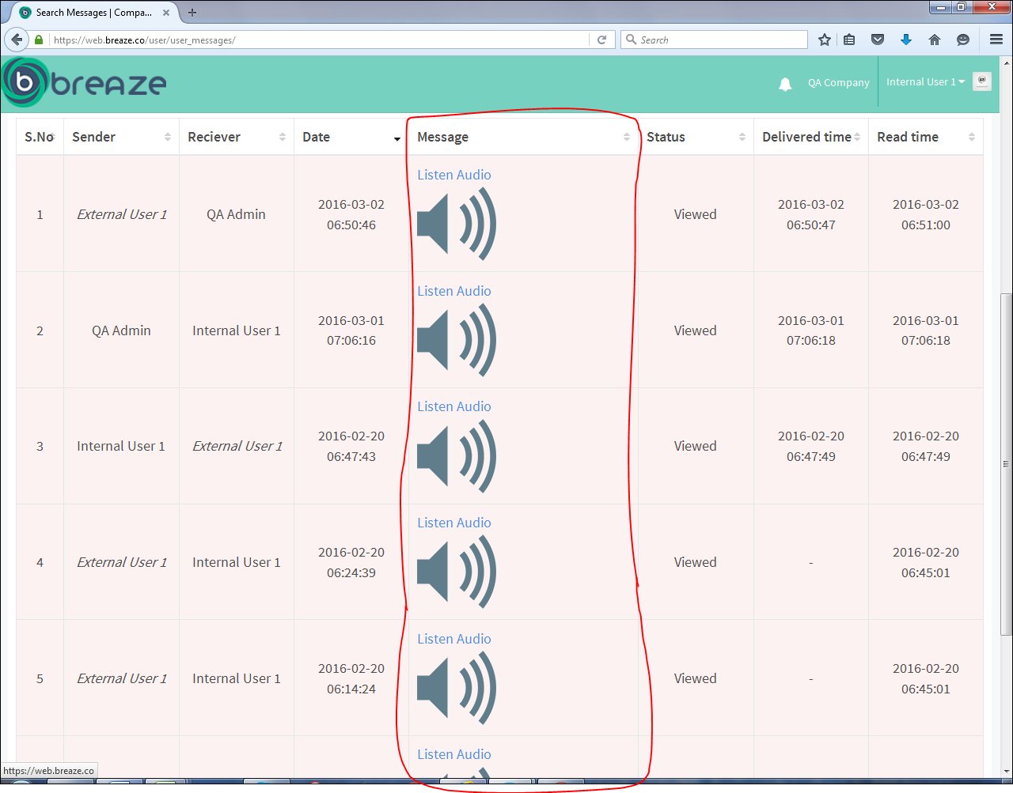  
  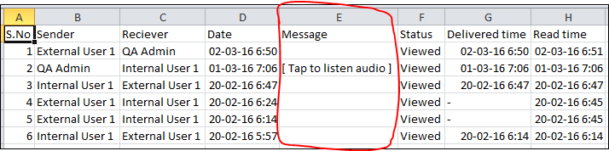  
    
    
    
    
    
    
  iii. Videos  
    
  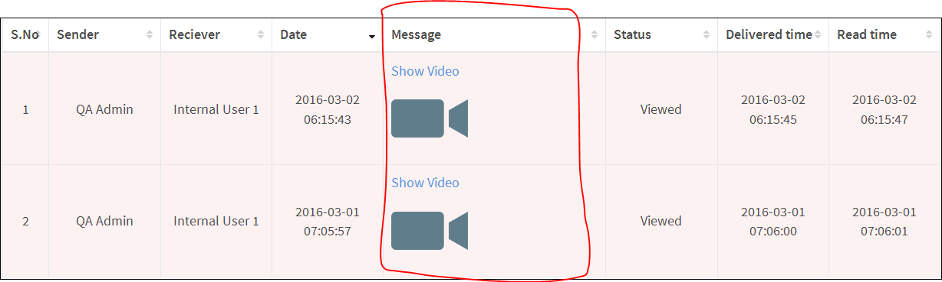  
  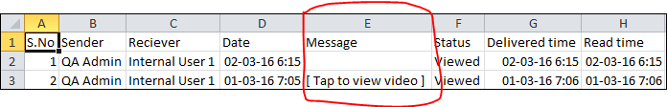iv. Doodles   
    
  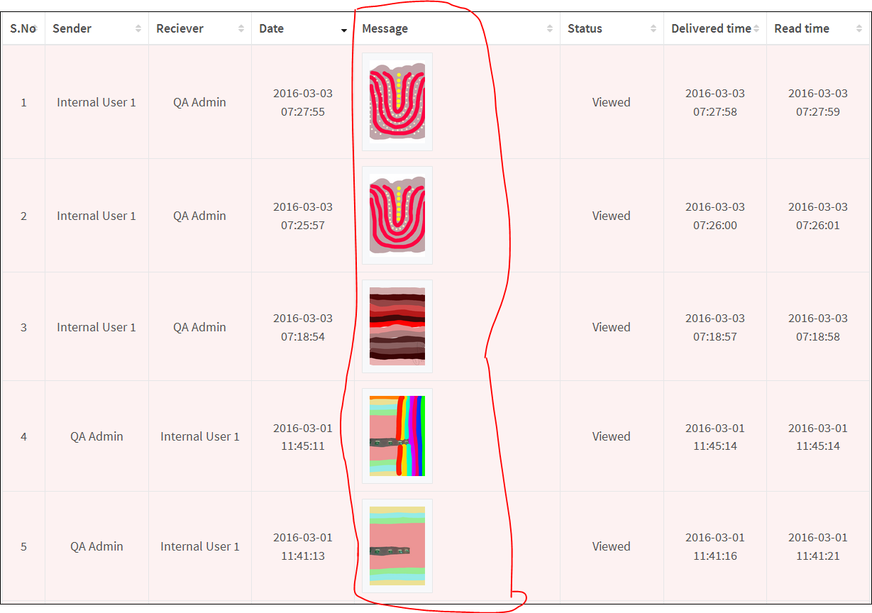  
  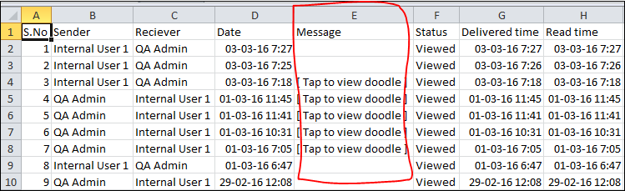  
  v. Stickers  
    
  