We would like our nurse users Christine Heil and ADMIN, Admin to be able to check the “Retrun to Assigned Doctor” box from their page. Here is what the box looks like for an administrative user such as me.
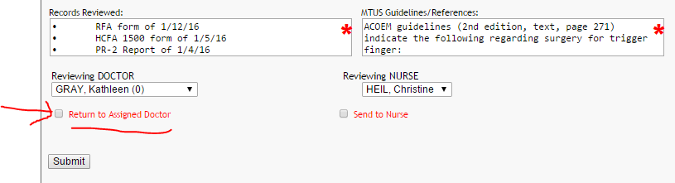

And below is what it looks like on the nurses page, it does not display that box as an option.
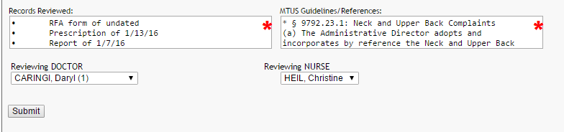
An additional feature we would like to know if you can do is to send an auto email to the reviewing doctor (like the one sent when a doctor first gets a review put on their page) when something is sent back to their page via the “Return to Assigned Doctor” check box.

