**Bug 10:**

**Case:**

Service is created without assigning a resource type.

**Step to reproduce:**

First service is made without adding a resource type (although at least 1 resource type is mandatory).

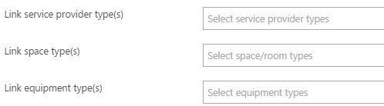

Once the service is made without any resource type then it is not being shown in the wizard but when we go to IScheduler Company and open service list then it is present and when it is being open for edit the no location is being shown which we have selected while making a company.

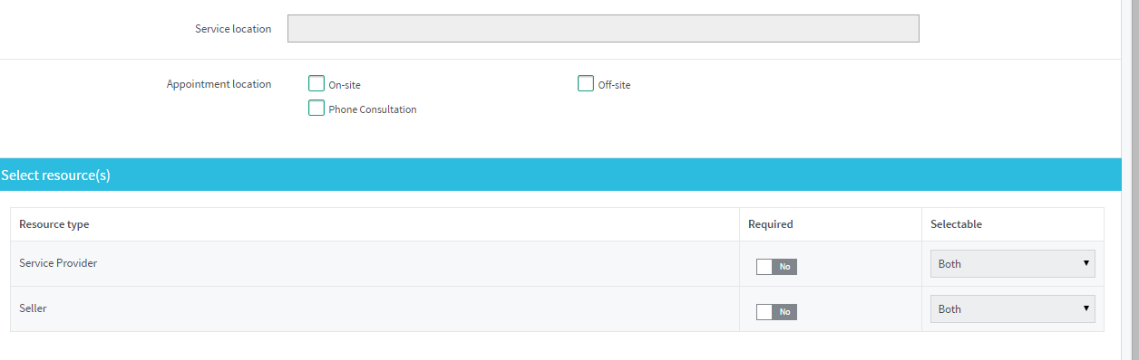

**Conclusion:**

Infect the service should not be created without selecting any one resource type.