**Bug 9: Case 1:** (Set Pricing Issue)

When we have multiple locations in our company then and we select any one location among them and then want to set price then of based on that location then all locations are being shown in set price option which should not be possible.

**Step to reproduce:**

Here we have two locations and we have selected only one as shown:

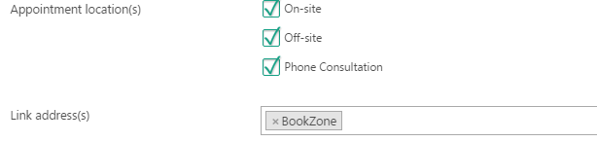

And the second location is not selected yet.

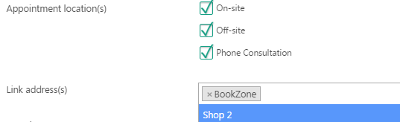

Now when we click set price button then it is showing all (two) locations “BookZone” and “Shop 2” which should not be happen.

