QA Of iScheduler

|  |  |
| --- | --- |
| **Product** | iScheduler |
| **version** | 05 |
| **Module** | Wizard |
| **Testing Type** | UI Testing |
| **Browsers** | Chrome, Mozilla |
| **Device** | Nexus 4 |

**Layout issues:**

**Issue 1:**

When we wish to login in iScheduler then t doesn’t appear with facebook plug-in.

**Step to Reproduce:**

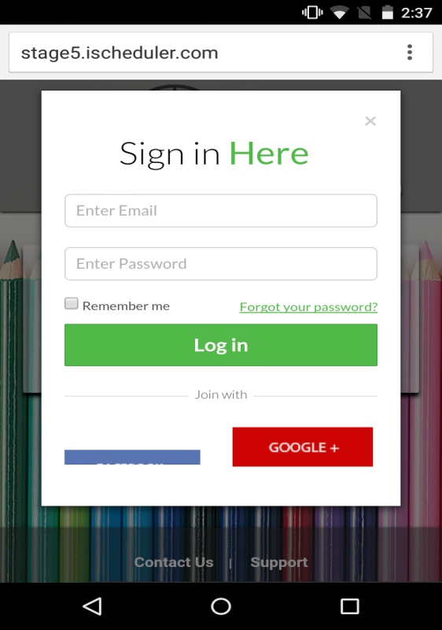

**Issue 2:**

IIf I have multiple business account then these appear as:

**Step To Reproduce:**

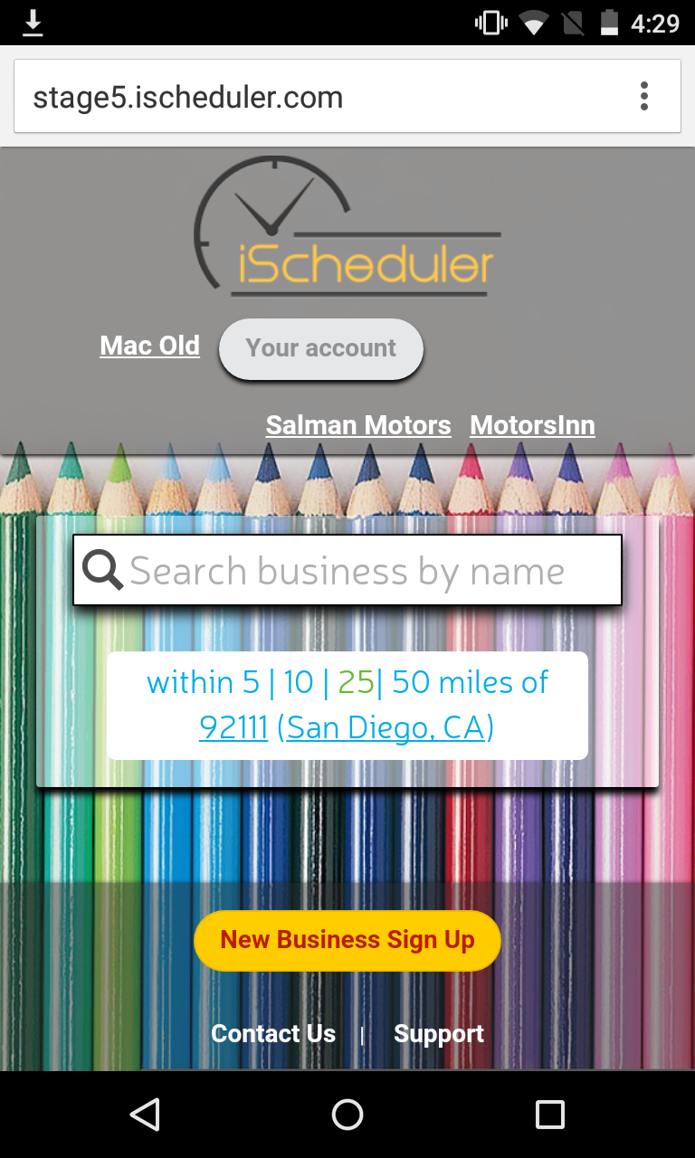

**Issue 3:**

When I wish to select any option by clicking specifically in dropdown and check boxes then it gets selected after multiple attempts.

**Step to Reproduce:**

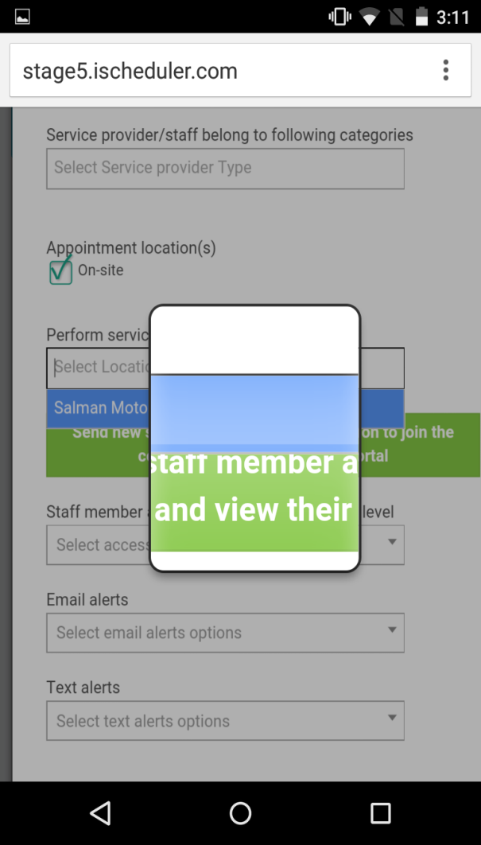 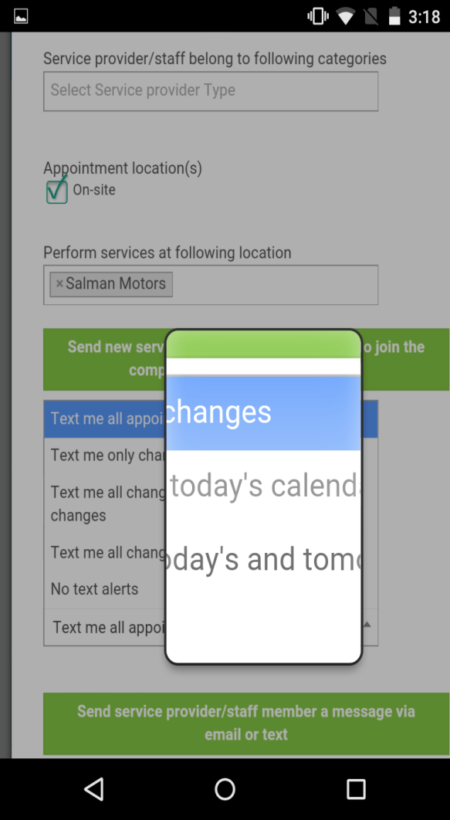

Issue 4:

When I want to sign in with g+ a/c then it is not being happen.

Issue 5:

The next button of Service provider is not working.