QA of iScheduler

**Bug No.1**

When we don’t have any default service in template then this message should not occur.

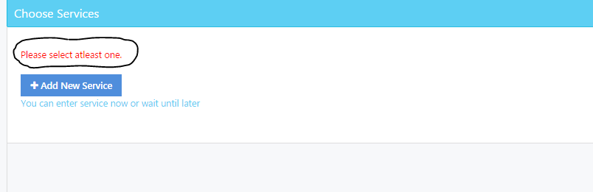

**Bug No:2**

While selection of service provider. We are having an error.

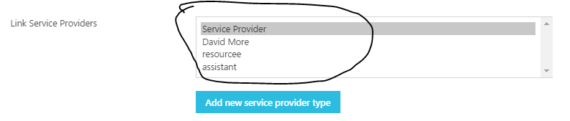

**Bug No:3**

After Default selection of service and service provider then if we want to add service provider type then it doesn’t getting added.

**Bug No:4**

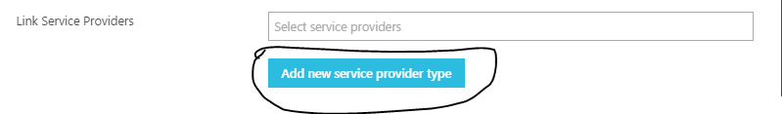

**Bug No:5**

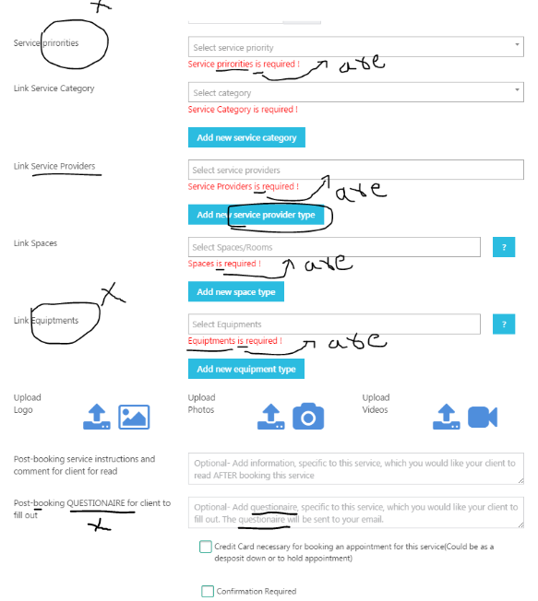

**Bug No.6**

When we want to add a resource type from wizard then it gets added as Resource type name field as ‘0’.

**Step to reproduce:**

