QA of iScheduler

**Bug No.1**

If we are attempting to add service provider type or space type or equipment type by naming them and hit ok button then ok button doesn’t work properly and no name is being inserted of any type.

**Step to Reproduce:**

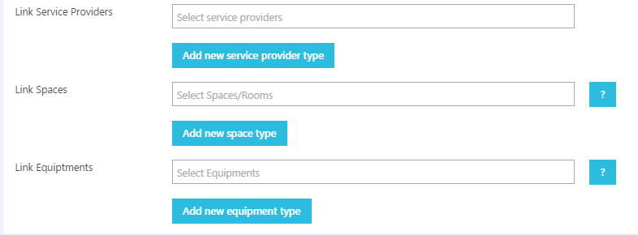

If we click any of these three, like

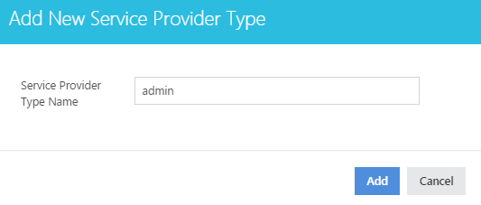

**Bug No.2**

No logo, image and video are being uploaded from computer.

**Step to Reproduce:**



**Bug No.3**

If i need only service provider (person) instead of equipment or space then there should be no additional field for these service types whom i don't want to include. Like...

**Step to Reproduce:**

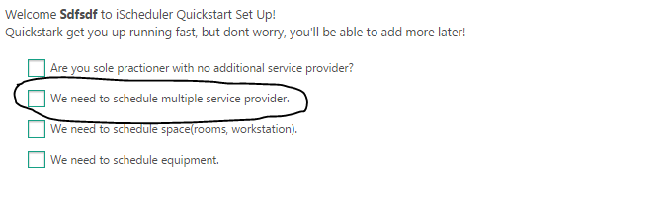

If i only select this one then these two fields should not come in the next step.

