**Cloudy buddy marketing strategy**

**Introduction**

Considering the diversity of cloud management services and plethora of categories that this industry breaks into, at this moment we would have to target only the most obvious categories (and keywords) to make our service and landing pages.

That being said, we do have an edge over our competitors in terms of cloud management services which is that our service model not only offers the managed service such as cloud system management, bandwidth management etc (that our competitors openly market as “basic management services”) - but we also offer high end software development/programming services in the cloud on the whole.

Which I think cannot be more clearly expressed as

**[4/4/2015 12:15:33 PM] Zafar Kazmi:** “*and most MSP do not have skills in programming. They just have system level knowledge, we bridge that GAP! So we provide all the services you mentioned at system level, but we also provide services at application level”*

Adding up the above statement a little more- we have a team of “[DevOps](http://en.wikipedia.org/wiki/DevOps)” which can be put at the disposal of any business or store owner having his business hosted on the clouds to manage not only their availability, backup operations…..etc but also optimize their store, its design and functionality from a developer’s perspective.

This is what we will be showcasing on our website’s design, its sliders, text snippets & banners in BIG & BOLD.

**Content Drilldown**Now coming to how our content will be displayed. Besides design modifications to include a proper navigation slider, hero area and most importantly a signup form/area (interactive) – we will also need to give a facelift to our existing main page content.   
The single page format that we have right now might be changed; with texts taking over images and the content will contain a little more accuracy (as mentioned above by prioritizing our business slogan)

**At the moment our website has images in place of text, which is not-crawl able**this is how I believe our main page should be like <http://www.netstride.com/> & <http://www.bulletproof.net.au/> . Notice the navigation bar on both the websites, (I prefer bulletproof better, it displays content in drop down style and breaks its service model in 4 packages, exactly the way we will do). Coupling this with large hero area, dual slider and feature boxes, we can imagine a web design we need.

**Pricing & Plans**

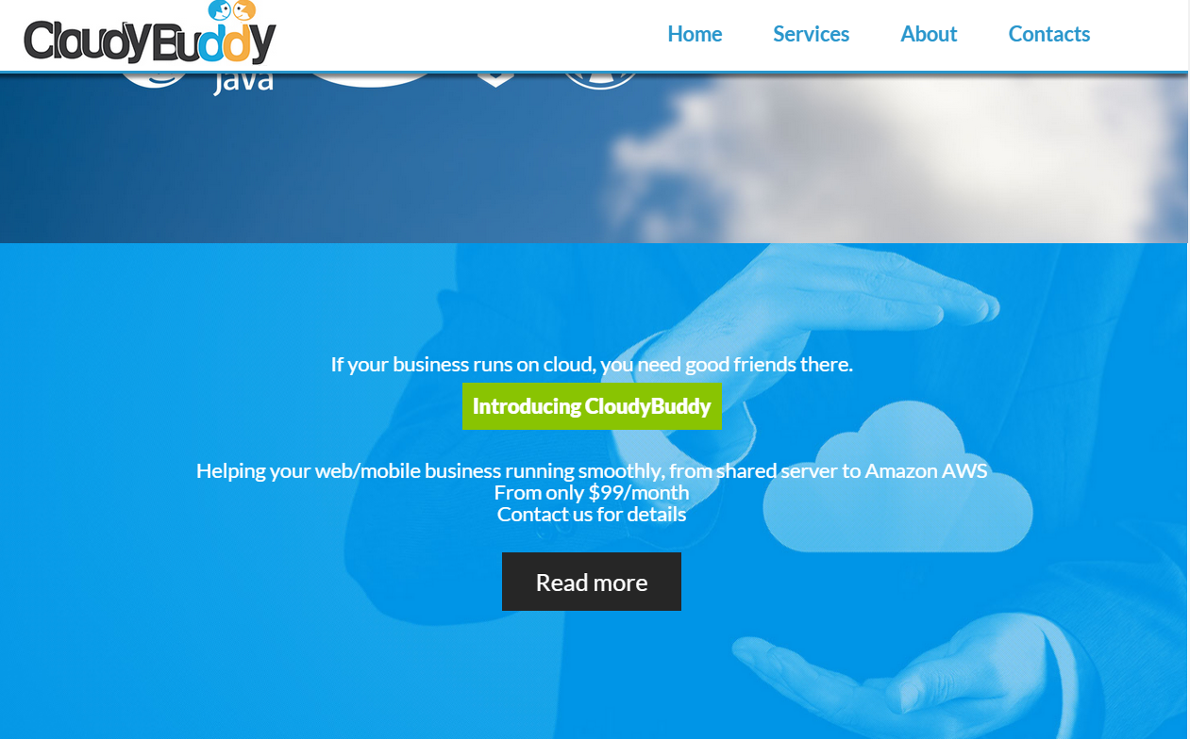

We will display our basic pricing information just as we do in our existing website (above image) However, from there we will take our visitors to an actual “Pricing” page where a Jquery form will allow them to decide & SCALE for themselves which services they want from us.   
I am currently looking for ideas on how our pricing form will be like, but I guess that it should have integrated radio buttons or a horizontal scale/scroll bar to choose services and automatically set charges.

**OR** we don’t show pricing at all, just display that we charge as low as $ 99 and from there take users to a simple message form. (Similar to Smartmicros) where they could tell us what services they want!

**Services/ Products and solutions/ Our Managed Cloud Services**

We will break our services into 4 quarters, each quarter breaking into further services & landing pages.

1. **Cloud System Management services/ Managed Cloud Services**
2. Cloud Performance management
3. Cloud Security management
4. Cloud Backup Services
5. Cloud Bug Fixes
6. Cloud Software management
7. Cloud OS Update management
8. Cloud Monitoring
9. Cloud Migration
10. Cloud Application patch management
11. Disaster Recovery
12. **Cloud Platform Management Services/Cloud Platform**
13. Amazon AWS Cloud management
14. Windows Azure Cloud management
15. Google App Engine management
16. Dedicated Servers management
17. Shared Servers management
18. Enterprise Cloud management
19. (MORE)
20. **Cloud Solutions By Business Case**
21. WordPress cloud management
22. WordPress migration
23. Magento cloud management
24. Magento optimization
25. Drupal Cloud management
26. Drupal Performance management
27. Ecommerce cloud management
28. PHP/LAMP website management cloud
29. Ruby On Rails Cloud management
30. **Other Services/ Solutions By Requirement**
31. Cloud Strategy
32. Performance optimization
33. Ecommerce
34. Websites
35. Application development & hosting
36. Devops, Agile development & Automation

This particular service model is best displayed in category style as done by this provider (<http://www.bulletproof.net.au/products-services/>)

***Note:***

In Total we will have around **35-40 pages.** Page titles and their number will be subject to a change and increase if necessary. Per page content will be around 500-600 words, making total word Content to be near **15000** words.

For keywords, we will be targeting the basic ones (as mentioned above/but high competition) and get them into separate landing pages. Variations of these keywords(long tail) will be to be used in the content.

This is for starters only, and even with this much content we will be coining a basic website. Later on we can produce more product (keyword) oriented landing pages. This is because each product, solution or a cloud provider in the industry has a following and a community, if we are to offer management and DevOps to such a following we need to be as specific with our marketing and pitch.

**Other Pages**

Following will be the remaining pages to be displayed in navigation and footer

1. **Customers**
2. Success stories/Case studies
3. Testimonials
4. **About Us**
5. **Blog**
6. **Live Chat**( This will actually be a popup contact us form which will request an email address and a message

**How To Begin**

I think we should start with designing mockups of the website we are going to use based on the above examples and few more inspirational design ideas we come across. I will begin producing the content starting with the main page content where our major sales pitch is going to be.   
Now considering the number of pages in “services & products” that we have to make (which is a lot) - I will try to write content for at least 3 landing pages for each service model.

Among 4 service models, if each of them gets around 3 three landing pages (selective) with descriptive content about the most obvious services in the MSP landscape- we can get the site LIVE if the design & development is done.

**Ending Statement**

If we begin in this way, I can get the initial content of around ***15 pages ready by 11th of May***. If the design is ready by that time, I think the website can be live by ***15th of May, 2015.***  Rest of the pages will be completed and uploaded beside marketing operations.

**Post -Website Strategy**

Once the website is live, our activities for on-page and off-marketing will be similar to that Smartmicros which is

**On-Page:**

1. Meta data integration
2. Blogging (articles, how-to’s, tutorials, reviews, news, promotions, Infographics)

(Consistency = everyday) preferably with news

**Off-Page**

1. Social media profiling
2. Social media marketing
3. Content marketing/Curation
4. Guest posting
5. Press releases
6. Article Submission
7. Directory submission
8. Niche relevant link building
9. Forum posting
10. Blog commenting
11. Reviewer invites/audits