QA of IScheduler

|  |  |  |  |
| --- | --- | --- | --- |
| **Project Name :** | IScheduler | **Tested By :** | Syed Babar Manzar |
| **Module :** | Agent Panel | **Dated :** | June 05,2015 |
| **Stage :** | 04 | **Tested On Browsers :** | Mozilla, chrome, IE, Sea Monkey, Opera, Safari. |
| **Version :** | 04 | **Testing Type :** | Functional |

**ISSUE 2:**

When we are going to make an appointment and do all steps accordingly then the appointment should be created but it is not being happened in first attempt either we do refresh the page again and again, but when we do all steps again in the same manner then the appointment is created. It is necessary to noted that the appointment should be created in the first attempt. Why we have to do all steps repeatedly in order to make an appointment.

In first attempt the screen appears as:

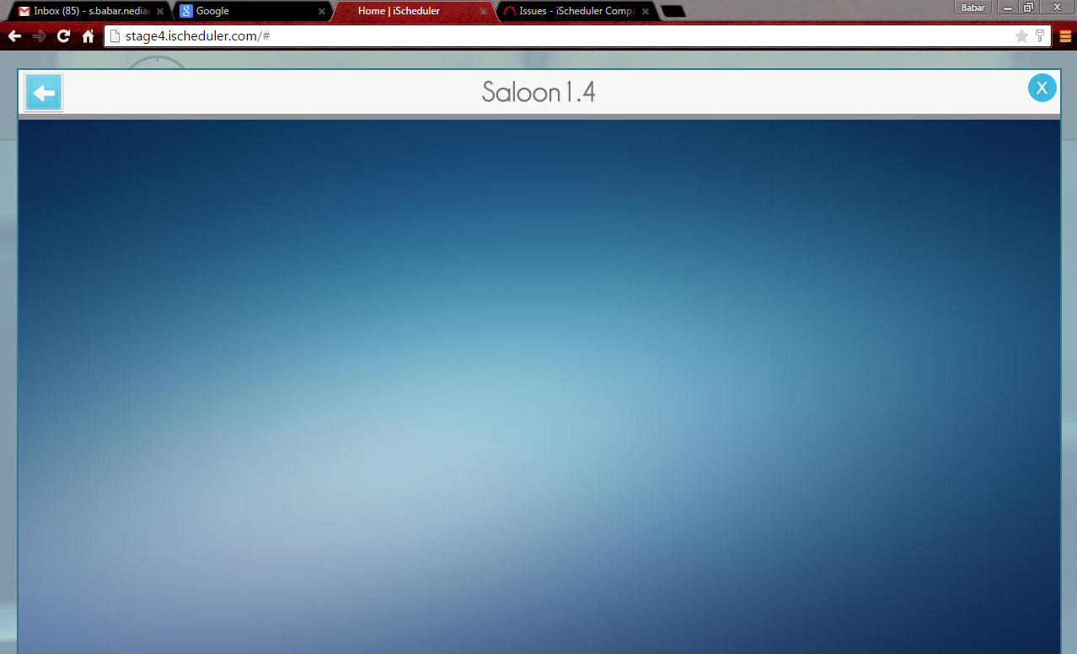

But in second attempt the screen the appointment successfully has created and appears as:

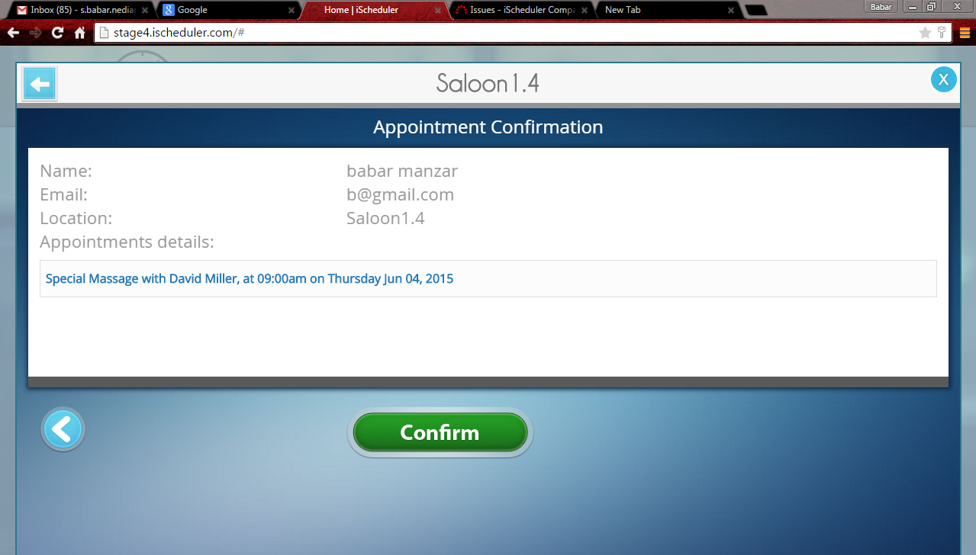

And finally appears as:

