QA of IScheduler

**Issue 1:**

1. While making an appointment when **‘just show me the best available time’** is clicked then it gives error but occasionally

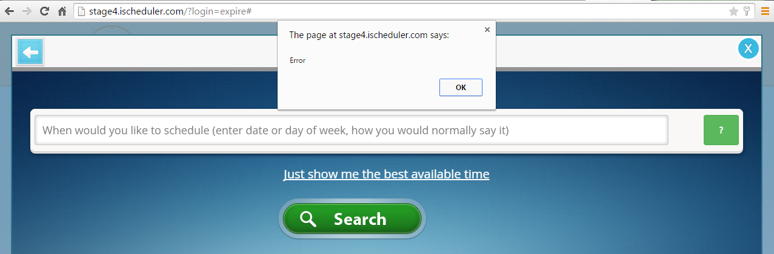

**Issue 2:**

3. On going back from appointment (without login) then it shows the following error.

