**Testing of IScheduler (stage4)**

**Issue 1:**

When we are making client account during creating appointment, once all required fields are filled and hit next so an error message is being generated:

**Step to Reproduce:**

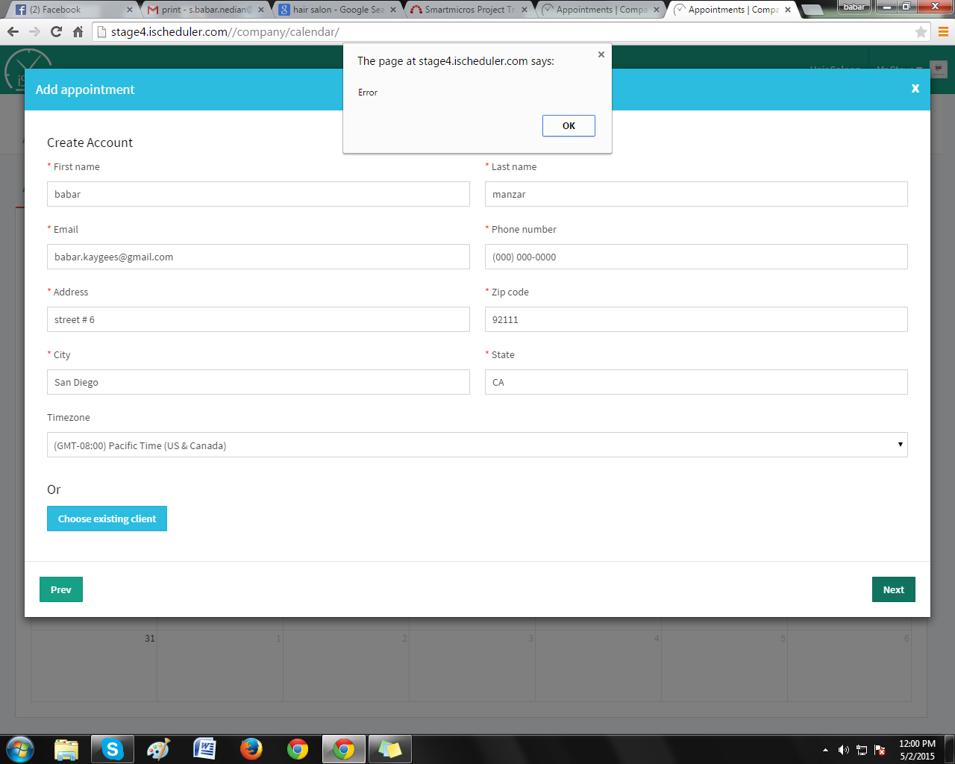

**Issue 2:**

After signing up, when we go to next page so again an error message is being generated.

**Step to Reproduce:**

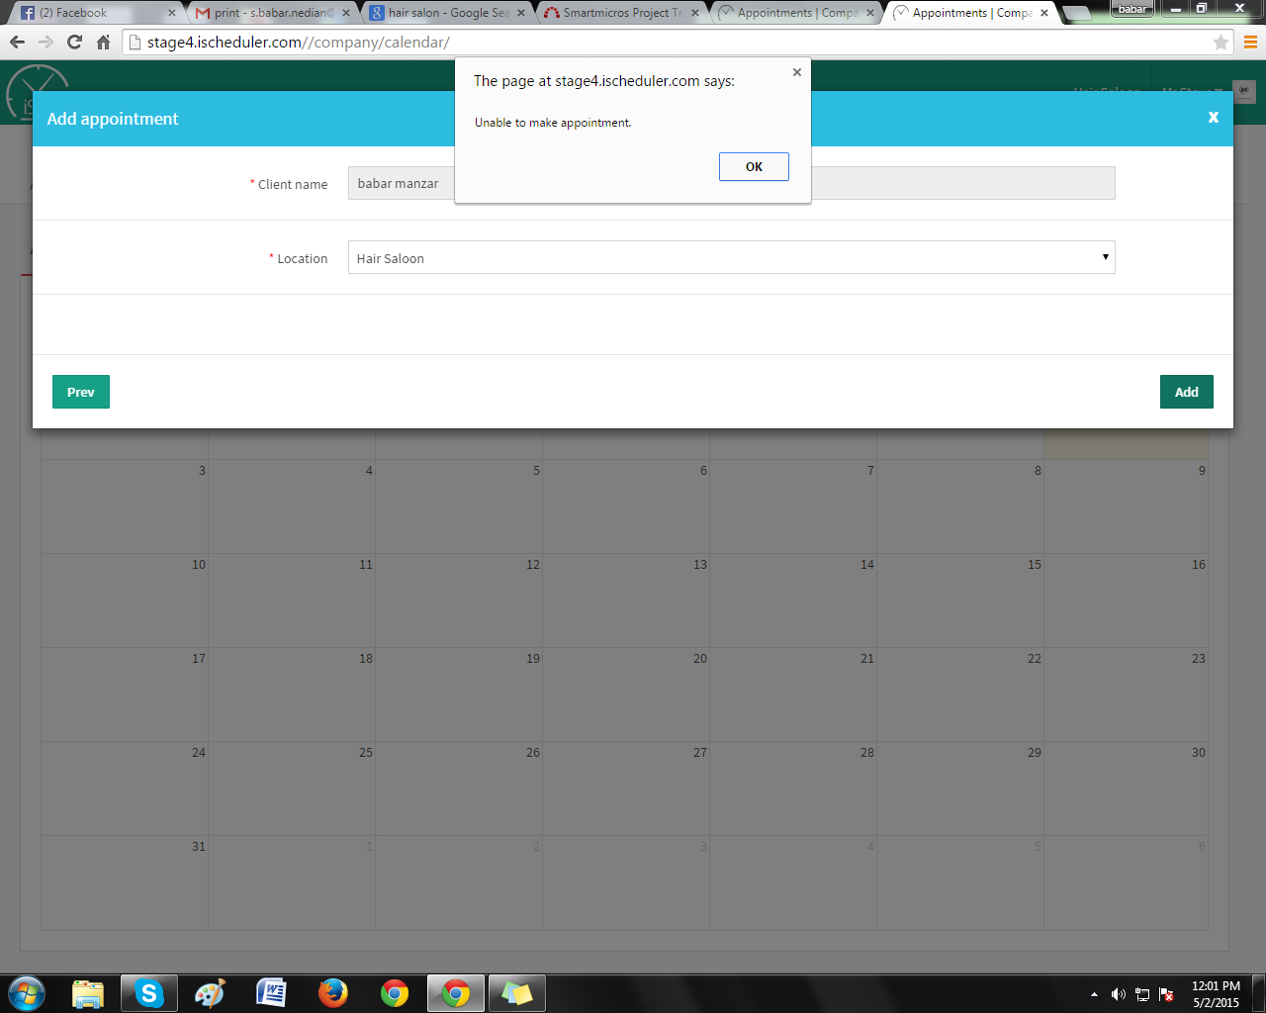

**Issue 3:**

When creating appointment process some unexpected resources come, which not come and the resources related to service should be in proper way.

**Step to Reproduce:**

