**Issue 1:**

* There should not be much space between the headings like shown in above.



**Step to Reproduce:**

<http://www.smartmicros.com/services/>

**Issue 2:**

* There should not be much space between the heading and the content like shown in above.

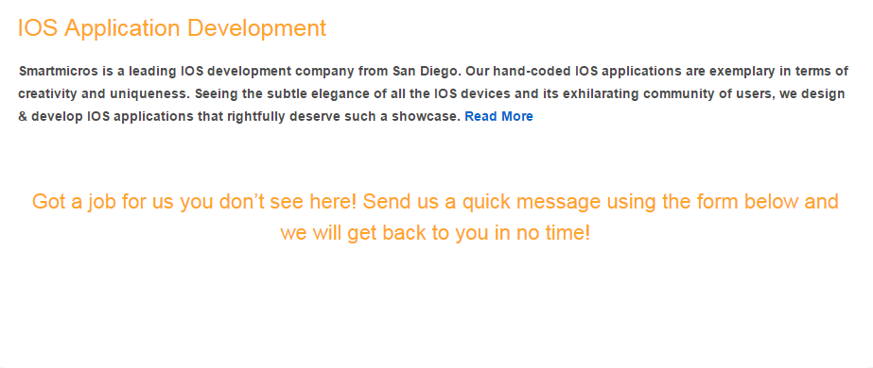

**Step to Reproduce:**

<http://www.smartmicros.com/services/>

**Issue 3:**

* In the second heading ‘Agile Software Development’ there is padding issue between heading and content.

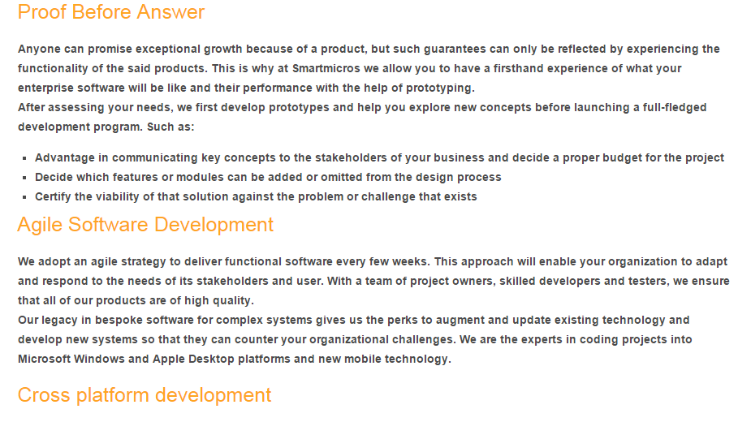

**Step to Reproduce:**

<http://www.smartmicros.com/enterprise-software-development-company/>

**Issue 4:**

* There should be some space between the paragraph because it looks so offensive to read like shown in above.



**Step to Reproduce:**

<http://www.smartmicros.com/about-us/>

**Issue 5:**

* There is an extra space between the following paragraphs which should not be happen.

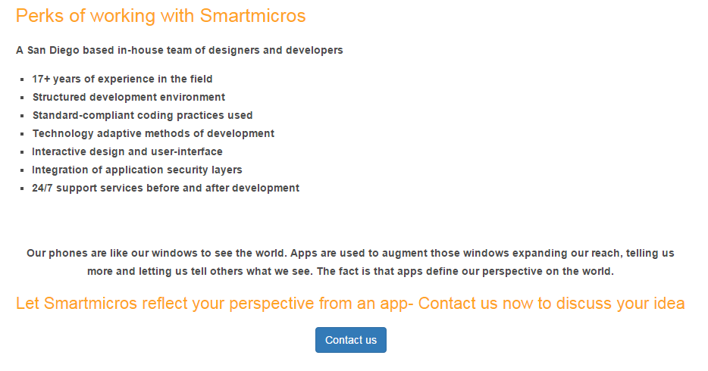

**Step to Reproduce:**

<http://www.smartmicros.com/san-diego-ios-application-development/>

**Issue 6:**

* The headings should be highlighted and bold for a different look from content.

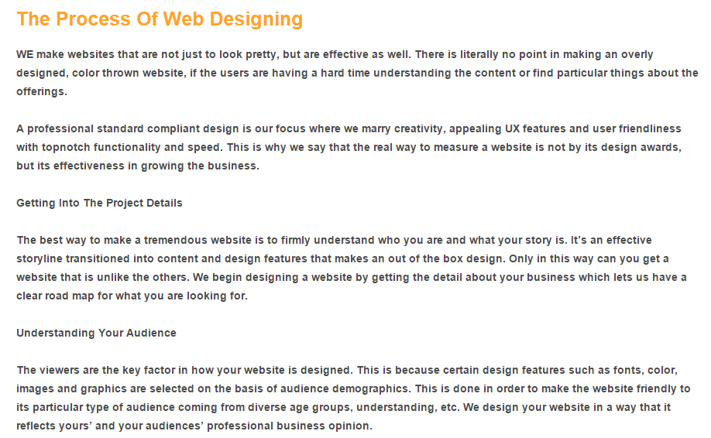

**Step to Reproduce:**

<http://www.smartmicros.com/san-diego-web-designing-2/>

**Issue 7:**

* There should be more spacing between the heading and the button.



**Step to Reproduce:**

<http://www.smartmicros.com/san-diego-web-designing-2/>

**Issue 8:**

* There should be more spacing between the heading and the button.



**Step to Reproduce:**

<http://www.smartmicros.com/san-diego-iphone-app-development/>

**Issue 9:**

* There should be more spacing between the heading and the button.



**Step to Reproduce:**

<http://www.smartmicros.com/san-diego-ipad-app-development/>

**Issue 10:**

* There should be spacing between the following paragraphs.

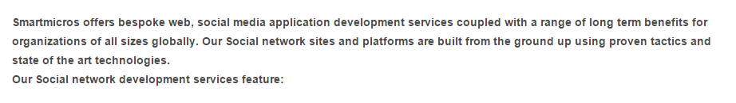

**Step to Reproduce:**

<http://www.smartmicros.com/web-social-media-application-development-company/>

**Issue 11:**

* There should not be much space between the content and heading.



**Step to Reproduce:**

<http://www.smartmicros.com/web-social-media-application-development-company/>

**Issue 12:**

* There should be spacing between the paragraphs.

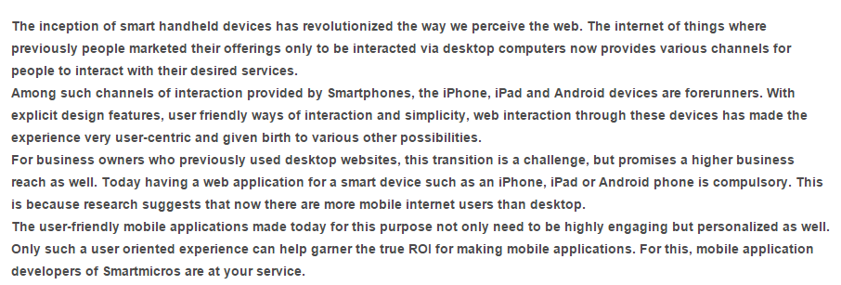

**Step to Reproduce:**

<http://www.smartmicros.com/iphone-ipad-android-app-development-company/>

**Issue 13:**

* There should not be much space between the content and heading.



**Step to Reproduce:**

<http://www.smartmicros.com/iphone-ipad-android-app-development-company/>

**Issue 14:**

* There should be spacing between the following paragraphs.

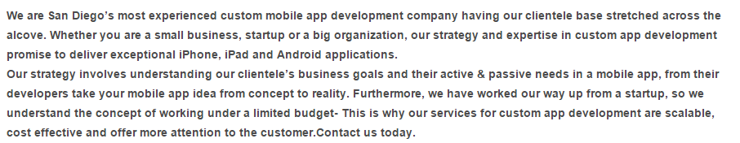

**Step to Reproduce:**

<http://www.smartmicros.com/custom-mobile-application/>

**Issue 15:**

* Heading should be proper highlighted and must be greater from the font-size of content.

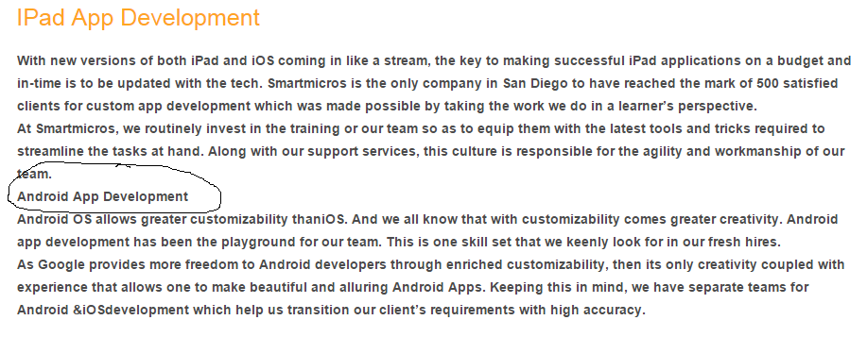

**Step to Reproduce:**

<http://www.smartmicros.com/custom-mobile-application/>

**Issue 16:**

* There should be spacing between the following paragraphs.

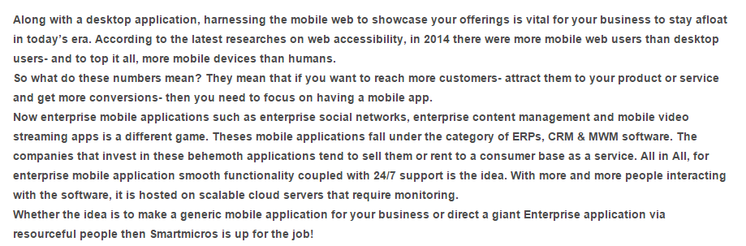

**Step to Reproduce:**

<http://www.smartmicros.com/mobile-app-development-company/>

**Issue 17:**

* There should be proper spacing between the content and the paragraph.



**Step to Reproduce**:

<http://www.smartmicros.com/mobile-app-development-company/>

Issue 18:

* There is much extra spacing between the contents and paragraphs in the **whole page**.

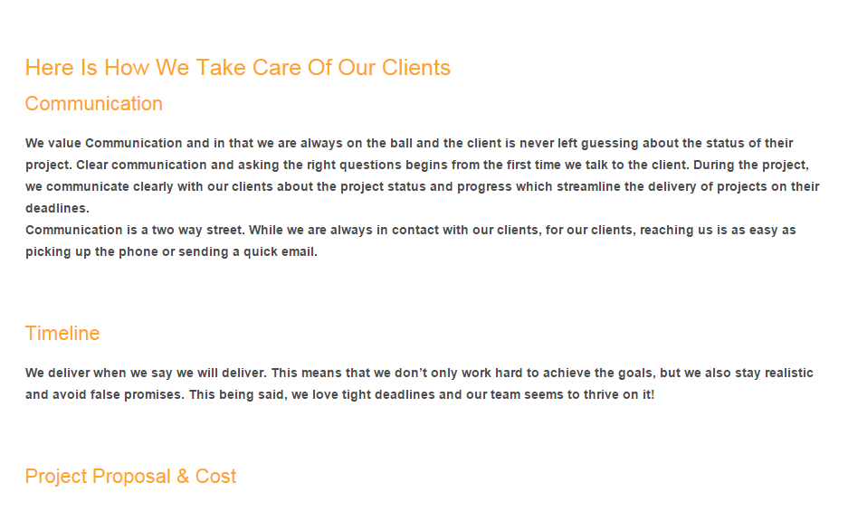

**Step to Reproduce:**

<http://www.smartmicros.com/business-app-development-company/>

**Issue 19:**

* Some paragraphs have spacing and some don’t have in the same page.

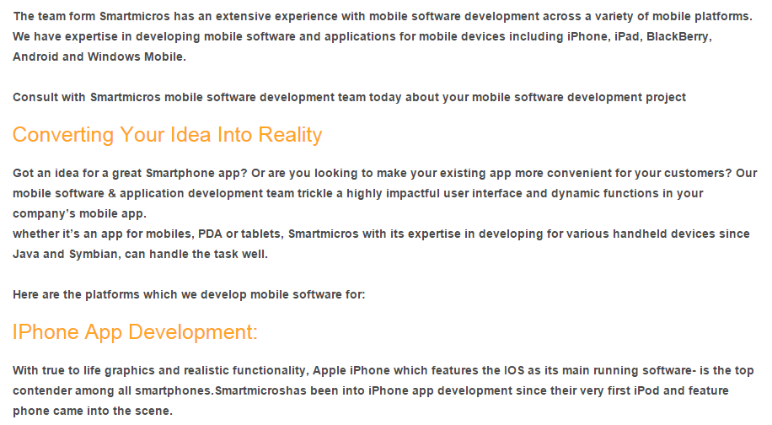

**Step to Reproduce:**

<http://www.smartmicros.com/san-diego-mobile-software-development/>

**Issue 20:**

* In this page there is a bulk of content in a single loop. No spacing in between the paragraphs.



**Step to Reproduce:**

<http://www.smartmicros.com/san-diego-enterprise-software-development/>

**Issue 21:**

* There should be some difference between the heading and the sub heading which was not focused properly.



**Step to Reproduce:**

<http://www.smartmicros.com/san-diego-enterprise-software-development/>

**Issue 22:**

* The heading must be highlighted and has greater font-size as compare to content or paragraph.

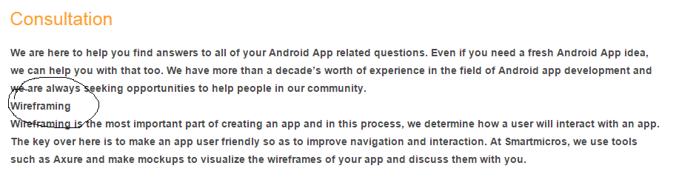

**Step to Reproduce:**

<http://www.smartmicros.com/san-diego-android-app-development/>

**Issue 23:**

* The heading must be highlighted and has greater font-size as compare to content or paragraph.

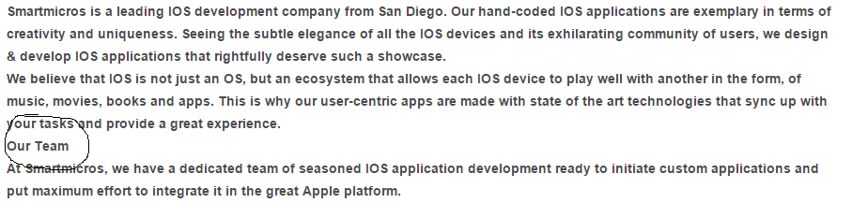

**Step to Reproduce:**

<http://www.smartmicros.com/ios-application-development-company/>

**Issue 24:**

* There should be spacing between the paragraph and the heading.

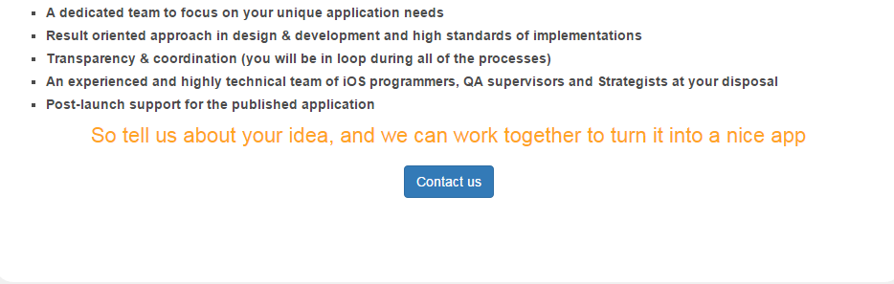

**Step to Reproduce:**

<http://www.smartmicros.com/ios-application-development-company/>

**Issue 25:**

* Headings and sub headings must have different font-size so that it will be easier for the user to read.



**Step to Reproduce:**

<http://www.smartmicros.com/android-application-development-company/>

**Issue 26:**

* The asterisk should be properly aligned.

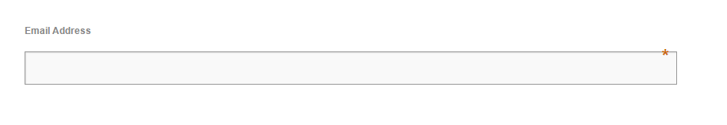

**Step to Reproduce:**

<http://www.smartmicros.com/scheduler/prelaunch-2014/>

**Issue 27:**

* The scheduler page of Smartmicros is not displaying any data.

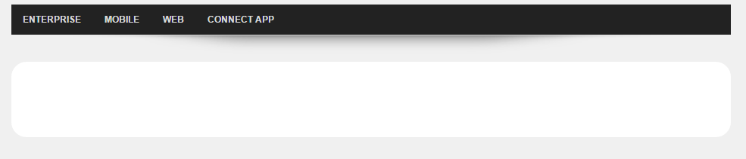

**Step to Reproduce:**

<http://www.smartmicros.com/scheduler/>