**QA Of Smartmicros**

**Tested On following Browsers:**

* Google Chrome
* Mozilla Firefox
* Sea Monkey
* **Issue 1:**

Line height issue in enterprise page

* **Step to reproduce:**

<http://www.smartmicros.com/enterprise-software-development-company/>

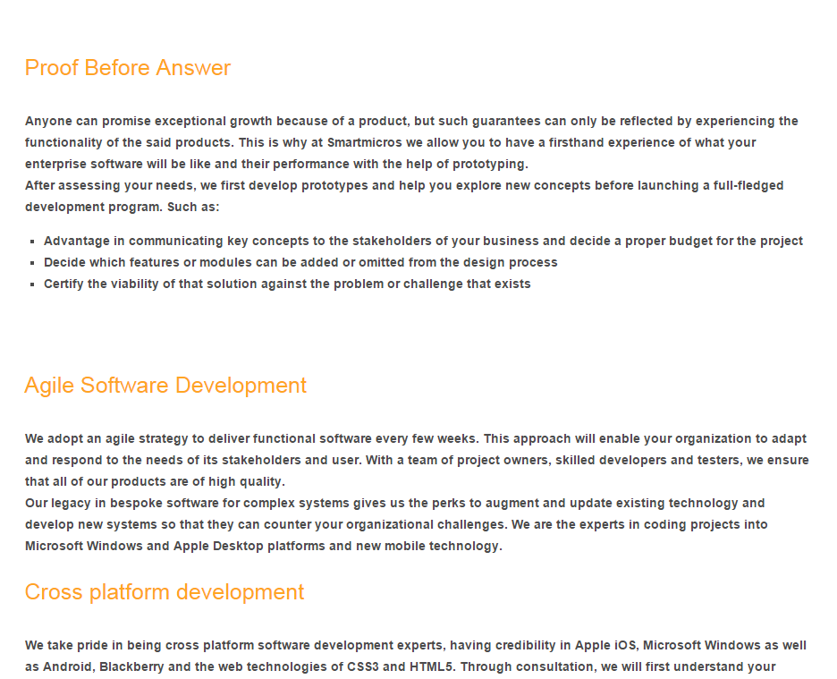

* **Issue 2:**

Line height issue in enterprise page (tag: software, cmms, crm, development, enterprise and San Diego)

* **Step to Reproduce:**

<http://www.smartmicros.com/enterprise-software-development-company/>

* **Issue 3:**

Padding issue between the paragraphs in ‘how we- work-page’.

* **Step to Reproduce:**

<http://www.smartmicros.com/how-we-work/>

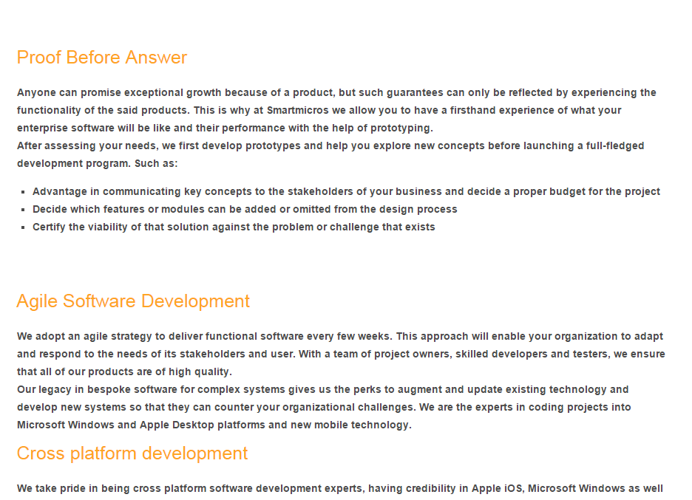

* **Issue 4:**

Text alignment issue in the following page ‘mobile-app-development-company’.

* **Step to Reproduce:**

<http://www.smartmicros.com/mobile-app-development-company/>

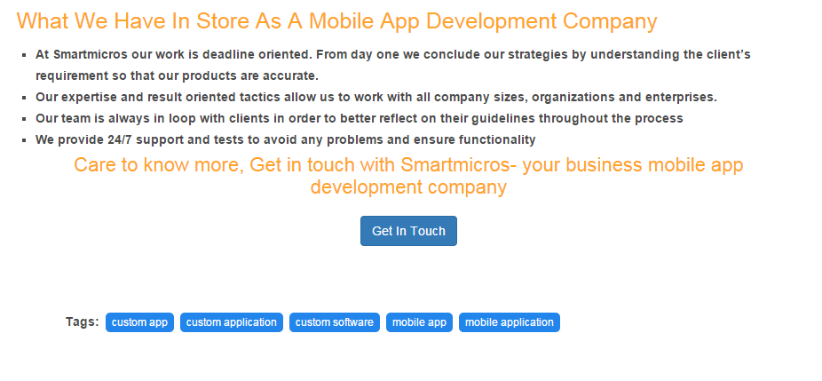

* **Issue 5:**

Text alignment issue in the following page ‘business-app-development-company’. There are more gap than required.

* **Step to Reproduce:**

<http://www.smartmicros.com/business-app-development-company/>

* **Issue 6:**

### Padding issue between the paragraphs Web & social media application development and Enterprise Software development.

### Step to Reproduce:

### <http://www.smartmicros.com/services/>

### Capture.PNG